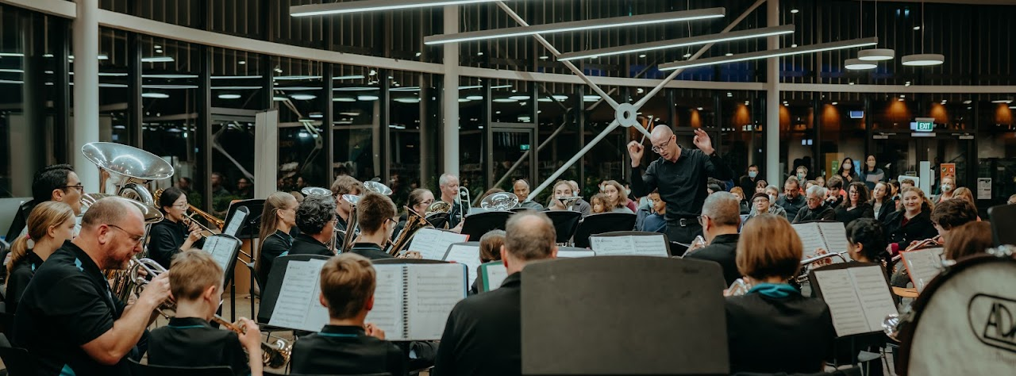

Nor’west Brass is a local brass band with a strong focus on developing brass and percussion players and making music accessible to the wider community.

Based in the northwest of Christchurch, our band is open to anyone from beginner to advanced. We aim to provide the opportunity to everyone who wants to experience and enjoy playing in the brass band, regardless of ability.

We are currently recruiting new players (from Year 3 upwards) to learn and enjoy playing a brass instrument. Players who reach a competent level by the time they reach high school will be better placed to make the most of the musical opportunities available.

It’s a lot of fun & the band is welcoming & friendly.

We look forward to hearing from you:

029 777 4233 (Bill Vail)
norwestbrass@gmail.com
www.norwestbrass.nz

