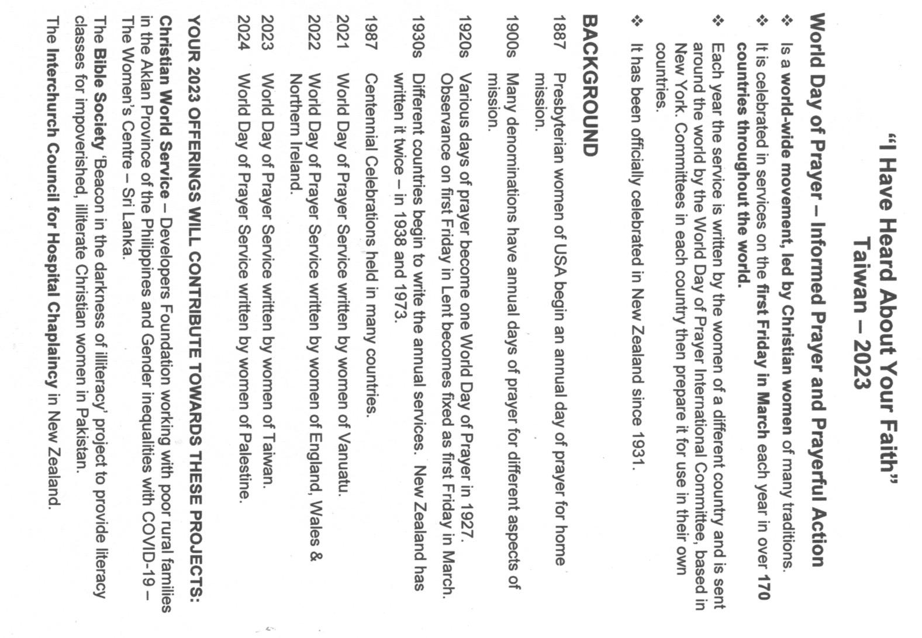

WORLD DAY OF PRAYER FRIDAY 3rd MARCH 2023

ECUMENICAL SERVICE for Dunedin West Churches
AT ST JOHN'S ROSLYN, 373 Highgate, Dunedin
at 10:30a.m.
A cuppa will be served from 10:00.
Any queries, please contact the St John's office 464 0240
This year's service has been prepared by the women of Taiwan.
Everyone is welcome to join us at St John's on Friday 3rd March at 10:30a.m.

