Mushroom & Lamb Ragout Pappardelle

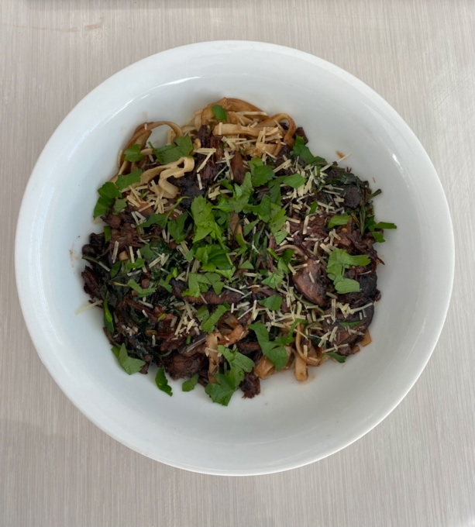
Stella and I made this together and this is our photo of our mushroom & braised lamb ragout made with fettucine instead of pappardelle.
SERVINGS 4 PREP TIME 25 min
COOK TIME 3 hours (braised lamb) mushroom and past 10 minutes.

INGREDIENTS

To braise the lamb:

Lamb rump or similar (at least 500g for 4 people)

3 cloves Garlic

1 onion

2 Tbsp rosemary chopped up

1/2 of Red wine

½ cup beef broth

1 Tbsp tomato paste

To cook the mushroom and pasta:

3 tablespoons (45 ml) extra-virgin olive oil

2 shallots halved lengthwise and thinly sliced

Kosher salt

3 (350 g) portobello mushroom caps (10 -12 ounces) sliced into 1-inch pieces

8 ounces (225 g) pappardelle pasta fresh or dried

1 garlic clove finely sliced

2 teaspoons finely chopped fresh rosemary leaves

1/2 teaspoon red chili flakes

2 tablespoons (30 g) tomato paste

1 teaspoon balsamic vinegar

2 tablespoons (30 g) unsalted butter

1 chunk (50 g) Parmigiano Reggiano or Parmesan cheese

Optional: spinach or a leafy green

INSTRUCTIONS:

Braised Lamb:

Soften garlic and onions, add rosemary for 2-3 minutes. Place lamb in dish and brown on all sides.

Place lamb in a covered oven dish with wine, broth, tomato paste & onions, garlic, rosemary mixture. Cover and slow cook for up to 3 hours (until it falls apart). Pull apart and leave in the juices (you will add this all to the mushroom mixture before serving the pasta).

Mushrooms and pasta:

Put the oil, shallots and a pinch of salt in a large skillet and place over medium heat. Cook, stirring frequently, until the shallots are softened, but not browned.

Add the mushrooms to the pan. Cook the mushrooms for a few minutes until they take on some color, then stir and add 1/2 teaspoon salt. Continue cooking until the mushrooms become tender and their liquid evaporates.

Meanwhile, bring a large pot of water to a boil and add 2 tablespoons kosher salt. Cook the pasta until al dente. Scoop out and reserve 1/2 cup of the pasta water, then drain the pasta.

Add the garlic, rosemary, chili, tomato paste, vinegar and butter to the mushrooms. Add 1/3 cup of the pasta water and stir over medium heat until the mixture becomes saucy.

Add the lamb to the mushroom mixture – stir through.

Optional - add in spinach or a leafy green if you would like too – simmer on a low heat with a lid on for 1 minute until wilted.

Add the pasta to the pan and toss gently with tongs to coat with the sauce, adding more water (and/or a dash or 2 of cream) if it seems too dry. Taste for seasoning.

Shave curls of Parmigiano cheese over the pasta with a vegetable peeler and add finely chopped parsley to serve.

