YOUNG PICASSOS T2MURAL SUMMERFUN!
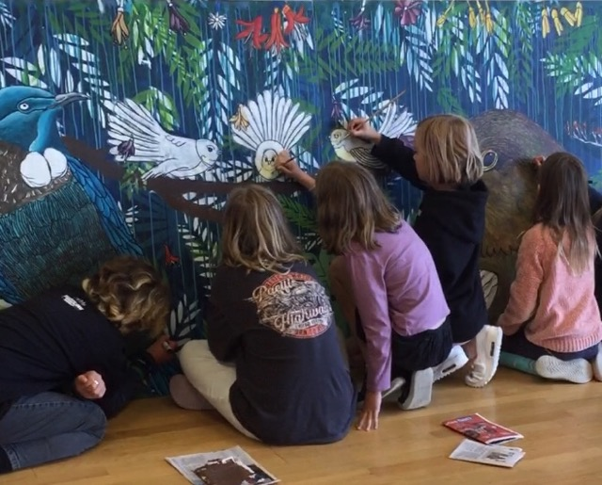
ENROL NOW FOR YOUNG PICASSOS TERM 2!
Enter an “artists world” and learn how to create an amazing outdoor mural based on summer fun while learning scale, key painting /drawing and concept creation! Group and individual work based. The Mural will be hung in a community space! Loads of FUN!
Book Now - 3.30 - 5pm $261 Wed - Arrowtown Community Centre or Friday Te Atamira
Email LisaDuncan BA Hons Dip Teach Txt 0223641127
lisadspaintparty@gmail.com/txt 022 364 112

