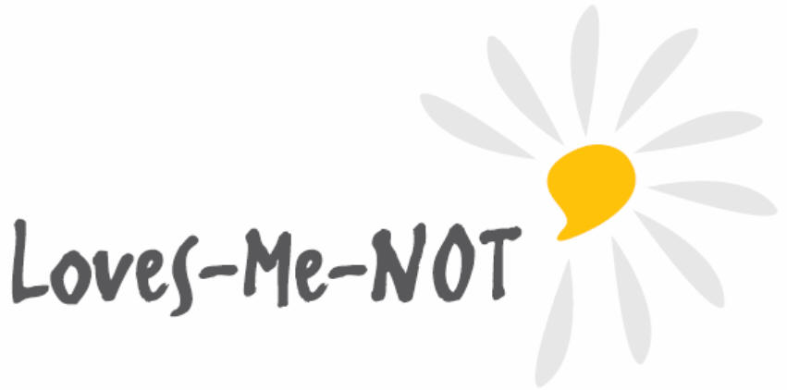Loves-Me-Not

Frequently Asked Questions

What is Loves-Me-Not?
Loves-Me-Not is a ‘whole-school approach’ to prevent abusive behaviour in relationships. It is based on a student inquiry learning process, where students take action (personal action, effective bystander action and community action) to prevent harm from relationship abuse.

Loves-Me-Not is designed for Year 12 students as the appropriate age to discuss relationship abuse and to start to take action for change.

What are the aims of Loves-Me-Not?
Loves-Me-Not aims to:
- assist schools that are seeking to support student well-being through a whole-school approach
- encourage and empower young people to absolutely reject abuse in relationships
- encourage young people to be safe and active bystanders who take action against unhealthy relationships
- encourage young people to take a stand against myths in society that perpetuate relationship violence
- help young people know who they can go to in their community to seek advice and support if they need it as either victims or perpetrators
- encourage young people to contribute to, or create a wider community response so as to encourage others to accept only healthy relationships.

Why should young people learn about relationship abuse?
Relationship abuse and family violence are one of New Zealand's biggest social and criminal issues. Insidious behaviour is often dismissed during the early stages of a relationship, when things are new and exciting. However, once someone has taken the power away from another person, it is often very difficult for the victim to get out.

Through education, young people are able to recognise:
- if they are in an abusive relationship, and how to get help before it becomes more difficult to leave
- if any of their behaviours are abusive and controlling, and get help to change these behaviours before they harm someone
- the early signs of abuse, and to make early choices to reject abusive relationships.

How is Loves-Me-Not implemented in schools?
A Police Loves-Me-Not coordinator or School Community Officer will work with a school manager and the school’s Loves-Me-Not coordinator to plan activities based on a ‘whole-school approach’. This ‘whole-school approach’ is described in the Loves-Me-Not Implementation Guide.

Some whole school approach activities that take place prior to the Loves-Me-Not workshop include:
- the school reviewing its policies and procedures related to having a physically and emotionally safe environment, and policies and procedures when situations of relationship abuse are disclosed
- a teacher meeting that includes clarification of the school's abuse disclosure procedure
- communicating with parents (e.g. parent meeting, newsletter, social media) to clarify the rationale for the Loves-Me-Not workshop - an informative video for parents is available online: https://youtu.be/c-gt7QG7GEc
- collaboration with community groups to coordinate support for students who disclosure abuse.

What is the Loves-Me-Not workshop?
Loves-Me-Not includes a one-day workshop facilitated with a class of up to 25 students.

The team of three trained facilitators will be made up of a nominated school staff member, a member of police, and a non-government organisation representative. At least one of the facilitators will be a male. This interagency model of facilitation is key to Loves-Me-Not, as it provides:
- community support for the school and the teachers to promote positive relationships
- a range of agencies that young people are able to access if affected by relationship abuse.

The Police and school Loves-Me-Not coordinators arrange the selection and training of personnel from the school, Police and non-government agencies to facilitate the workshop.
Details about the planning for delivery of the workshop are described in the Implementation Guide.

What does the Loves-Me-Not workshop consist of?
During the educative journey of six focus areas in the Loves-Me-Not workshop, the students:
- explore qualities of good relationships
- recognise early signs of relationship abuse
- understand sexual consent, what it means, and why they need it
- apply critical thinking about who is advantaged by societal myths, and how these myths may perpetuate relationship abuse and acts of sexual abuse
- explore if, when and how to be an active bystander
- are encouraged to 'take action for change' for themselves, their friends and family, and the wider community to have safer communities together.

The workshop is based on The New Zealand Curriculum through incorporating its principles, values and key competencies and learning activities based on effective pedagogy.

Does Loves-Me-Not work?
An evaluation of Loves-Me-Not in 2014 showed that young people understood the messages, found the workshop valuable, were engaged with the activities and provided fantastic feedback on improving the delivery. Staff and students agreed that this is a real issue for young people and that it is relevant to their lives.

After the evaluation, some young people and school staff shared stories of taking action by using their new knowledge and skills – for example, by challenging attitudes, educating peers and family members, and assisting friends and family to get help.

Each year the previous year’s process and impact evaluations are analysed to inform revising and enhancing the effectiveness of Loves-Me-Not.

