
Easter Market
Saturday 20th April
10am to 1pm
On the Green beside Lincoln Library
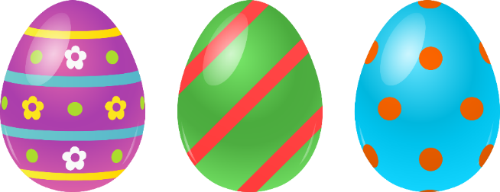
Featuring Adam All Sorts!
Easter Egg Hunt for the kids
Go in the draw to win an Easter Basket

(Must be there for the draw at 12.30pm)

