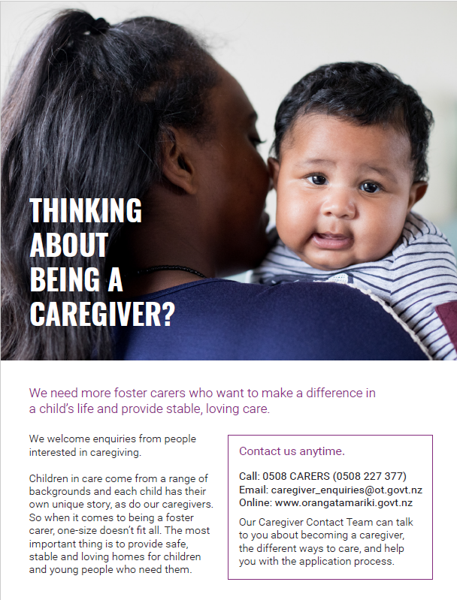

Prefer talk to our local team?

**Phone – Lorraine Paish - Care and Adoptions Social Worker Resource Assistant on 03 955 3482 or email Lorraine.Paish@ot.govt.nz**

