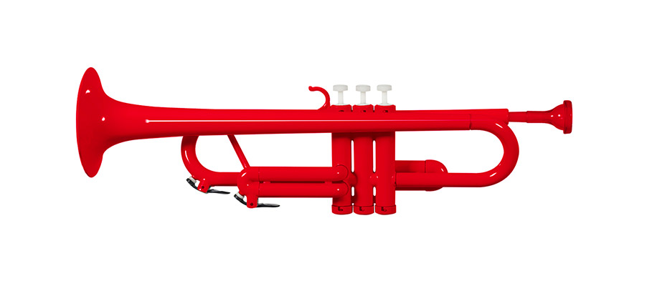**Allbrassclass**

**Introduction for children and family**

Tutor: Errol Moore

**Welcome to your P Instrument. I hope it brings you many hours of happy music making.**

**Here are some helpful tips:**

1. **Be patient** with yourself! It usually takes several weeks before you can play more than a few notes. Your brain and lips have to learn to talk to each other in a different way than for singing or speaking.
2. **Take care of me.** Each time you practice take me (your instrument) out and put me back in the case gently after you have finished. “I am plastic so I break easily if something falls on me, or I fall over”. Don’t take the instrument to pieces until we have done this about Lesson 3. NEVER hit the mouthpiece when in the instrument. Yes, it makes a cute noise, but it costs $20 for another one if it jams.

**Play most days for 10 to 15 minutes… ‘be ever so patient’… Notes for whanau to help you:**

1. Do breathing exercises like sighs and panting before you play the instrument. Support the lungs by using the stomach muscles. Saying ha ha ha or whoooosh loudly gives you the idea of using the diaphragm.
2. Our lips were not designed to play a brass instrument. We have to teach the lip muscles what to do. Hold the mouthpiece only and get the raspberry (buzz) going. Can you buzz a tune you know? Yes, it will sound funny but it helps the brain learn to control the lips.
3. The first notes each practice need to be long. Hold them as long as you can, 5, 10 even 15 seconds. Play long notes that come easily (usually lower notes). Do this for a couple of minutes. As you get more confident spread the range of long notes (Low and High).
4. The hold of the instrument needs to be firm but relaxed. Gripping it hard means you are trying to hard. Do sit up but not tense. If the instrument is close to horizontal as you play your posture is probably good ☺. It is a good idea to practice in the mirror to check. Also check, that the mouthpiece stays close to the centre of the lips (sideways and vertically).
5. Your lips will feel funny when you play for the first few days/weeks. That is natural as the muscles change. Push only gently on the mouthpiece as your lips are easily bruised. It is not a good idea to push hard to get higher sounds to impress! It can seriously damage lip muscles.
6. It is the lips and air that makes the sound. The more you play, the less you will need to kick notes off with the tongue. In fact, you will be taught to produce notes without using the tongue (Blow Notes). The tongue should always work behind teeth and flick off the top of the mouth like a tap to let the air through.
7. The brain also has to control the fingers doing the valve work. Without playing, practice moving one valve at a time but keep the other two fingers on their valve. Then try this making sounds. Learn the habit once and correctly.
8. If you or your family want to know more about producing notes there is lots of help on line. Here is an example: <http://www.trumpetexercises.net/en:for-beginners>

Enjoyment of playing tunes will come quite quickly if you play 10-15 minutes, 4 times a week. By the end of the year, I hope you will go for up to 20 minutes or more. If you work, by end of year you will be able to play about 18 notes, a dozen or so tunes and a variety of warm up exercises that build control of fingers and lips (embouchure).

Good Luck!! Enjoy!

Errol 0272896570 [allbrassclass@gmail.com](mailto:allbrassclass@gmail.com)