Sustainability Initiatives at Rangi Ruru Girls’ School
Manaaki whenua, manaaki tangata, haere whakamua
Care for the land, care for the people, go forward

Purpose
Rangi Ruru prepares our students for a lifetime of sustainable living, through its teaching, values and its day to day practices. It is guided by a commitment to care for:
• Oneself (our health and wellbeing)
• Each other (across cultures, distances and generations)
• The environment (both locally and globally)
Our school values and actions show respect for other people, cultures and the natural world through an underlying sense of care. Care instils responsibility, and as a school we accept the responsibility to develop this within our community. Sustainable schools are great places to learn, where pupils develop self-esteem and reach high standards of achievement. In operating this way, Rangi Ruru Girls’ School demonstrates responsible practices for their young people and communities and engage them in learning about the issues and potential responses.
Rangi Ruru Girls’ School defines sustainability according to the NZ Curriculum which groups it into the following categories:
Environmental sustainability is about maintaining the integrity of life support systems. This aspect incorporates the important notions of biodiversity and ecosystem services. Environmental sustainability is fundamental to a sustainable future.
Social sustainability is about equity within and between generations and within and between ethnic and social groups. It is inclusive of people’s mental and physical wellbeing and the cohesion of their communities based on a fair distribution of natural resources.
Cultural sustainability refers to the nourishment and sharing of attitudes and values that represent diverse ways of viewing the world. Cultural sustainability is inclusive of political sustainability, which is about all citizens having the opportunity to express their views freely and participate in decision making.
Economic sustainability means using resources to provide necessary and desirable products and services for the present generation without compromising the ability of future generations to do the same.
Under the umbrella of this definition specific action plans are created. These are promoted within the school community via curriculum, student lead interest groups, management and day to day operations of the school.
Five years ago, an ambitious Sustainability Philosophy with specific policies, was developed by students and staff and adopted by our Board of Governors. A Director of Sustainability was appointed to develop our shared vision and to work alongside student led Action Groups and mentor the Head of Sustainability to support students to implement initiatives. We kicked off changes by displaying three cubic meters of waste including the contents of 128 large black rubbish bags of mixed waste outside the entrance to our school chapel. As each person slowly walked past, the mountainous pile the shocked our school. It was alarming to see how much waste we were producing daily! This symbolised the end of an era. We are immensely proud of our changes and progress to date.
In establishing and promoting healthy habits for ourselves, others and the earth, as a school we show our commitment “meeting the needs of the present without compromising the ability of future generations to meet their own needs.” (The Brundtland Commission’s 1987 definition of Sustainable development)

Food and Drink We prepare healthy meals, maximizing our use of local suppliers and onsite production. Taking time to sit down and enjoys meals together is promoted. Our school café is open at both interval and lunchtime. Freshly made salads, sandwiches, muesli with yoghurt and delicious cooked meals are made daily onsite and sushi is brought in. Fruit is always offered, cut up as a salad or as individual pieces. In producing nourishing food onsite, rather than buying in highly processed, packaged convenience foods, Rangi Ruru is a leader in this area. Local and international studies consistently show positive impact on learning, student health and wellbeing as a result of establishing healthy food and drink habits.
Meatless Mondays have significantly helped reduce our carbon footprint and expose students to nutritious vegetarian meals.
In the Boarding House small changes, such as eliminating small single use butter packets and using cut up wedges instead has reduced plastic waste, costs and helped prevent contamination of green bins. Cling film use has also dropped. Once freshly made sandwiches and salads were routinely wrapped. Now they are not!
Our water only policy, adopted in 2016 has contributed significantly to reducing waste at Rangi and has created healthy drinking habits. There has been a noticeable shift in our students’ ability to focus and engage in learning after lunch, especially in the junior school. Prior to removing sugary drinks and food from our café, data showed Year 7-10 students were the largest consumers of these drinks and vending machine products. It was alarming to discover over a third of students aged between 11 and 14 at our school were consuming more sugar at lunch time, than the recommended daily intake, in some cases twice the recommended levels. This evidence contributed to the decision to adopt a water only policy and have the vending machine removed. Staff and students are encouraged to bring their own reusable water bottle. Drink bottles are available to purchase onsite in the Dining Room and Uniform Shop or a washed preloved one can be taken from our reuse depot at any time.
Healthy habits are reinforced in Connecting Time and Whānau Time, through student and staff run wellbeing discussions. Student Senior Leaders come together with support from their student councils and mentored by our Director of Wellbeing to encourage and celebrate healthy habits through themed weeks and presentations in assembly. Our school handbook has daily healthy habits and questions as reminders and prompts to make good decisions to respect oneself, each other and the environment. Outcomes of discussion and class projects have heightened awareness of our responsibilities as consumers to respect our planet.
All single use plates, bowls and cutlery used in the Dining Room are compostable and cups are biodegradable. All eggs used onsite are free range and cartons are returned and reused by our suppliers, as are milk bottles.
Rangi Ruru became a certified Fairtrade School in 2014, one of only two in Christchurch. We are proud of our certification and enjoy collaborating with Heaton Intermediate School on Fairtrade Art Exhibitions and events. We promote fair trade awareness and use a number of fairtrade products on a daily basis. Fairtrade products are available in our Dining Room and used in catering for meetings. Our much loved Rangi fudge is made in our kitchen and sliced into small, bite size pieces mouthful of pure delight for special community events and celebrations. Our large Founders Day cake is also made using fair-trade ingredients where available. Fairtrade coffee and tea are served in our staffroom and at school functions.
The student run Sustainability and Service Councils, and Year 12 Global Living Sustainability students alongside Science and Social Studies and are working together to plan learning programmes based around growing vegetables onsite in our own glasshouse and vegetable garden. Produce grown will be used by staff at our regular volunteer cooking slots at the Christchurch City Mission and Ronald McDonald House and given to our local branch of Women’s Refuge. For the past few years our gardeners have planted fruit trees and we will continue to build an orchard area near the boarding house. Our established espalier fig, apples, pears and citrus trees close to the Food Technology room were lost when school buildings were demolished following the Christchurch earthquakes. These crops were enjoyed by many and as such, we continue to establish edible gardens within our school grounds. The opportunity for girls to be involved in gardening helps raise awareness of the simple joy of growing food, and the beneficial calming effect of spending time doing this. Students are involved in identifying native plants through Te Reo and this year we will be labelling botanical names.

When produce is flourishing, staff bring in excess from their own gardens to share. Often in our staffroom there will be home-grown fruit and vegetables. In sharing resources, we prevent waste.
Our healthy food and drink practices have been celebrated nationally. The University of Auckland Food in Schools Survey, School-FERST National Study 2016-2017 outlined our healthy habits as an example of good practice to inspire other schools. We are committed to being mindful about what we make available in our school and products we use for fundraising. These actions show Rangi Ruru’s strong commitment to the environment, animal welfare and social responsibility.
Energy and Water We endeavor to design for, and operate with energy efficiency, using renewable energies and energy conservation strategies.

We provide ongoing education to minimize water usage and promote water conservation techniques, through education in the wider community and connections with local projects. Senior students are currently discussing an idea with the Christchurch City Council to adopt Little Hagley Park and Millbrook Reserve, plus the associated stretch of the Ōtākaro river that runs alongside the two reserves. Students have proposed being involved in caring for these areas, collecting data, monitoring insects, water testing, riverbank planting and keeping the area free from litter. These beautiful parks are at our back door and offer valuable hands-on learning opportunities.

Sustainable landscape design and planting methods are employed onsite, with native and other plants chosen specifically for their ability to cope with dry Christchurch summers and to minimise the need for irrigation. This also encourages native birds and biodiversity. In many cases we have been able to eliminate irrigation requirements by using endemic drought tolerant species.

Planning is currently underway to establish a compost digester and biogas production system to convert our green waste to gas. This will enable us to meet some of our own energy needs onsite and to model a sustainable approach, that could be established in other NZ schools to help meet our government CO2 targets. In establishing and running our processing plant, there is the opportunity for hands-on student learning for both our own girls and students in the wider community. Energy audits will form the basis of collaborative teaching and learning. Articles and short films to inspire others in promoting sustainable energy solutions in schools, are showcased through our student run ICE Production publications and screenings. This is going to give all students a better opportunity for renewable energy education and building the leaders of future sustainable practices.

Our goal is to have Stage 1 implemented by 2020. In doing this we hope to lead the way in showing our wider community innovative ways to meet New Zealand and the United Nation’s ambitious energy goals. We envisage benefits not only to the local community, but also in the future, this could be the norm in all NZ schools. Data shows installing this system is financially beneficial with great economic returns and enormous savings on waste removal, electricity and gas. We are applying to for funding to establish a biodigester onsite. As well as reducing our waste removal costs, Rangi will produce our own biogas, thus reducing current gas and electricity costs. In the process, we will also produce digestate as an organic, odorless fertilizer, as an asset.
Rangi is planning on increasing our solar power capabilities. Currently we create some solar energy for heating our new buildings and clever design uses the sun to heat the water for our school pool, by running hosing over the hot roof. The next building development, the Gym and Wellbeing Center, has solar panels as part of the initial planning. Through the green waste to biogas conversion system, hot water is produced, a further asset produced in the biodigester process.
Travel and Traffic We promote sustainable travel through assembly presentations, tutor time, competitions, incentives and awareness. Walk and Wheel Wednesday is one of our daily Healthy Habits. Students and the wider community are encouraged to use healthier, less polluting modes of transport, or for those coming by car, we aim to reduce vehicle use and promote carpooling networks within the school community. The school has helped reduced traffic by establishing bus links from communities outside of the central city to school. Students receive clan points when they come to school in an environmentally friendly way. Our exemplary students and staff earn Eco Warrior badges.
We currently have a Cycle Action Group working on ways to encourage cycling. They are also looking at establishing a set of bikes for the school that could be used by students to get to sport in Hagley Park or for PE classes. They are putting together a proposal to have some covered bike parks.
Purchasing and Waste We promote sustainable procurement and procedures, using goods and services of high environmental and ethical standards from local sources where practicable. We show a strong social conscience by reducing, reusing, repairing, recycling and composting as much as possible.

Four years ago, a passionate group of students and staff collected, cleaned, undercoated, spray painted and ‘upcycled’ hundreds of boxes and bins from around the school to indicate Blue-Reuse, Green-Compost, Yellow-Recycling and Red-Landfill. We felt it was important our source separation was the same as our system at home. Wheelie bin stations were set up and an education plan put in place. In doing this we dramatically reduced waste to landfill. The skip no longer needs to be emptied on a daily basis. At this stage we have reduced landfill waste from an average of 15 cubic metres/week to under 8 cubic metres/week. More recently we have started using colour coded compostable tube style bags in purpose-built stands. This system is set up throughout the Boarding House thanks to a generous PTA donation. Landfill waste from the Boarding House has reduced by 62% through source separation of waste. The longopac compostable bags are designed to compress waste.

A dramatic reduction in waste and packaging has occurred in our dining room/cafe. With education, healthy habits, our water only drinks policy and a commitment to reducing single use packaging, waste in this area has plummeted by 78%. The largest contributor to our waste stream prior to changes were single use drink bottles and flavoured milk boxes (56%) The other major contributor to waste in the past were plastic drinking cups (32%).

As well as changing all plastic cutlery, plates and bowls to compostable, we also changed from plastic or styrene cups and have committed to using biodegradable cups for soup. We no longer provide single use cups at the dining room water station. Single-use takeaway cups are not essential to our way of life!

Through education, we suggest students and staff make their own takeaway packs for their bags, with a reusable cup and their own cutlery to use when purchasing takeaway food from shops. We have had Refuse plastic straws, Say NO to microbeads and Choose compostable cotton buds student run campaigns at Rangi, as these products are enormous contributors to waste found in our oceans.

In setting up these initiatives we have increased value for money by reducing, reusing, repairing, recycling and composting as much as possible. Printers are set up to print double sided, however any paper able to be reused is collected in GOOS bins (Good On One Side). Note pads are made from this paper. All staff and students make a difference by sorting their waste correctly to minimise contamination. Rangi has become a more sustainable school, through teaching, values and day to day practices we have shown respect and an underlying sense of care for other people, cultures and the natural world.

We work with suppliers to ensure we chose sustainably sourced items where possible and request minimal packaging. An example of this is in the Art Department where we worked with Gordon Harris to significantly reduce packaging of student Art packs. By having these delivered directly to the school in bulk, rather than couriered to individual homes, we also reduce our carbon footprint. We have an extensive Reuse Collection and build close partnerships with the local community. An example of this is our bra collection, where these are collected and given to the Oncology Department at Christchurch Hospital to send to the Pacific Islands. Rangi has a similar initiative where we collect medical gear such as braces and moon boots that can be reused. This year we will be joining forces with Christchurch Boys’ High School to get their collection of sports gear and our reusable medical gear to Tonga. Another initiative around purchasing and waste is the promotion of preloved clothing. The focus in our Textiles Department is based on a philosophy of reuse and recycling, with students often using found materials in their designs. Collaborative sustainability focused Art Exhibitions show evidence of our shared vision.
Rangi was invited to be involved in the Whole House Reuse project and exhibition at Christchurch Museum. This showcased the beautiful objects and creative possibilities of reusing waste. Every part of a house from New Brighton was used to produce stunning artworks. Very inspiring.
Buying preloved clothing and mending rather than throwing away, are concepts actively encouraged by the student Sustainability Council. They have initiated second hand clothing mufti days to celebrate reuse. Awareness and actions have gained momentum and shifted thinking and behaviours. It has been great to see so many staff and students making a sustained effort to make a positive change and establish a new habit.
When purchasing, we look for the most sustainable option. Paper used in printers is recycled or produced from sustainably sourced forestry. Printer and photocopier toner cartridges ae recycled or reused.
The Boarding House are shifting to greener and better cleaning methods trialling the use of micro fibre, silver lined clothes for chemical free, non-toxic cleaning. Micro fibre cloths work by trapping dirt and bacteria and lifting them out of surfaces. Because of this, chemicals are either not required, or not required to the same degree. This is better for cleaning staff, other users of the spaces, and for the environment.
Purpose-built stands that hold compostable bags designed to compress waste have been installed in shared spaces in the Boarding House. Girls no longer have a single bin in each room, but instead bring rubbish to a station in the corridor to sort.

In 2017 our young farmers in the Boarding House made an inspiring video outlining environmentally friendly practices on their farms and at Rangi. They were placed first equal in the national AgRecovery Competition. This sends a strong signal out into the community about what we stand for.
Education around waste reduction is a focus of our Environment Club. Newsletters, demonstrations and talks give practical advice on how to make your own bees wax wraps, cosmetics and cleaning products. The Environment Club also oversee our Reuse Depot. The following items are collected:
- Plastic food storage products/cling wrap/snap lock bags, all oral care waste including tooth brushes and floss containers, The Collective NZ yogurt pouches and all packaging, Fonterra pouches, Nescafe Dolce Gusto and Nespresso coffee capsules (Sent to Terracycle to be made into moulded plastic products)
- Mobile phones. Sent to Remobile (Supporting Sustainable Coastlines in NZ)
- Creative junk (Offered to Rangi Ruru Preschool or Creative Junk)
- Hazardous waste (Taken to CCC Eco Drop to ensure it does not contaminate landfill)
- Egg cartons and milk bottles (Returned to suppliers for reuse)
- Clothes, sports gear and clan gear (Reused onsite or donated to Women’s Refuge)
- Bras and togs (Oncology Dept at Christchurch Hospital sends to Pacific Islands)
- Medical gear/splints/moon boots (Donated to Pacific Island hospitals)
- Books and stationery (Reused or donated to Christchurch Hospital, schools/charities)
- Soft plastics (Soft plastics recycling programme)
- Electronic devices (Parts are collected locally and recycled or reused)

Buildings and Grounds Rangi Ruru’s beautiful grounds bring students closer to the natural world, capture their imaginations through the outdoors, and help them learn about sustainable living, environmentally friendly practices and biodiversity.
In keeping with our Sustainability Philosophy, our plants are not sprayed with toxic chemicals. We are committed to being pesticide free to ensure the health of our bees. Once we begin making biogas onsite, sprays and detergents could impact on the ph levels and ability of anaerobic digester to process the organic waste.
We use environmentally friendly material in the construction of the hard landscape features.
Fruit, vegetables and herbs grown onsite is used by Food Technology students and our kitchen staff. Our gardeners have been planting fruit trees and are always happy to discuss horticulture, botanical names of plants and composting with students.
Coffee grinds and food scraps from the staffroom are fed to the school worm farm. We are currently exploring options to have a beehive within the school grounds. Honey will be used in the kitchen and available for the community to purchase.
In the past three years we have been awarded over six hundred native trees and shrubs through the Paper for Trees programme. A number of these have been planted onsite, to attract bees and native birds, while others have been planted on Banks Peninsula and wider Canterbury region, in many cases, protecting the land from erosion. We are currently in the process of naming our trees. Our Te Reo Māori, Science and Art students are frequently seen learning in the garden.
Our buildings have been designed in ways that visibly demonstrate sustainable development to the wider school community. Rangi’s new buildings, produced since the Christchurch earthquakes are energy efficient, with sensors and specific design features to conserve energy. One example is in Mana Wahine, where lights automatically go off if there is no movement in the rooms. Concrete is left unpainted to reduce future maintenance and where walls are painted, water-based paints are used. Floors are made of tiles that can be replace if damaged, thus saving costs and resources in the future. Good natural ventilation and external shading helps keep buildings cool in summer, while double glazing and thermal mass keep in the warmth in winter.
All new learning spaces, designed post-earthquake, make use of natural lighting and have breakout spaces, acting as a catalyst for encouraging interaction and the sharing of ideas amongst students and staff. Our new buildings have won awards for their sustainable approaches.

In the Science Faculty breakout spaces botanical artworks, diagrams and displays shed light on sustainability principles and house information relating to the local area, including an seismic device and a deep cross section of layered earth from below the school.

Inclusion and Participation, We endeavor to always ensure social inclusion to enable all members of the school community to participate fully in school life while instilling a long-lasting respect for human rights, freedoms, cultures and creative expression. Our school values Respect, Aroha, eNdeavour and eNthusiasm, Generosity of Spirit and Integrity and our wellbeing programme reinforce this. Students are involved in an enormous number of cultural and sporting groups as well as leading action initiatives, councils, clans, tutor groups, peer support, attending hui and exchanges. Students are involved in Global Living courses and are able to work together on passion projects, connecting with projects outside of the school.
Service is an important part of the senior school. A number of students give over one hundred hours a year to volunteer their time and share expertise. In 2019 there is an expectation that all students give some time to serve in our community.
Every girl is known, cared for and encouraged to be themselves at Rangi, thus creating a feeling of belonging and connection. There is a strong sense of sisterhood. Themed weeks such as International Week and mufti days vibrant and affairs with everyone, including staff getting involved.
Wellbeing We encourage an interactive process of becoming aware of and practicing healthy choices to create a more successful and sustainable lifestyle. Promoting awareness of multiple aspects of wellbeing including emotional, physical, social, environmental, spiritual and intellectual.
Conservation and sustainable practices are becoming embedded in our everyday life at Rangi Ruru. We believe in the holistic view that our individual wellbeing is connected to the health of the community and the natural environment.
Traditionally Māori trace their ancestry to the beginning of existence, the single entity that became Ranginui and Papatūānuku. Papatūānuku became the mother earth, providing sustenance, while Ranginui became the sky and their children taking the form of various physical elements that humans eventually came from. This concept shows the inseparable relationship between humans and the environment. At Rangi, we believe every one of us needs to show a strong sense of care and responsibility through our everyday actions.

Healthy habits, digital citizenship, mindfulness and gratitude and growth mindset are taught as part of our Wellbeing Programme. Form Seniors and Senior Leaders are actively involved in the planning and delivery of learning opportunities around wellbeing.

Local Connections Our school motto Whaia to te Rangi – suggested by Māori Chief of Rāpaki Pa, Paora Taki translates to ‘wide sky shelter’ and indicates that from its beginnings our school has stood for hospitality and generosity. We open our doors to collaboration with other learning institutions and community groups to use our beautiful facilities and see our sustainable actions operating. The school hosts national conferences and hui regularly and provide the wider community with speakers to inspire, challenge and empower.
Not only our immediate community, but many others beyond the school will be able to see first-hand how our school has found an inventive solution to the problem of removing excess compostable waste produced onsite. In doing this we are also able to decrease our carbon footprint. We aim to create sustainable partnerships with the local community, engaging collaboratively with people and organizations to improve the environment and quality of life in the community. Year 7 and 8 students enjoyed a Challenge Based Learning week focusing on ways to reduce waste. This collaborative learning involved visiting local CCC resource recovery facilities, making connections, actions, and sharing ideas in the wider community. ICE Productions and Young Enterprise form relationships with businesses in the wider community. Through service, many girls connect and get involved in tree planting, cleaning up waterways, community cultural and sporting events or giving their time to help others. In 2019 all Year 7 classes will be involved in a workshop at CCC to find out what happens to the green waste once collected from the gate. Year 9 students will attend a hands- on session to learn about recycling and what happens to the resources they put in their yellow bin.
Rangi open our facilities for others to use. We have hosted a number of conferences and Wellbeing/Yoga retreats and Sustainability hui. In 2017 we held a Canterbury Sustainability forum here at Rangi, where PHD students, ECan, Geography/Science/Social Studies/Art/History/Language teachers and Sustainability/Environmental Group leaders came together to encourage greater awareness and support for those wishing to offer Education for Sustainability NCEA standards. We believe collaboration and bringing people together for a common cause is a hallmark of sustainability approaches.
Rangi Ruru is an Enviroschool and works alongside other schools in the network to educate and take actions to reduce our impact on the planet. The Enviroschools kaupapa is based on five guiding principles
- Empowering students – to enable meaningful participation, value student perspectives and support students to take action for real change.
- Learning for Sustainability – teaching and learning that fosers student decision-making, action and sustainable outcomes
- Maōri Perspectives – honors the status of tangata whenua in this land and the value of indigineous knowledge in enriching and guiding learning and action.
- Respect for Diversity of People and Culture – Acknowledges unique contributions and perspectives of individuals and groups, reinforcing the need for participatory decision-making
- Sustainable Communities – act in ways that nurture people and nature, now and in the future, to maintain the health and vitality of our environment, society, culture and economy.
We are excited about our Enviroschools journey and appreciate the support of the network and ECan staff to help facilitate deep and meaningful learning across the curriculum and help foster relationships with community groups.
In 2018, Rangi Ruru was a finalist in the NZI Sustainable Business Network Awards – Hardwired for Social Good category. We are very proud of this achievement and believe the health and wellbeing of our community has improved since implementing a philosophy based on care and sustainable practice.
Global Dimensions We endeavor to practice global citizenship, enriching our educational mission with activities and partnerships that improve the lives of people living in other parts of the world. Rangi fosters a relationship and with communities in Samoa, Tonga and Fiji. We also support Cool Earth, with all funds from our Reuse Initiatives and Sustainability Week fundraising going to this effective charity, who support communities to continue to live in rainforests.
Many students have enriching and empowering experiences through going on exchanges and hosting students in their own homes. We have a close bond with Yokohama Jogakuin, our sister school in Japan.
Our international students and exchange students allow students to learn about different languages and cultures. International Week celebrations and International Food Day are a highlight on the calendar each year.
International collaborations around concepts of identity and sustainability have provided wonderful learning opportunities for students and staff. Visual and Performing Arts in have made a number of global connections. In 2017, forty Year 10 students from Rangi shared an Art project with 40 students at Al Khor international School in Qatar. The works dealing with self-portraiture and concepts around identity, turangawaewae and whakapapa, were exhibited in both countries. Rangi is also part of an international collaborative learning community ‘My Climate’ allowing students to address issues and come up with solutions to reduce carbon emissions.
Carbon Neutral
A number of successful sustainability initiatives led to Rangi becoming carbon neutral in 2017. Extensive calculations were undertaken to establish our school carbon emissions and consider ways to further reduce our carbon footprint as individuals and as a community. In the year 2016-2017 our school operations, including electricity, gas, and school trip transport caused just under 600 tonnes of carbon dioxide to be emitted. Having a detailed picture of which of our activities are the most polluting, shed light on areas to focus on. We continue to work on reducing our emissions as much as possible and offset the rest through effectively protecting rainforests from logging through our partner charity Cool Earth. Our student driven initiatives are having great impact. The first step towards the school’s goal of carbon neutrality was awareness.

At Rangi, we believe it is possible to meet the needs of the present generation without compromising the ability of future generations to meet their own needs, but we need to make big changes in our habits. Sustainability is about the relationship between people and planet and the process that allows Earth’s natural resources and systems to be maintained indefinitely without irreversible damage. Our societies (including economies) depend upon healthy biological and physical systems. At present, we are depleting the resources on which we depend for survival. A sustainable society is one in which people can lead healthy, satisfying lifestyles which are within the capacity of the planet to support.

Through our commitment to education and sustainability, Rangi is attempting to reduce our current impact on mother earth and prepare students for the future where resources are part of a cyclical process and reused indefinitely.

We are committed to pedagogy, to developing deep thinkers who have the capacity to understand and respond wisely to the challenges of creating socially and ecologically sustainable societies. We need people across all disciplines who are literate in sustainability principles, who can think critically and laterally, who can work cooperatively, who can think in terms of systems, relations, and connections, and who are prepared to participate and make a difference.

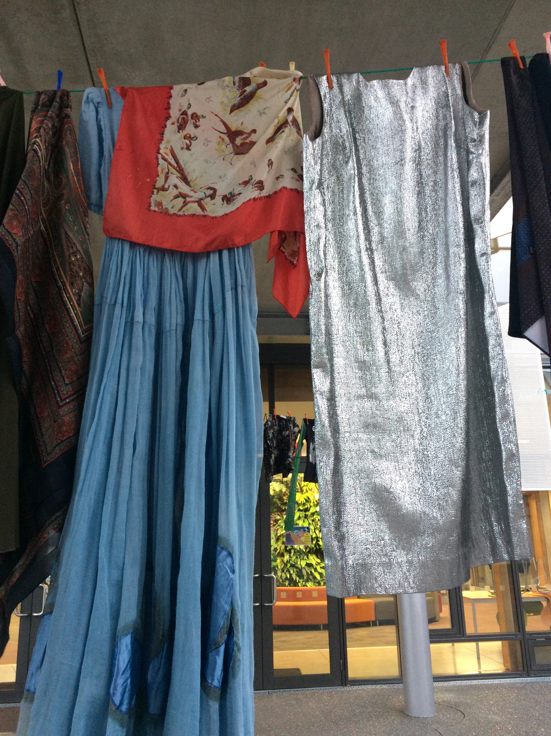
Sustainability Week celebrations – upcycled clothes

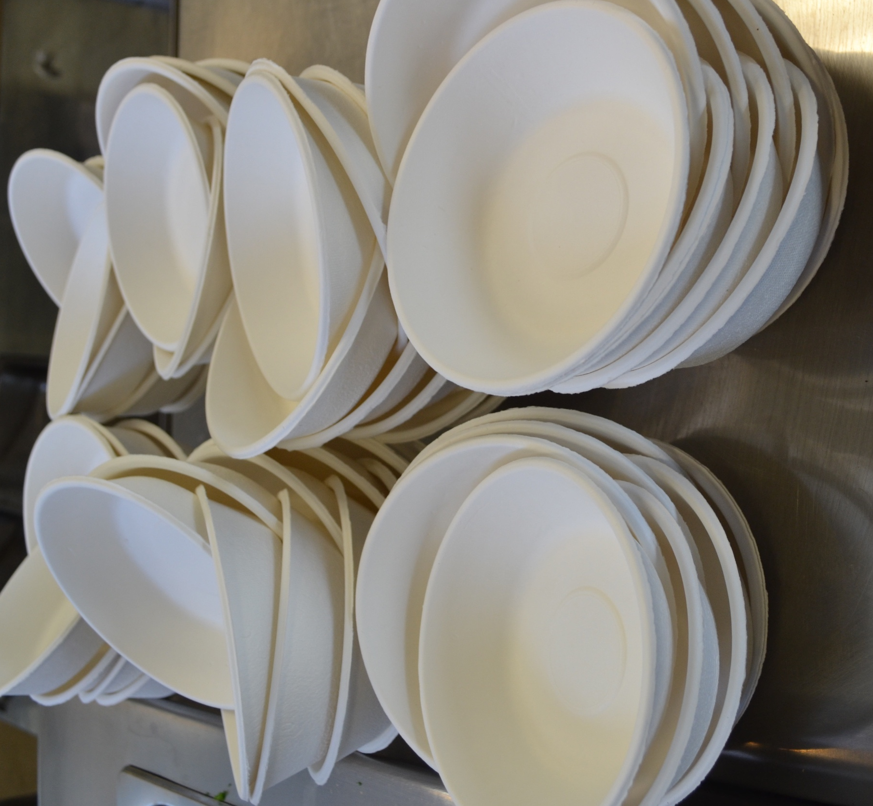
Compostable plates

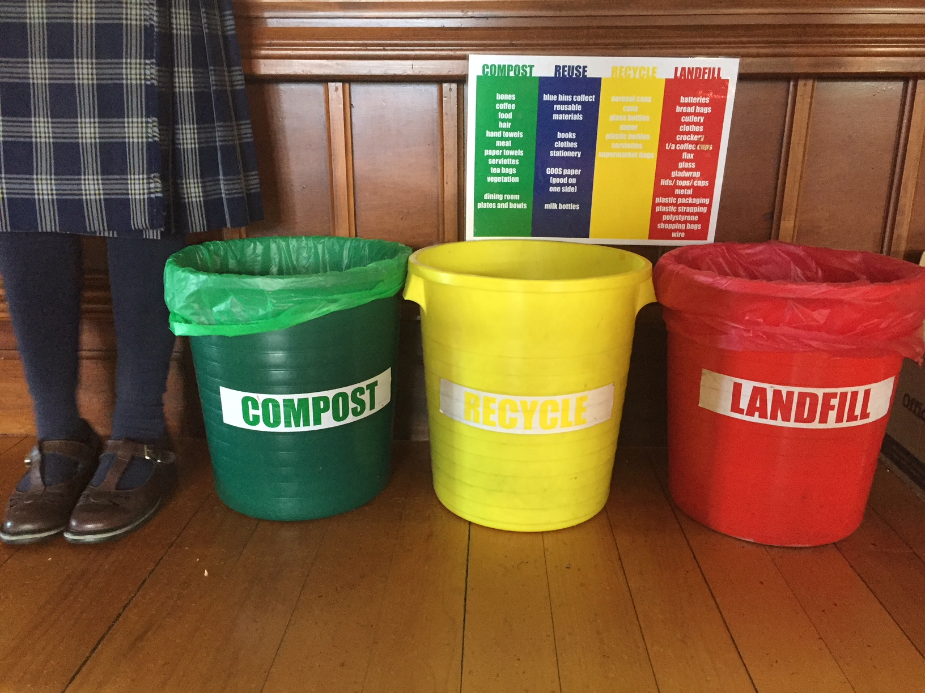
Source separation of waste

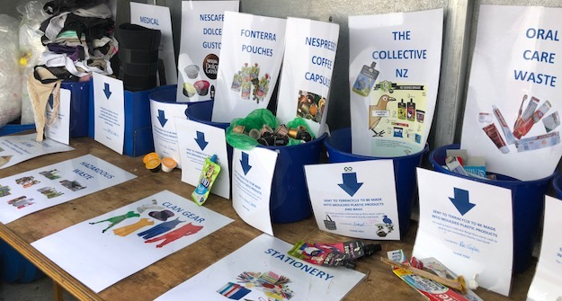
Some of the many items collected through Rangi’s Reuse Depot

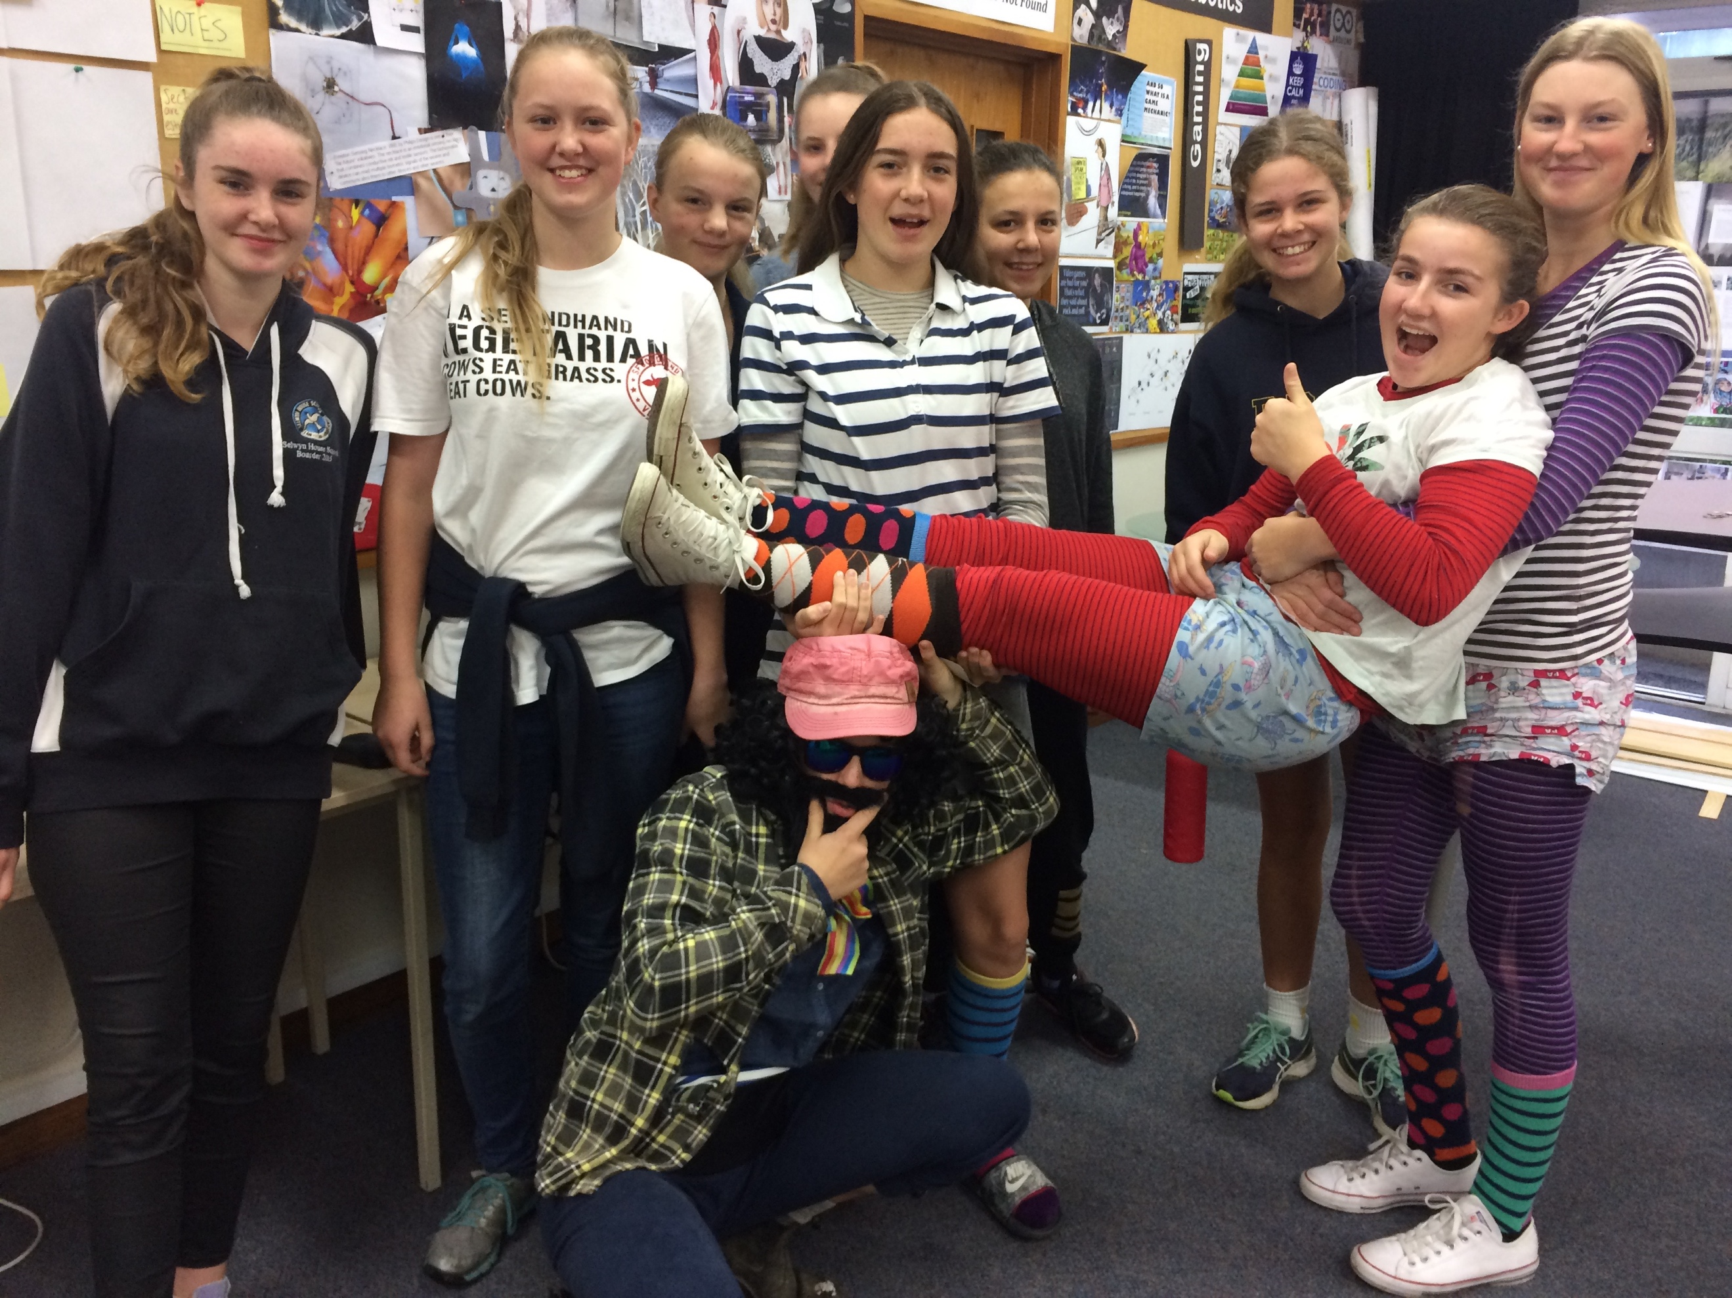
Students wearing preloved clothes on Mufti Day

