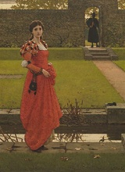
In the Winter Garden
George Leslie

Dead Garden
A young Duchess stands alone in a dead garden, where her father used to look around at his once bright flowers. The place where he tended his violets and planted his daffodils. Picked flowers an arranged the in a little wicker basket to give to the duchess as a little girl, hardly bigger than the Orange tree at the back of the garden.
But this year, the magnolias didn't blossom, the tulips didn't spring from their buds. The roses faded and wilted. The ivy died and lost its lush dark green colour and the flowing turquoise water turned green and brown with slime. The pruners left in the shed to rust.
The reverend waits at the gate, bible in hand, ready to give the dead kings funeral after the duchess finishes mourning. The duchess takes a single maple seed, her dad's favourite tree, and plants it carefully in the middle of the garden, marking it's spot with a single white cross.

Emma Lilly

