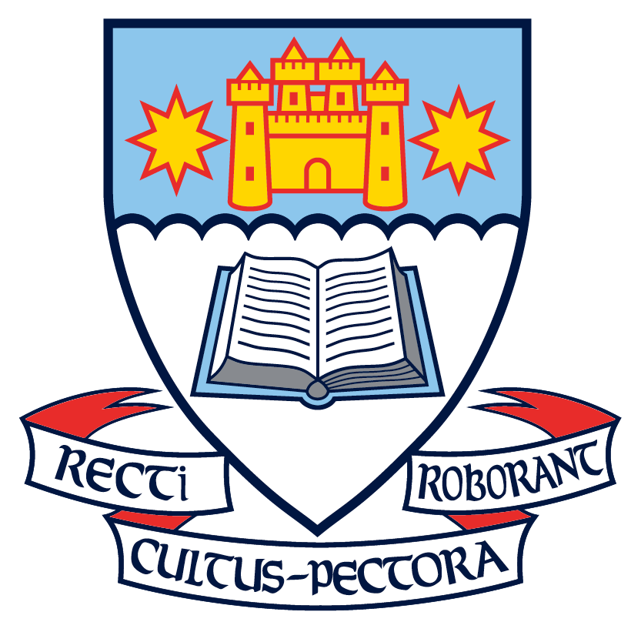
Fundraiser First Aid Kit
Why buy a kit?
♦ Everyone should have more than one updated First Aid Kit handy.
♦ They are a practical item that make a great gift.
♦ These kits may cost you less than replacing the same contents in your old kit.

- Please support the OBHS PTA fundraising efforts by purchasing one of these first aid kits.
- Proceeds from the sale of the first aid kits will go the OBHS Parents Association.
- Please refer to the product information below and/or check out the sample at the school office and fill in your order details on the order form.
As part of the Otago Boys’ High School Parents Association fundraising efforts, we are supplying a large quality first aid kit which you can purchase for only $39.95. These first aid kits are excellent value for money and similar kits often retail for well over $60.
For every kit sold, $12 will go towards our fundraising efforts.
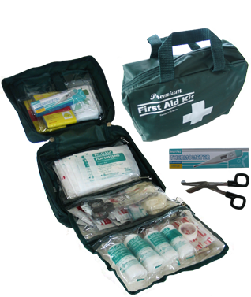
Product Details
The First Aid Kit that we are selling for our fundraiser is a large, carry kit with transparent fold-out compartments that contains 77 items including a digital thermometer. (Measures 240mm x 180mm x 85mm.) Follows OSH and consumer regulations.

Kit Contents
FREE Digital Thermometer, FREE INSTANT ICE PACK, 2 x Emergency Blankets, 1 x CPR Resuscitation mask with valve, 1 x Eye Pad 5.5cm x 7.5cm, 2 x Burns Dressings 20cm x 30cm, 2 x Conforming Bandage Rolls 6cm x 400cm, 2 x Conforming Bandage Rolls 8cm x 400cm, 20 x Band Aid strips 7.5cm x 2cm, 2 x Triangular Bandages 90cm x 90cm x 127cm, Long adhesive strip 6cm x 20cm, Adhesive Multi-pore Tape Roll 13mm x 5m, 3 x Butterfly Adhesive Plasters 7.4cm x 4.5cm, 2 x Knuckle Adhesive Plasters 7.5cm x 3.7cm, 4 x Semi-permeable Dressings 6cm x 7cm, 3 x Adhesive Island Dressings 6cm x 7cm, 2 x Adhesive Island Dressings 6cm x 10cm, Combined/Abdominal absorbent pad 23cm x 12.5cm, Scissors 15cm, Tweezers (metal), 4 pairs large PVC safety gloves, 10 x safety pins, 4 x Soap wipes 20cm x 19cm, 4 x Saline Cleansing Wipes 20cm x 19cm, First Aid Guide

