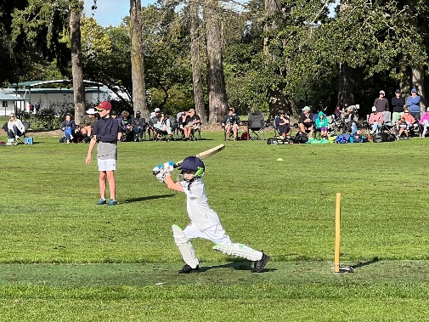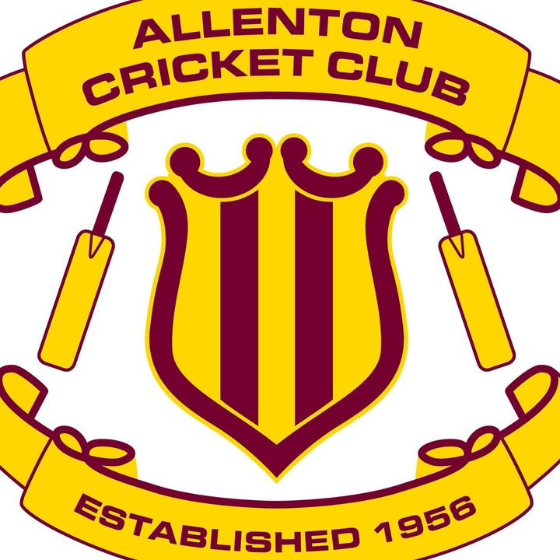

Allenton Cricket 2022/2023
Anyone interested in learning and playing cricket?

Three Junior Programmes:
Smash cricket: (beginners): cricket skills and games Tuesdays in the Ashburton Domain (Terms 4 and Term 1) 12 weeks starting late October
Bash cricket: (entry level play): uses incrediball (soft ball). Fridays in Ashburton Domain starting 18 November
Junior Grades : Saturday mornings beginning 15 October.
Term 4 and Term 1
Check out our Allenton Cricket Club facebook page for the link or register using the link
https://www.playhq.com/

Further enquiries to Caroline Polson or Jane Fowles allentoncricket@gmail.com

