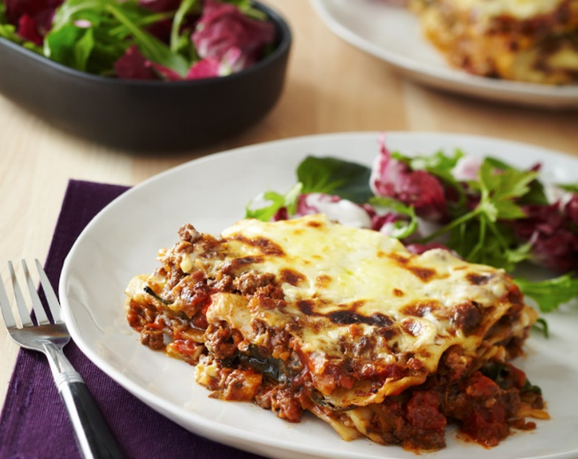Beef Lasagne

**Prep:** 45 minutes

**Cook:** 45 minutes

**Serves:** 2-3

**Ingredients**

|  |  |
| --- | --- |
| **Mince**   * 250g beef mince * ½ onions, finely chopped * 1 clove garlic, crushed * ¼ large carrot, grated * ½ stick celery, finely chopped * 2 mushrooms, grated (optional) * ½ cup tomato puree * ½ cup liquid beef stock * ½ 400g can or 1 cup chopped tomatoes * ½ teaspoon dried oregano * ½ teaspoon dried basil * ½ teaspoon brown sugar * 1 anchovy, very finely chopped (optional) * ½ tablespoon balsamic vinegar * ½ cups spinach, chopped * 100g packet of lasagne sheets | **Cheese Sauce**   * 25g butter * 1 Tablespoon flour * 1 cup milk, warmed * ¼ cup cheddar cheese, grated plus extra for topping * 1 teaspoon Dijon mustard |
| Method Preheat the oven to 180°C conventional bake. Mince  1. In your largest frying pan, heat a little oil over a high heat. When the pan is hot, add the onion and garlic. Cook until the onion is golden. 2. Add the mince, breaking up the big lumps quickly with a wooden spoon. Cook mince until it browns. Add carrot and celery, and cook, stirring for about 10 minutes until soft. 3. Add tomato puree, chopped tomatoes, beef stock, oregano, basil, sugar, anchovy (if using), and balsamic vinegar. Simmer gently for 25-30 minutes or until reduced and thickened slightly (do not over reduce or the lasagne sauce will be to dry). Add the spinach with 5 minutes to go. Season to taste. Set aside  Cheese sauce  1. Warm milk in the microwave for 30-40 seconds 2. Melt butter in a large saucepan over a medium-low heat. Add flour and cook, stirring, for 3-5 minutes (don’t let it brown). Remove from heat and slowly add all the warmed milk in a thin stream, whisking all the time, until smooth. Return to heat and cook, stirring, until thickened. Add the cheese and mustard, stirring until smooth. Season to taste and remove from heat.  To assemble  1. Grease your largest baking dish (or two small). Add a layer of lasagne sheets to the bottom and spread over a third of the meat sauce followed by a third of the cheese sauce. Repeat until ingredients are used up, finishing with a layer of white sauce. Sprinkle with extra cheese. 2. Cook for 20 minutes or until golden and heated through   *Serve with a fresh crunchy salad and tangy vinaigrette. | |