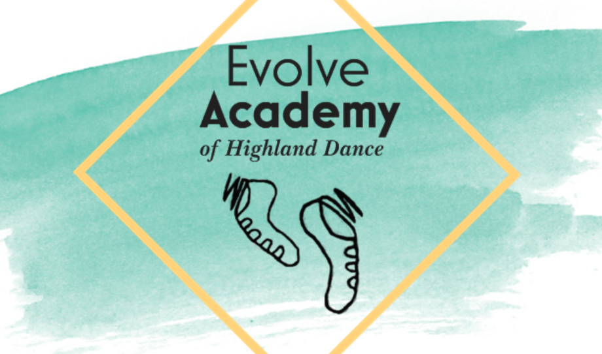

Evolve Academy is looking for students who would love to learn Highland Dancing. It is a fun, challenging sport suitable for children five years and older.

For more information please contact Leah.

**Phone: 021 08323612**

**or**

**Email: leah.cammell@outlook.com**