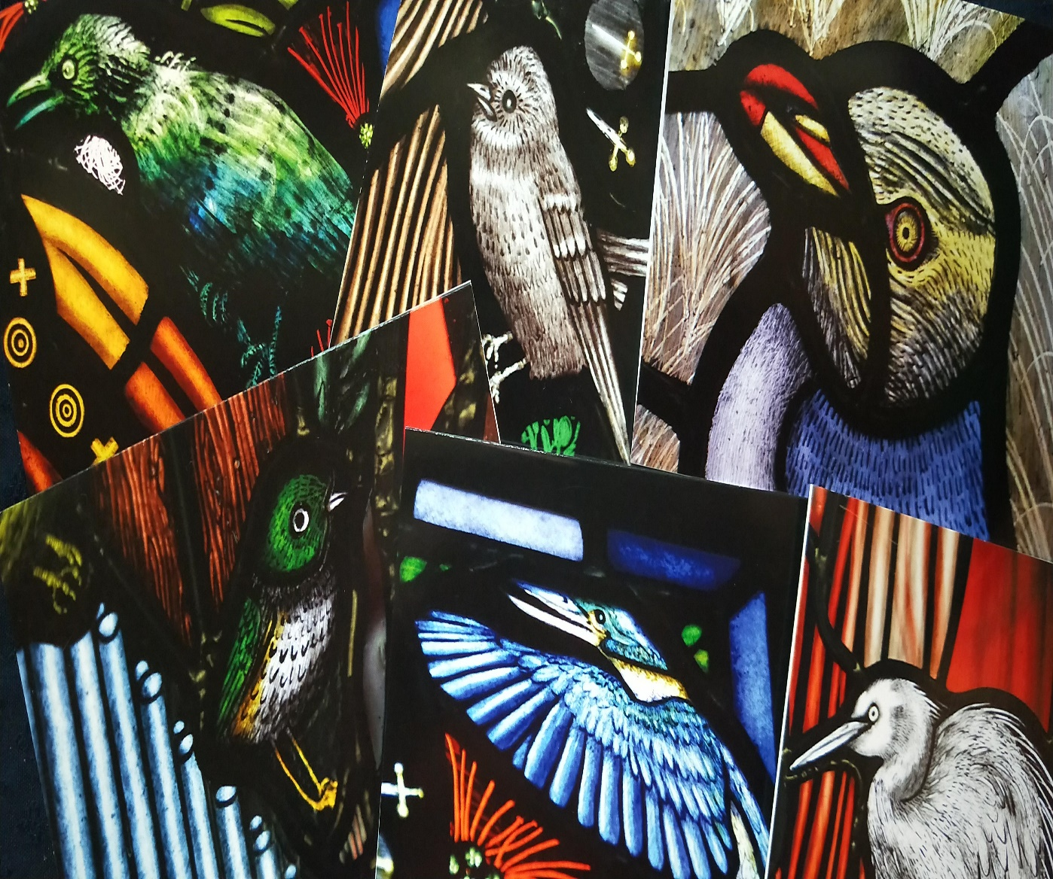

A Window on Dunedin 2019 Calendars
  - Purchase YOUR St Paul’s cathedral centennial calendar FROM THE CATHEDRAL SHOP. Two SIZES AND DESIGNS AVAILABLE ($15/$20). We also have range of other lovely christmas cards and gifts.

