BADMINTON
Racketlon Holiday Programme,
Once again Tawa Tennis, Tawa Squash and Wellington North Badminton are running the Racketlon holiday programme these school holidays.
Players rotate around each sport spending 1.5 hours at each club. Qualified coaches will take each session.
Please note holiday programme is for age 6 years and older.
Thursday 28 and Friday 29 April 2022, 9am - 3pm
Cost per day: $50 or both days for $85
Registrations: https://bit.ly/3ICegs2
For more information contact Babette at babette@wnba.org.nz or call 2324774
Nga mihi

Next newsletter a thank you to NZCT for the grant to turf Te Manawa
how good it looks and how much our tamariki like sitting on a warmer
floor

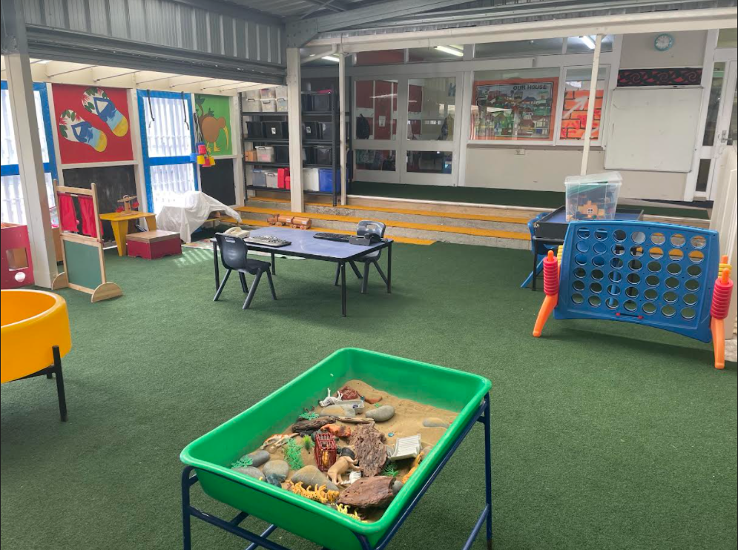

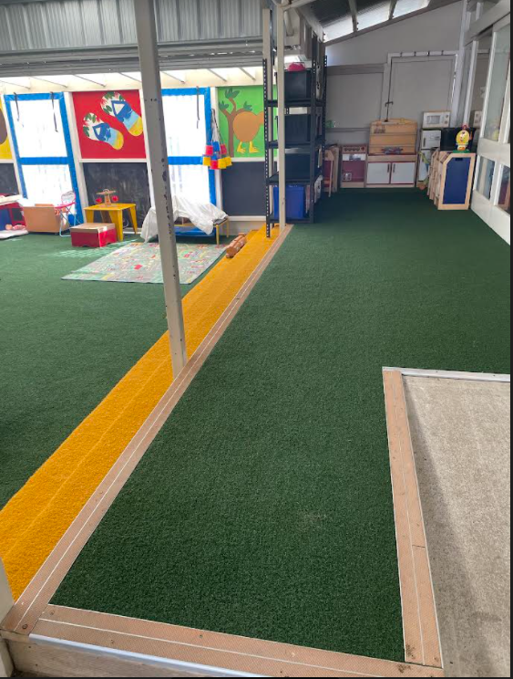

PRINCIPAL SECTION

I have been thinking about Tītahi Bay School and what has changed in my time as a Principal -

All the gardens and brick work
All the murals around school, there were none in 2010
The big senior playground
Rooms 14,15,19 and 20
The kitchen in the hall
The decking outside Rooms 7-13
The bike track and the ……other track
The colourful bins outside
The deck off the hall
The bike container with all our school bikes
The gates and fences all around school
The sand pits
Old ugly classes gone and a far more positive environment for learning

I could go on and on of things I am proud of. It is nice to leave knowing I did my job and made our school have a warm environment for our tamariki.

Then you think a little more. there was no KURA, our vision and values all came about after 2010. This was a beautiful piece of work that our staff did and it has really taken off in school and our community.

It has been a privilege to lead Titahi Bay School and work with a community I love and are part of. It is now time to do other things in my life and for the next 6 months I will work for the Ministry of Education as a Senior Advisor so I will still get to work with Principals and schools, just in a different way.

A highlight for me has always been chatting with ex KURA kids who are so keen to let me know what they are currently doing. I feel very proud when I hear their stories and know that our school was part of their development.

I have hung up my crown I will no longer be Princess Kerry……. Or maybe occasionally for fun.

I want to acknowledge Shelley Cheyne and Sarah Campbell who have been my Chair of the Board, they both worked in a collaborative manner with me and our school and always wanted what was best for our community and KURA kids.

I have worked with a stunning staff who come to school every day to do their best and ensure our KURA kids get the most effective education. I have loved working with them all and there are so many fabulous teachers I have worked with over my time at school.

When I was interviewed for the Principal position - Terry Crawford asked me how would i know in the future if I have been successful leading the school my answer was….When I am an old lady and I walk down a street in Titahi Bay or I am out and about in Porirua I have ex KURA kids come up to me to ask how I am and what they are currently doing in their lives. Terry I have been a success because this happens now.

KELLY SPORTS



KELLY SPORTS APRIL 2022 HOLIDAY PROGRAMME – NGATITOA DOMAIN (Yrs 5-13)
Our hugely popular Kelly Sports Holiday Programme is back for the April Holidays for children 5-13 years. Come and join the Kelly Sports coaches for the best in sports coaching and competitions!
We have created an Action Packed Programme including: Easter Extravaganza, Goal Day, Tag Your It!, All Ball Day, Anzac Day, Twisty Triathlon Day plus trips to The Marine Centre and Ice Skating and lots more!
Click here to view the Activity Planner
To enrol got to https://kellysports.co.nz/kelly_events/view/13942

PAREMATA PLIMMERTON RUGBY



PAREMATA PLIMMERTON Junior Rugby Registrations.
Registrations are still open online
Come & join our awesome community! All Juniors will receive a brand new top for the 2022 season and a PPRFC boot-bag to keep.
Register now, Preseason is starting, Season kicks off May 6th.
Please register online via this link
https://www.sporty.co.nz/viewform/175373

