**Student Council 2015 Umbrella Fundraiser**

The Student Council of 2015 would like to offer you, the community of John McGlashan, an exciting opportunity to purchase an exclusive John McGlashan College umbrella.

During these cold, rainy winter days it is important to be prepared everyday for whatever winter throws at you. A John McGlashan umbrella will be essential for walking to work on those wet Dunedin days or supporting your boys on the side-lines.

The money raised from this fundraising effort will go towards student council goals, funding rounds, leavers gift and charities. Not only will this benefit the students but also the wider community.

The umbrella we will be selling is the G12 model from Lethaby – supplied by Ombrello and Uptown Art – at $25 per umbrella or $45 for two umbrellas.

Additionally, the umbrella comes with a 1-year guarantee so you will have peace of mind when you are out and about in those winter storms.

Yours faithfully,

Guy Guilford

Student Council Chairman

[guy.guilford@mcglashan.school.nz](mailto:guy.guilford@mcglashan.school.nz)

-------------------------------------------------------------------------------------------------------

**Student Council Umbrella Fundraiser Order Form**

Please fill in the form below to purchase an umbrella.

|  |  |  |  |
| --- | --- | --- | --- |
| Name of son | Form class | Contact number | Quantity |
|  |  |  |  |

I, ____________________, agree to purchase ________ John McGlashan College Student Council umbrellas and give permission for $­­­­­________ to be charged to my son’s account.

Signed: ____________________________ Please print & return to the school office

**G12 Umbrella**

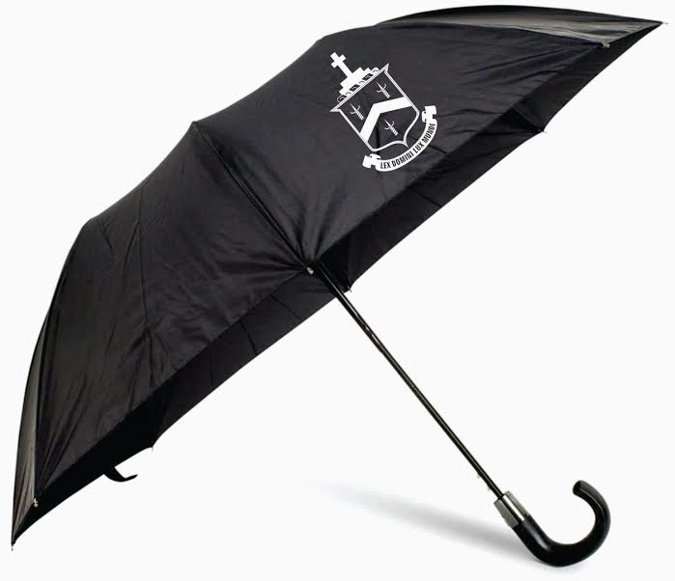Mid range folding umbrella

Top of it’s range due to stronger metal rib construction

* 53.5cm radius
* Auto open & manual close
* 8 metal ribs in 2 sections
* 2 section metal shaft
* Plastic hook handle
* Nylon fabric
* 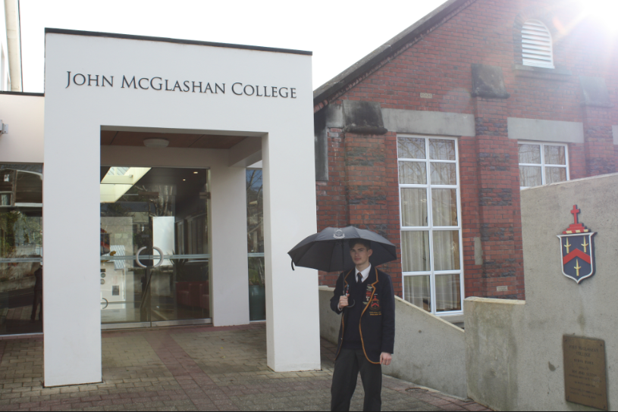43.5cm when closed