Sacred Day Retreat
“Raise your Energy”
Saturday 14th August
Graham Valley, 9 am – 9 pm

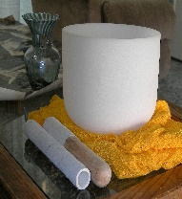
This Photo by Unknown Author is licensed under CC BY
9 am – Welcome
9.30 am – Yoga
11.00 am– Morning tea
11.30 am – Sacred Synergy Elemental honouring healing
12.45 pm – Lunch
2pm – 6pm – Sweat Lodge & reflection time
6 pm – Dinner
7.30 p.m – Sound Healing Meditation
9 ish – Closing circle

$99 for the day including lunch & dinner
$55 for dinner and Sound healing meditation
Limited numbers so booking essential

Contact John Romeo – johnromeo2005@hotmail.com 021 2591355
Emily Whinney – emilywhinney@hotmail.com 021 1066150

