**Year 10 – Online Learning for Weeks 1, Term 2**

**TOPIC INTRODUCTION**

Term 2 our unit of work for Health will be Total health and for Physical Education will be fitness. This means we will look at a range of topic areas that improve, challenge and effect our wellbeing/hauora and our bodies, therefore, our total wellbeing.

**AKO** Week 1 – Wednesday 15th -Tuesday 21st

I will choose 4 tasks from the table below and complete these over 7 days.

I will review these tasks once completed and access my Total Wellbeing.

**HUA** – I can complete 4 activities to assess my Total wellbeing. I can review the affects on my wellbeing and ways I can enhance/improve it for the following week.

**TIPS -**

* Rather than 2-3 hours of lesson work, we expect you to do complete 4 tasks and then the review for Week 1.

**ADDITIONAL EXERCISE OPTIONS**

* Check out some of the exercise routines you could try below, it’s up to you how much you exercise! But we normally have PE twice a week and some of you would have your own sports and interests on top of that.
* Walk, Jog, Run/Walk, Bike ride, City fitness online <https://www.cityfitness.co.nz/>, Yoga online <https://www.youtube.com/playlist?reload=9&list=PLZkDZKOcvYTh4dRDXQ71m7gQUmWkDmLAl>, HIIT class on youtube <https://www.youtube.com/watch?v=q20pLhdoEoY> , Les Mills class <https://watch.lesmillsondemand.com/browse> or search up any fitness workout e.g. <https://www.nerdfitness.com/blog/beginner-body-weight-workout-burn-fat-build-muscle/>.

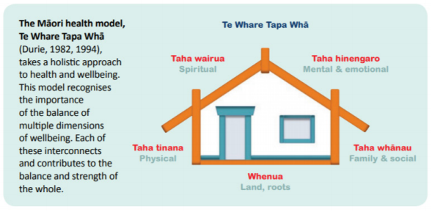I have provided you with options of tasks you can complete to enhance each aspect of your wellbeing/Hauora (physical, social, mental/emotional and spiritual) your ‘Te whare tapa wha’ (Total Well-being/hauora) during this time at home.

You need to complete at least ***FOUR*** for this week – that is ONE from each category of hauora. Please keep track of which ones you have completed.

After completing this week’s 4 tasks you will need to review your Total Wellbeing which involves answering questions and providing any pictures/evidence of you completing the tasks.

|  |  |  |  |  |
| --- | --- | --- | --- | --- |
|  | **Taha Tinana - Physical** | **Taha Whānau - Social** | **Taha Wairua - Spiritual** | **Taha Hinengaro - Mental** |
| Options for Week 1 (Weds 15th – Tues 21st) | Go for a walk/jog around the block  Or  Get a really good nights sleep  Or  Eat a well-balanced healthy meal.  Or  Do some exercises of your own or complete an exercise class such as yoga, stretches etc.  Or  Dance- use your favourite song / Create a tick tok. | Facetime a friend that you haven’t spoken to in the last week.  Or  Do some baking / cooking and share with the family.  Or  Call a family member you haven’t talked to in a while and check in with how they’re doing.  Or  Paint, draw, write, or be creative in a way that suits, about a special person in your life. | Meditation   * [5 min meditation](https://www.youtube.com/watch?v=inpok4MKVLM) * [3 min body scan](https://www.youtube.com/watch?v=ihwcw_ofuME)   Or  Ask about your background /culture your family history / whakapapa.  Or  Set yourself a goal of a new thing you would like to learn this week (eg. Cooking a new meal, DIY skills, learning how to do washing, a new tik tok etc.  Or  List 5 things that make you unique and special and 5 that you value about your life. | Make a list of 5+ things that made your day today amazing.  Or  Do 5 + things that would help out a member of your whanau.  Or  Express your feelings through words, pictures, movement, music, or whatever ways suit your personality.  Or  Create a playlist with your favourite tunes for feeling calm and peaceful, or for feelings of happiness. |

|  |  |  |  |
| --- | --- | --- | --- |
| **Week & Date** | **ACTIVITY** | **ANSWER** | **Notes/Photo Evidence** |
| **Question 1**  Explain how **one** activity you did this week had a positive impact on your well-being  **Question 2**  Explain how **another** activity you did this week had a positive impact on your well-being  **Question 3**  Explain if you feel like you have or haven’t enhanced your Total Wellbeing (all 4 dimensions of your well-being) this week.  **Question 4**  Explain what you are going to do next week to enhance or improve your Total Wellbeing. |  |  |  |