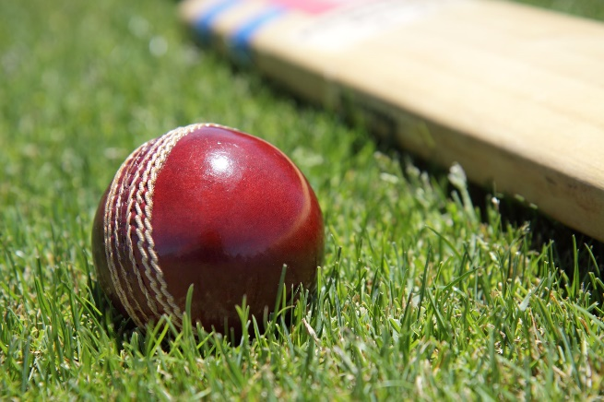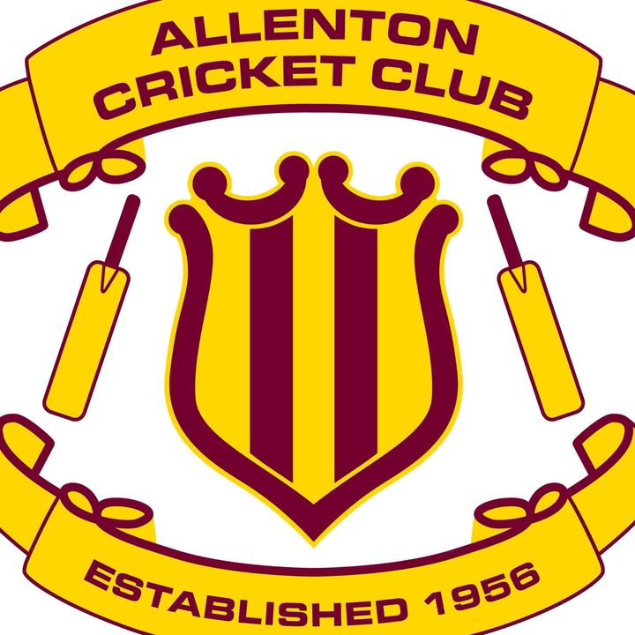

Allenton Cricket 2023/2024
Come and enjoy summer cricket!
Three Junior Programmes:
Smash play cricket: (newcomers years 1-6) cricket skills/games Tuesday afternoons starting late October
Bash cricket: (entry level play) 6 aside games (soft ball). Friday nights starting late October
Junior Grades: (20 overs) Saturday mornings from 14 October
Register before 17th September and be in the draw to win a cricket bat (conditions apply)!
See Allenton Cricket Club facebook page for registration links https://www.facebook.com/allentoncricket
Further enquiries to Jane Fowles or Caroline Polson allentoncricket@gmail.com

