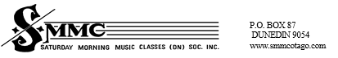

After School Recorder Lessons in Mosgiel for Primary School Children.
Starting Term Two
Suitable for age 6 years and older
On Wednesdays 4pm at Elmgrove School, starting May 5th.
Any enquiries? Email: <barrie@smmcotago.com>

