

Permanent Scale A Teacher

(Year 4, 5 or 6)

Application Pack
August 2016

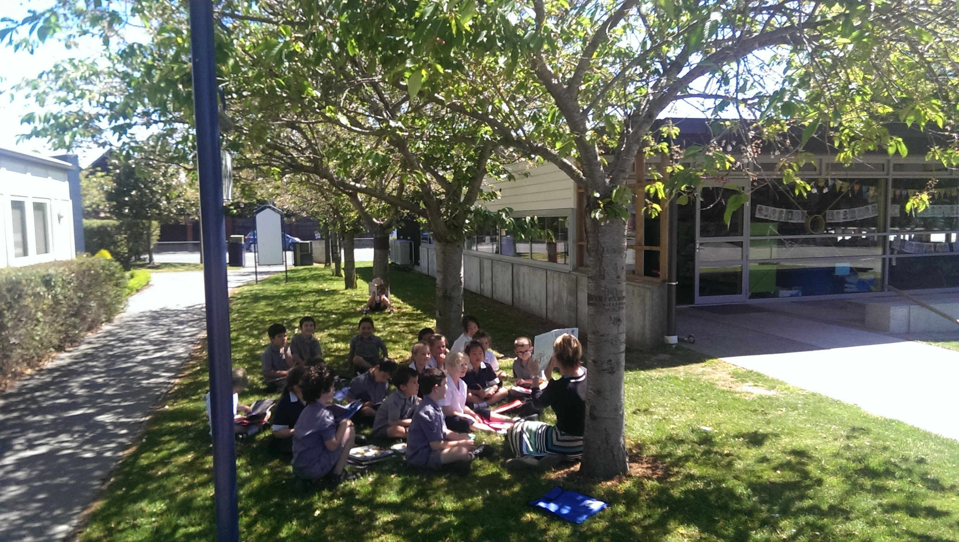
“Inspiring learners for life”

Fendalton Open-air School
168 Clyde Road, Fendalton, Christchurch 8053
03 351 9788
www.fendalton.school.nz/

INDEX

- Job description
- Important notes for applicants
- Appointment process
- Application for employment
- Identification verification, criminal record and right to work
- Key questions
- Equal employment opportunity information statement
- Health and safety declaration
- Authority to approach other referees

JOB DESCRIPTION

Fendalton Open-Air School
Scale A teacher, permanent. We seek an experienced NZ registered teacher to join our senior team (year 4 to 6). We are looking for an innovative, passionate and collaborative teacher with a thorough knowledge of the curriculum. Must be committed to building effective relationships with students, staff and community. A willingness to participate in extracurricular activities would be an advantage. Position to commence term 1, 2017.

Applications close 12.00pm, Friday 16 September. Visit www.fendalton.school.nz for an application pack or email raewyn.saunders@fendalton.school.nz
IMPORTANT NOTES FOR APPLICANTS

Thank you for applying for a position with our school.
- Please fully complete this form personally. First, read it through, then answer all questions. Please submit a paper copy, signed and dated where indicated.
- Include an unbound A4 size curriculum vitae (CV) containing information about your educational qualifications, employment history and the names of three people who could act as referees for you.
- Copies only of qualification certificates should be attached. If successful in your application you will be required to provide the originals as proof of qualifications.
- If you are selected for an interview you may bring whānau/support people at your own expense. Please advise if this is your intention.
- Failure to complete this application and answer all questions truthfully may result in any offer of employment being withdrawn or appointment being terminated, if any information is later found to be false.
- All applicants will be required to give consent to a Police vet.
- (a) Applicants may not be employed as a children’s worker if they have been convicted of a specified offence listed in Schedule 2 of the Vunerable Children Act 2014, unless they obtain an exemption. The Criminal Records (Clean Slate) Act 2004 will not apply to these specified offences and these offences will be included in your Police vetting results.
(b) The Clean Slate Act provides certain convictions do not have to be disclosed providing:
- you have not committed any offence within 7 consecutive years of being sentenced for the offence
- you did not serve a custodial sentence at any time
- the offence was neither a specified offence under the Clean Slate Act 2004 nor a specified offence under the Vunerable Children Act 2014
- you have paid any fines or costs
Please note that you are not obligated to disclose convictions if you meet the above conditions but can do so if you wish. If you are uncertain as to whether you are eligible contact the Ministry of Justice.
- Shortlisted applicants being interviewed will need to provide originals of both a primary identity document (e.g. passport) and a secondary indentity document (e.g. New Zealand driver’s licence). A list of acceptable primary and secondary documents is available in the last sections of the Vunerable Children Regulations 2015.
- This application form and supporting documents will be held by the board. You may access these in accordance with the provisions of the Privacy Act 1993. If you have any queries, please contact the person cited in the advertisement.

APPOINTMENT PROCESS

Please include in your application:
- A covering letter
- Your curriculum vitae (CV) containing information about your educational qualifications, employment history and the names of three people who could act as referees for you. Unbound, A4 size.
- Application for employment
- Identification verification, criminal record and right to work
- Key questions
- Equal employment opportunity information statement
- Health and safety declaration
- Authority to approach other referees

Please submit your application to:
Raewyn Saunders
Principal
Fendalton Open-Air School
168 Clyde Road
Fendalton
Christchurch 8053
raewyn.saunders@fendalton.school.nz

Dates
22 August 2016 Job description posted on school website and submitted to Education Gazette.
16 September 2016, 12.00pm Applications close.
17-19 September 2016 Shortlisting. Unsuccessful candidates advised of outcome by email.
21-22 September 2016 Interviews.
26 September April 2016 Shortlisted candidates advised of outcome.
28 January 2017 Duties commence.

For further information contact:
Raewyn Saunders
Principal
03 351 9788
raewyn.saunders@fendalton.school.nz

APPLICATION FOR EMPLOYMENT
Position applied for: Location: Vacancy/Reference Number:
Permanent Scale A Teacher Fendalton Open-air School

Mr / Mrs / Ms / Miss / Other preferred title:

Surname/Family name:

First names (in full):

Birth name (if applicable):

Are you know by any other name(s)? (if yes please provide below) Yes / No

Full postal address

Email address

Contact telephone numbers

Personal: Business:

IDENTITY VERIFICATION, CRIMINAL RECORD AND RIGHT TO WORK
Immigration Information

Are you a New Zealand citizen? Yes / No

If not, do you have resident status, or Yes / No

A current work permit Yes / No

Have you ever had a criminal conviction? Yes / No

If “Yes” please detail:

(A board may not employ or engage a children’s worker who has been convicted of an offence specified in Schedule 2 of the Vunerable Children Act 2014. The Clean Slate Act does not apply to schedule 2 offences.)
Have you ever received a police diversion for an offence? Yes / No

If “Yes” please detail:

Have you ever been charged without conviction for an offence? Yes / No

If “Yes” please detail:

Do you have a currently New Zealand driver’s license? Yes / No

Have you ever been convicted of a driving offence which resulted
In temporary or permanent loss of licence, or imprisonment? Yes / No

If “Yes” please detail:

Are you awaiting sentencing or do you have charges pending? Yes / No

If “Yes” please state the nature of the conviction/cases pending:

In addition to other information provided are there any other factors
that we should know to assess your suitability for appointment and
your ability to do the job? Yes / No

If “Yes” please detail:

Have you ever been the subject of any concerns involving child
safety? Yes / No

If “Yes” please detail:

Have you had any injury or medical condition caused by gradual process,
disease or infection, such as occupational overuse syndrome which the
tasks of this position may aggravate or contribute to? Yes / No

If “Yes” please detail:

For teaching/principal positions:

Do you hold a current practising certificate from the Educational Council
of Aotearoa New Zealand? Yes / No

Please enter your registration number:

KEY QUESTIONS
What are your strengths as a senior school (Year 4-6) teacher?

How do you foster positive relationships with students and parents to ensure inclusive practice?

What personal qualities or attributes will you bring to Fendalton School?

What are your curriculum and extra-curricula strengths?

What ICT skills will you bring?

EQUAL EMPLOYMENT OPPORTUNITY INFORMATION STATEMENT
CONFIDENTIAL

Fendalton Open-Air School (“FOS”) is an Equal Employment Opportunity Employer.
The information set out in this questionnaire is for FOS’s equal opportunity statistics only. Completing it will assist FOS to meet its equal opportunity goals. THE QUESTIONNAIRE AND INFORMATION PROVIDED WILL NOT BE FORWARDED TO THE SELECTION PANEL WITH YOUR APPLICATION and will remain confidential. If you choose not to provide the requested information, please complete Section One and return to The Chairperson, FOS Board of Trustees, 168 Clyde Road, Christchurch 8053, New Zealand.

Section One
Name: Position Title:
I do not wish to complete any further questions on this form:

Section Two
a) Gender: Male Female

b) Date of Birth:

c) Ethnic Identity:
Which Ethnic group(s) do you belong to:

New Zealand Maori If you wish to identify your iwi please do so:
Pakeha / Caucasian
Pacific Islander If you wish to specify please do so:
Asian If you wish to specify please do so:
Other ethnic group If you wish to specify please do so:

d) Please indicate your Nationality.
New Zealander
Other If you wish to specify please do so:

e) Do you live with the effects of injury, long-standing illness, medical condition or disability?
Yes No If you wish to specify please do so:
HEALTH AND SAFETY DECLARATION

The following information is required to assist Fendalton Open-Air School to meet its obligations under the Health and Safety in Employment Act 1992 and subsequent amendments and the Injury Prevention Rehabilitation and Compensation Act 2001, and to assess your ability to perform the duties of the position safely.

It is important that you let us know of any health issues or disability that you have that is relevant to the role you are applying for, if you require special services or facilities, and it is reasonable for Fendalton Open-Air School to supply these, then we will work to accommodate you. Letting us know that you have a medical condition or disability will not exclude you from being considered for the position.

Do you suffer from or have you suffered from any injury or medical condition
caused by gradual process, disease or infection (e.g., gradual process injury, back injury or strain, hearing loss, sensitivity to chemicals), which the tasks of this job as listed in the job description may aggravate or contribute to?

Yes / No

If “Yes” please provide details:

Have you any other injury or medical condition which may affect your ability
to effectively and safely carry out the functions and responsibilities of this
position?

Yes / No

If yes, please provide details. Also detail any technical aids, equipment or adaptations to the workplace that would increase your ability to perform the requirements of the role.

Signature: Date:

Note: In some situations, further specific medical information relating to the requirements of the position may be needed. In such cases the applicant may be required to undertake a pre-employment medical examination (arranged and paid for by Fendalton Open-Air School).
AUTHORITY TO APPROACH OTHER REFEREES

I authorise the Board, or nominated representative, to approach persons
other than the referees whose names I have supplied, to gather information
related to my suitabilityfor appointment to the position. Yes / No

I authorise the Board, or nominated representative, permission to
Access any information held by the Education Council of Aotearoa New
Zealand (EDUCANZ) or any other educational organisation, including
Information regarding matters under investigation, to gather information
related to my suitability for appointment to the position. Yes / No

I certify that:
- The information I have supplied in this application is true and correct.
- I confirm in terms of the Privacy Act 1993 that I have authorised access to referees.
- I know of no reason why I would not be suitable to work with children/young people.
- I understand that if I have supplied incorrect or misleading information, or have omitted any important information, I may be disqualified from appointment, or if appointed, I maybe liable to be dismissed.

Signature: Date:

Note: If completing this electronically a hard copy (signed) must be provided.

Custodial sentence means a sentence of imprisonment and includes corrective training, preventative detention, a sentence of imprisonment served by home detention, borstal training, detention centre training and any other sentence that requires the full-time detention of an individual. Non-custodial sentence includes, but is not limited to, a community-based sentence, a sentence of home detention, a sentence of a fine or reparation, a suspended sentence of imprisonment, and a specified order.

