Firstly, I was really impressed with the boys the whole week. From the moment they arrived at the airport all ahead of time, right down to polished school shoes, to the Friday clean up and trip home, they were magnificent.

A week in Palmerston North can best be described as a week standing in front of a hairdryer on a cold setting, with a fireman and his hose on full bore while your mate flicks the lights on and off. A week in Woodville, beyond description!

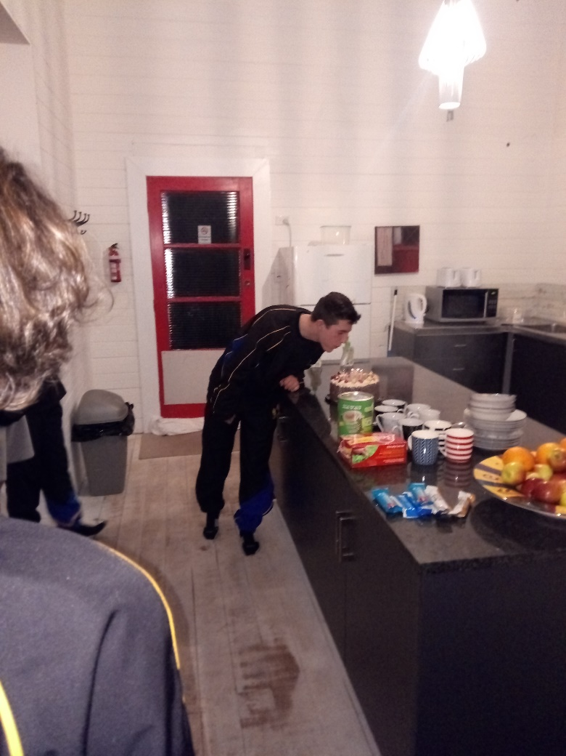
Sunday saw us arrive at Palmerston North where we introduced the boys to a shopping list and Pak n Sav. They were pretty good to be honest, although the group that had 20 disposable cups on their list miscalculated slightly with 80 in the trolley! We then made our way to Woodville to be greeted by our AirBNB host who explained that the washing line had been stolen! Welcome to Woodville. The accommodation was interesting, rustic, rural and other euphemistic adjectives. However, once we settled in, I thought the concept of the large house and space was a great bonding experience for the team, and I believe contributed to how well the week went. We had a quick training session down at the Woodville domain, including a low key greeting by some locals cruising in a Holden with red patches. That night we ate at the Cosmopolitan Club where Burnside were still griping about not qualifying for Napier, then returned to Woodville to celebrate Josh Solly’s 18th birthday with a gateau cake, candles and the movie Mike Bassett England Manager, a classic football documentary and a good way to start their football education for the week..

The Monday saw us convincingly destroy Wanganui Collegiate 8-1 on beautiful grounds at Massey University. A great performance included a hat trick to Ben Crowley, a possible booking for Omar Cameron despite not being in the vicinity of the crime, and the tournament’s worst tackle by Chris Boomer! However, the afternoon was one of frustration against Paraparaumu. Despite being the better footballing team, having a penalty magnificently saved by their keeper and generally dominating the game, we succumbed to a disappointing 0-1 loss. To cap the day off, Sam called in to Palmerston North Boys’ hostel to collect our dinner, only they had forgotten! However, in a can do attitude they whipped up a dinner with the boys none the wiser, which feed us all with plenty left over. During the Monday, Sam and I had attempted to solve our laundry dilemmas but hiring a drier in Palmerston North during winter is simply not achievable. Undeterred, Sam scoured Woodville’s commercial district and hotels for a drier, but returned three minutes later unsuccessful. Armed with a smile and a newfound determination spurred on by the weather forecast, we sent Sam out again. Thirty minutes later he returned…carrying a drier. Our new friend and neighbour, Brendon from Woodville, had done his washing for the week and lent us his fifty year old drier for the remainder of our stay. Laundry problem solved at the cost of a carton of DB! Only in Woodville! Monday evening’s entertainment was a football quiz in which the boys displayed their absolute lack of knowledge of New Zealand’s football history mistaking Wynton Rufer for the eyebrows of New Zealand legend Steve Sumner. The eventual winners were Omar Cameron and Tom Noonan, convincingly ahead of the pack.

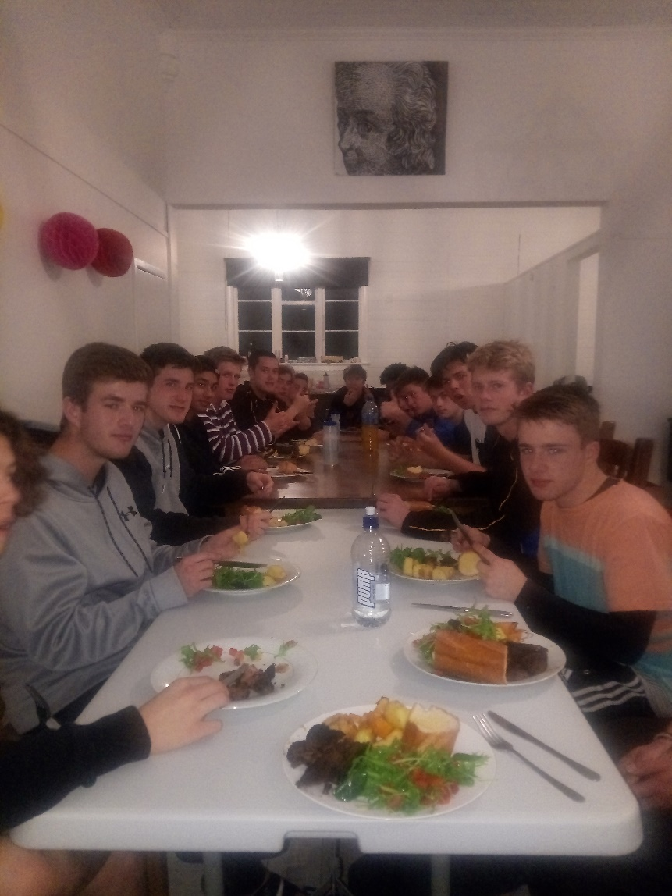
Tuesday morning saw a very early start with an 8:30am kick off against Hutt Valley. I thought this was our best performance of the week. Hutt Valley were actually quite good up front, but in trying conditions we scored into the wind and then defended like Davy Crockett to win convincingly 3-0. However, once again the afternoon game saw us lose 0-1 to Rosehill from Auckland. We had chances, and so did they. We even swapped pitches during the match due to a serious injury to one of their players. At that point I thought we were on top as their players were dropping like flies. However, a prolonged stoppage at a critical point saw them regroup and snatch a late winner. Such is the emotional trauma of tournament week. However, Sam and I whipped up a stunning meal of spiced BBQ leg of lamb with roast pumpkin and potatoes with a green salad and garlic bread. This was followed by carrot cake, a round table confiscation of phones during dinner, ‘best part of the day’ from everyone and Muhammad Mann smiling twice and revealing that he actually has braces! During this time the boys were device free for at least 58 minutes and the humour and conversation was priceless. Tuesday evening’s entertainment was the Table Tennis World Champs won by Josh Solly and Seb Sutherland Todd.

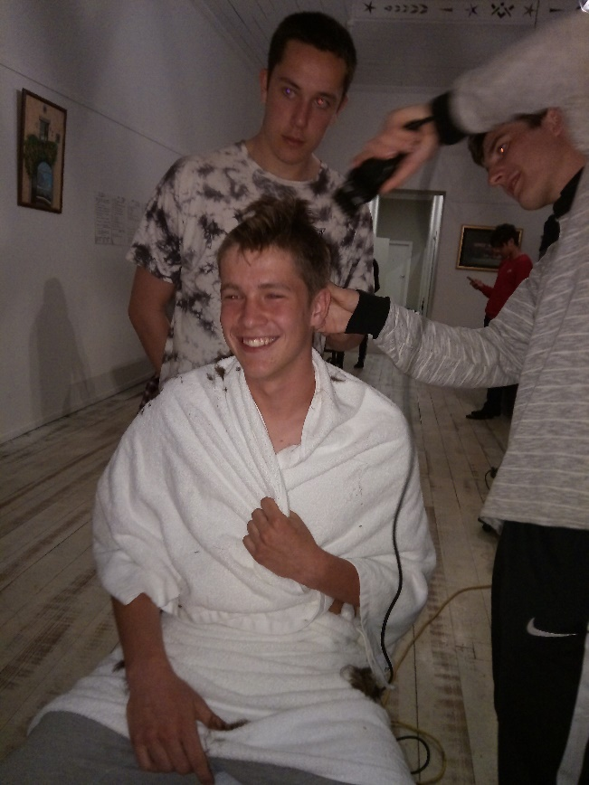
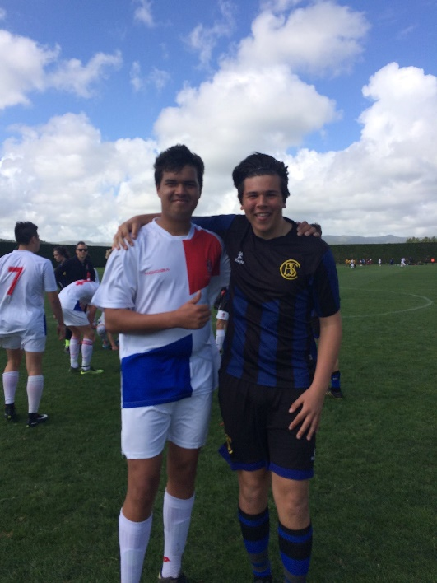
Wednesday saw a must win game against Lindisfarne to give ourselves a chance of making the top eight and quarter finals. Several things happened. The wind blew. Then it blew harder. And then a bit more before settling down to a gale force zephyr. Tom Noonan found his long lost twin playing in midfield for Lindisfarne. Tom also found the back of the net to score a well taken goal to give us a 1-0 victory. Lindisfarne were okay…but we were just better, just! A quiet afternoon saw many of the boys sleep most of the afternoon and recover while awaiting the Hutt Valley result to see if we had done enough to progress to the quarter finals. Unfortunately, with them playing immediately after us they knew exactly what they had to do and scored 4 goals. This meant we ended up level on points and goal difference, and despite mercilessly crushing them, lost out to goals for in the next countback criteria. Sam and I managed a quick romantic sojourn to the Windfarm Café in the heart of Woodville along with a visit to the local antiques shop to buy the trophies for the team awards, meet a Viking of all things (only in Woodville, and maybe Dannevirke) and buy some pool balls as emergency foam rollers. Wednesday evening saw our traditional visit to what I thought was the RSA. This has been a tournament week tradition for us over the years given the school’s association with the armed services. However, it turned out the RSA only use the Distinction Hotel for functions. Nevertheless, the boys in uniform certainly looked the part at dinner, which ironically we shared with Hutt Valley, clad in tracksuits, hoodies and caps. At least we had now beaten them twice. Several parents joined us and I would like to thank all those parents that supported us during the week. Wednesday night was haircut night. Rules were put in place. Parental consents were sought. Boys tried to negotiate. Most boys need to work on their negotiation skills as Sam mercilessly crushed their hairdressing ambitions.

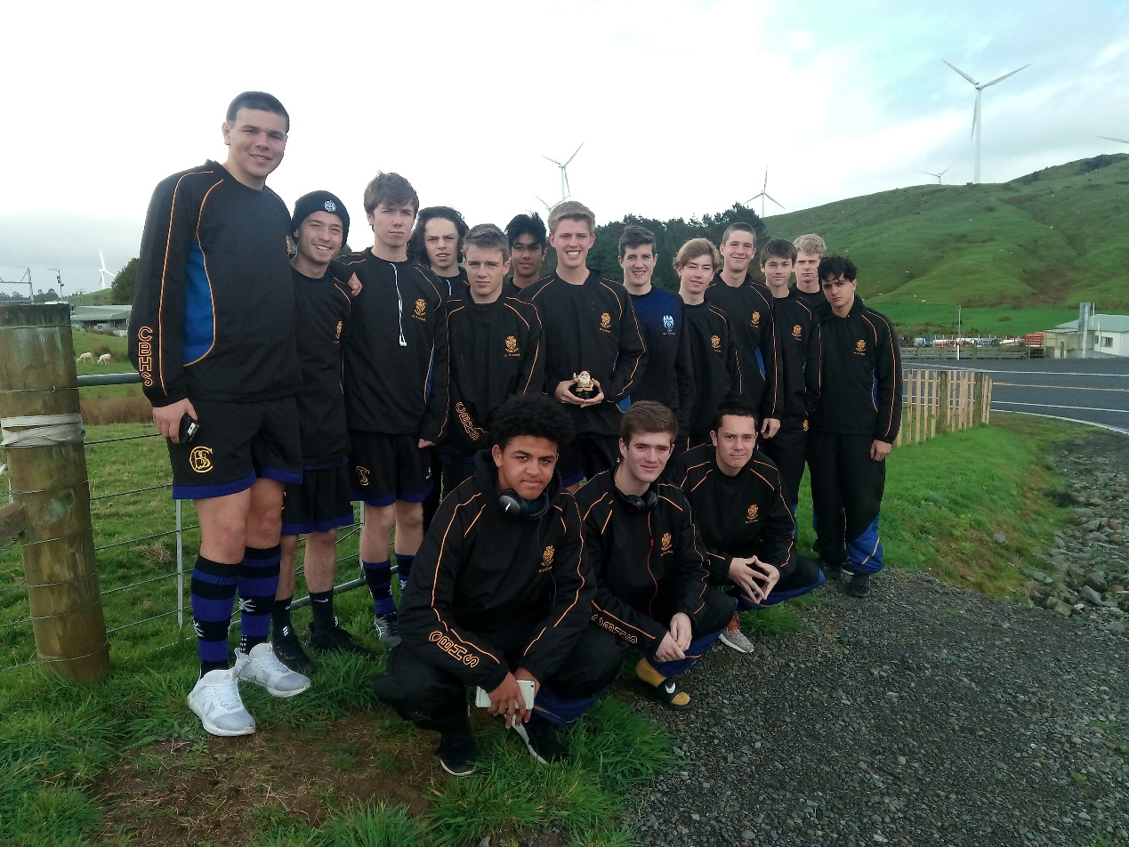
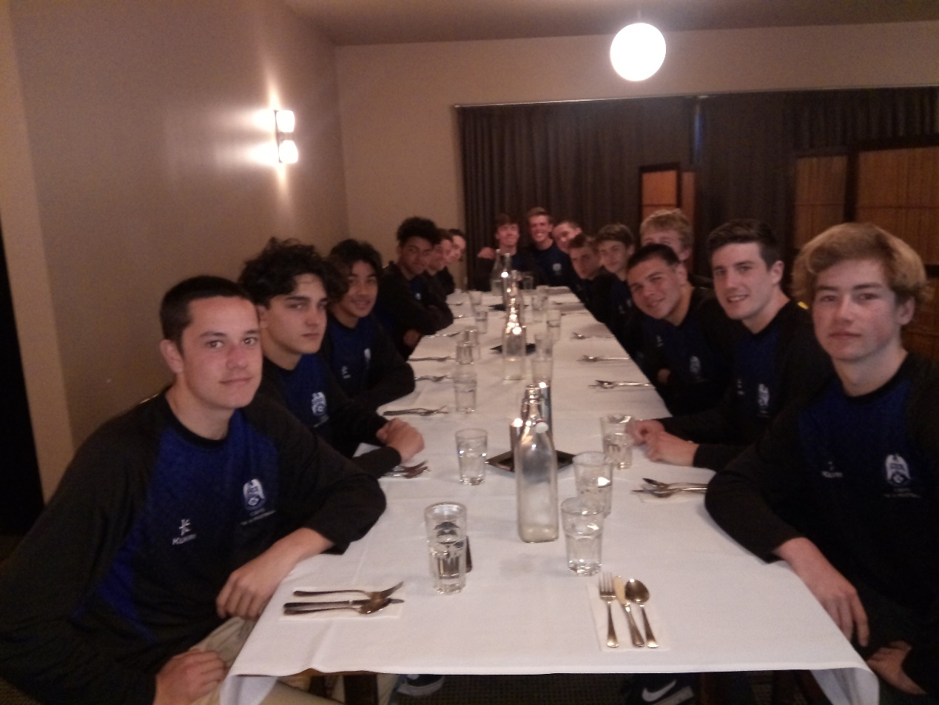
Thursday began early. About 12:31am when the lightening, thunder, monsoonal rain and howling wind started. Sam and I curled up closer to the fire and waited for the roof to lift of the Lodge! Fortunately, by breakfast the rain was heavier and wind stronger. On our trip over to Palmerston North, we stopped atop the Tararuas for the obligatory team photo only for a windfarm worker to move us on due to lightning strikes peppering the area. We arrived at the ground to see soft North Island kids running from the fields as some light hail and wind swept the grounds. Okay…to be fair it did feel like the four horsemen of the apocalypse were trampling their way across Celaeno Park! Warm up completed in the vans, we exited and played Wanganui High School. Despite conceding an early goal and pools of water covering large parts of the pitch, we ended up dominating the game and winning 5-1. Chris Boomer might have scored a hat trick but I was looking the other way. The thing that most impressed me today was the way the boys approached the game given the appalling conditions and disappointment of missing out on the quarter finals. They revved themselves up, were determined to finish the week well and got out there under horrible conditions and showed more determination than the other team. Nice! Special mention to Shar Sutherland Todd for a very well timed coffee delivery and to Alan Ball and his team supply of polyprop gloves in classic white. The plan had been to stay at the ground between games but we decided to return to Woodville for a quick thaw out, shower and lunch. Needless to say, games were abandoned for the afternoon. We weren’t that disappointed to be fair. Another afternoon in Woodville, a visit to the Nibbly Pig café, laundry duties and a wee nana nap saw the afternoon race by. Brendon’s drier was dutifully returned with DBs and we closed the laundry for the week. That evening we dined at The Black Stump in Paihiatua. Surprisingly, we managed to secure a last minute booking for 18 and enjoyed a very nice meal. Back home at The Lodge saw our traditional awards evening in which we got to roast the boys and recount moments of hilarity from the week. This was followed by some packing and light cleaning duties, then Sing Star. It would be fair to say that apart from Harri Rowe, the team’s capacity for harmonious melody is sadly lacking. I had returned Brendon’s drier to him that afternoon during which he commented how quiet the boys had been. I didn’t have the heart to tell him Sing Star was coming! The neighbourhood cats were surprisingly quiet that evening.

Friday morning saw the boys straight into domestic duties. Enthusiasm is not the word I would choose to use….perhaps a functional resignation would be better. But to be fair, they did a great job and I think we left The Lodge cleaner than when we arrived. Back to Massey to check the wind hadn’t abated…and fortunately it hadn’t…and a final match against Trident High School. A very early goal to Jasper Mintrom saw us take the lead only to concede just before half time. However, a penalty converted by Chris Boomer saw us take the lead into half time. Not satisfied with how many grey hairs Sam and I had accumulated during the week, the boys decided to hold on to a 2-1 lead all the way to the conclusion and another gutsy, gusty win. We finally succumbed to the wind at halftime of the final with Burnside 2-0 up over Hutt, wondering for ourselves what could have been. And then home. The wind, in one last vengeful act, buffeted us all the way to Wellington with one of those famous sideways landings to complete the week.

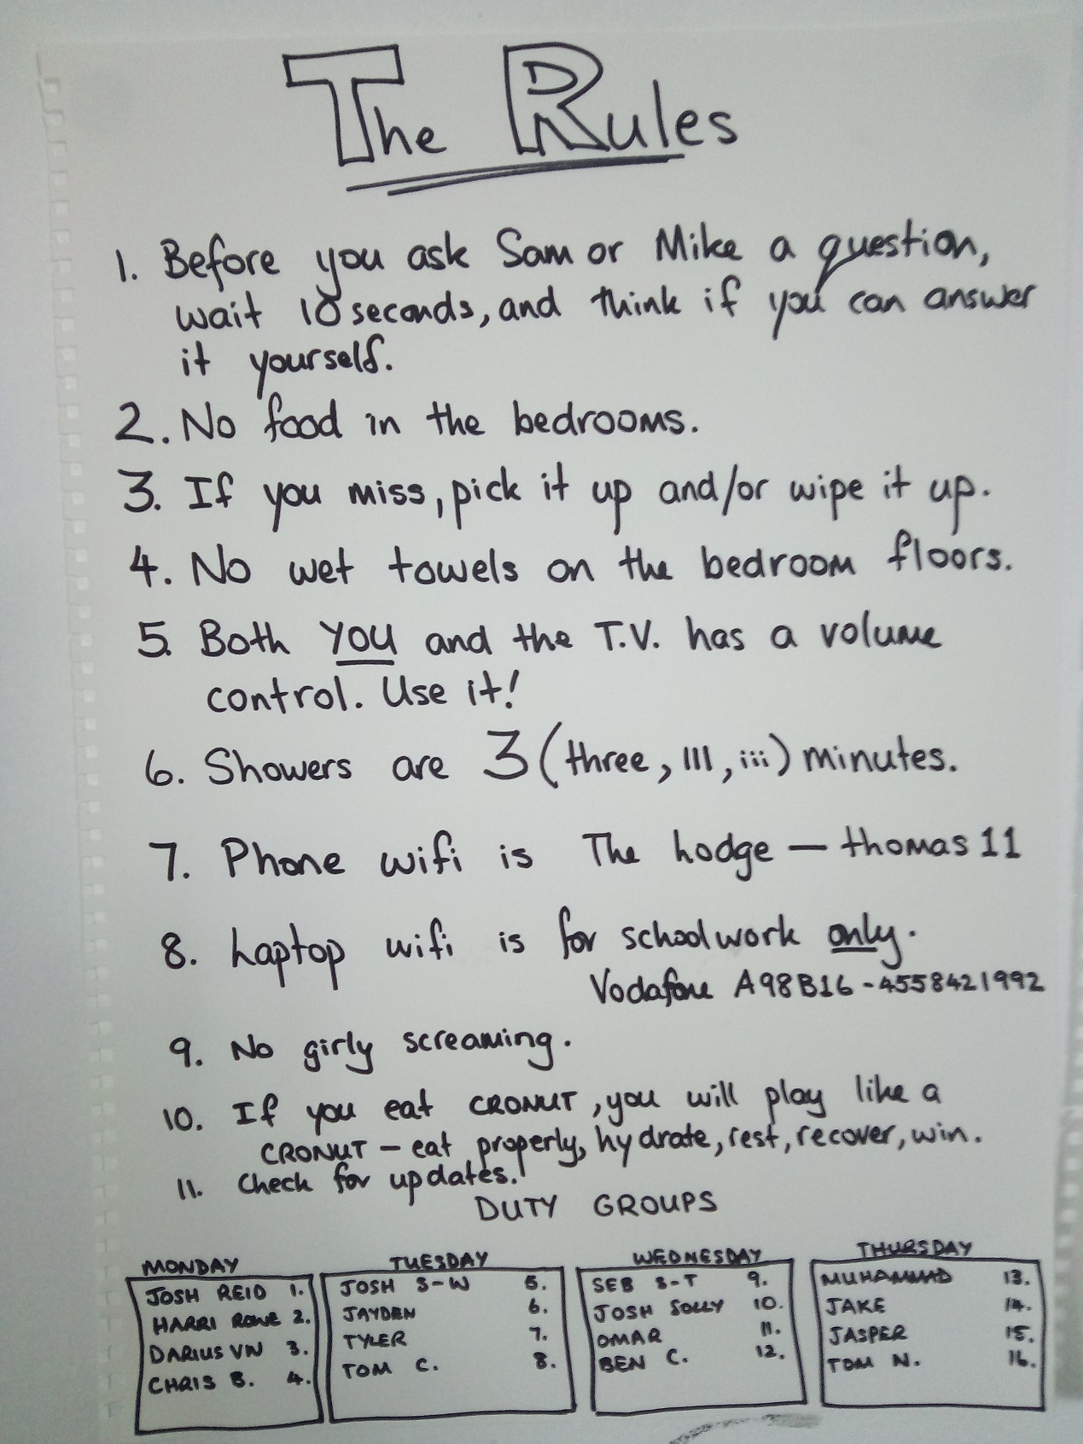
Sam and I really enjoyed the good humour of the boys throughout the week. To a man they were courteous and helpful and funny, and as their individual personalities emerged it reminded us of the joy of teaching young men. I think they all got on really well, and hope they enjoyed the experience which is largely more important than the football. I think the big house worked well in terms of camaraderie (although winning always helps) and the boys got a real sense of the other New Zealand that exists beyond the cities. In terms of the football, the boys followed our plans, played with passion and commitment and were a tad unlucky not to finish higher. The thing I enjoyed most was not having to give them a rev up in any of our half time talks (usually it takes one per tournament) or at The Lodge. Each morning and afternoon they dragged their tired bodies out and gave it their best. Sam and I really couldn’t have asked for more.

