
Parent-teacher interviews will be held at the following times:
- 3:00pm - 6:00pm Monday 1st January
- 3:00pm - 6:00pm Monday 1st January
To book your interviews, go to www.schoolinterviews.co.nz/code in your browser, and enter the event code ?????. Then follow these three simple steps:
 | First enter your name, your student's name, and your email address.  If you need to book for more than one student, change the “Book for x students” setting, and enter the other student's name.
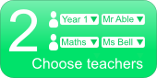 | On the next page, pick the teachers you want to meet.  First select the subject, then choose from the list of teachers.
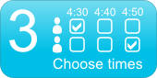 | Then you'll see a timetable showing when your chosen teachers are available. Simply click on the times that suit you.
When you have finished, your interview timetable will be emailed to you. And you can return to the site and enter the event code ????? again to change or cancel your interviews.
If you don't have internet access, please call ????? at the school office (phone ?????). She will be able to make a booking for you.

