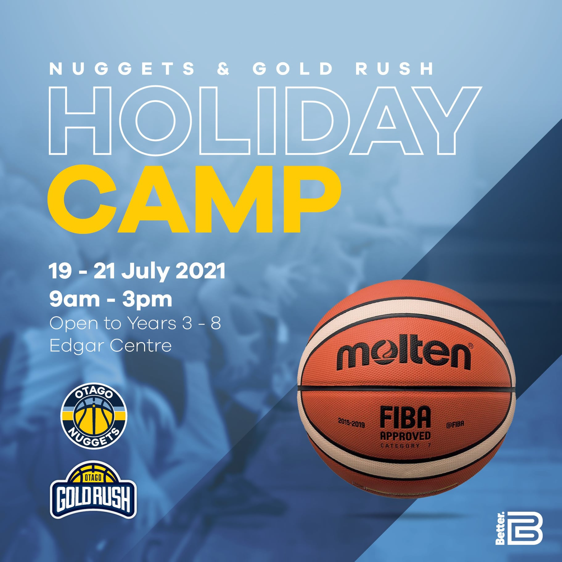

Ages 8 to 13. No experience necessary.
Go Media Otago Nuggets Coach Brent Mateheare will be running the camp.
So come and see if you like basketball or continue to hone your skills if you’re already into the game with our Go Media Nuggets, Firebrand GoldRush Players!!

Cost: $250 for all 3 days of $85 per single day.
Limited entries: If you wish to be included, please register as soon as possible!!
Register here: https://membership.sportstg.com/regoform.cgi?formID=98629

