Dunedin Tertiary Open Days App

- In order to use the App, you must register for it using the below link or QR code:
https://events.otago.ac.nz/2022-tertiary-open-day/opendays 

You will be sent a confirmation email containing the download link and login information. This can take up to five minutes to arrive – check your junk/spam folder if you haven’t received the email in this time.
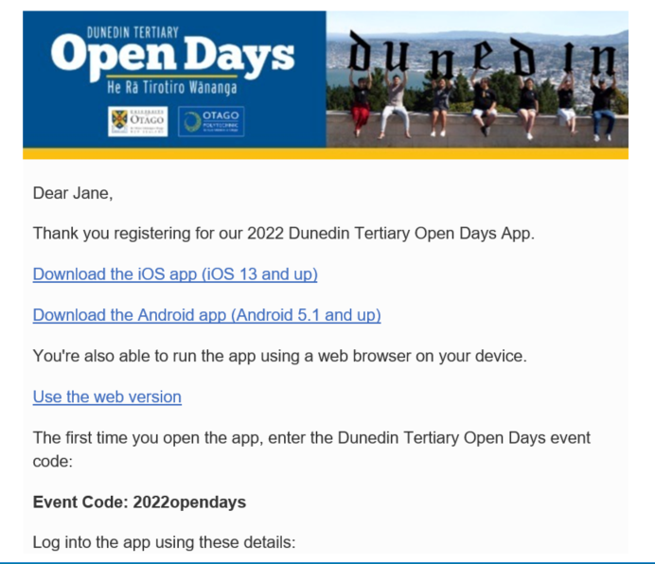
- Download the app using the link in the email.
  - The app has been developed for iOS devices 13 and up, and Android 5.1 and up – older devices are able to download the app but the content will not load (an error message will appear).
  - Older devices can run the web version of the app (the other link provided in the email) – this has the same functionality but will run through the web browser instead of an app.
Open the app and enter the Event Code: 2022opendays (same for everyone).


- Enter the login information provided in the confirmation email:
  - The email is the address you registered with.
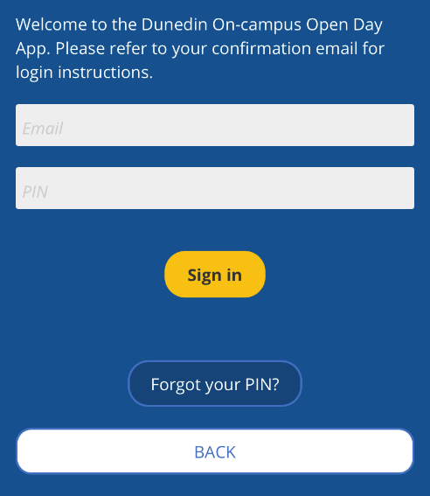
  - The PIN is a six-digit combination of numbers and letters that is in your confirmation email (PIN is not case sensitive).
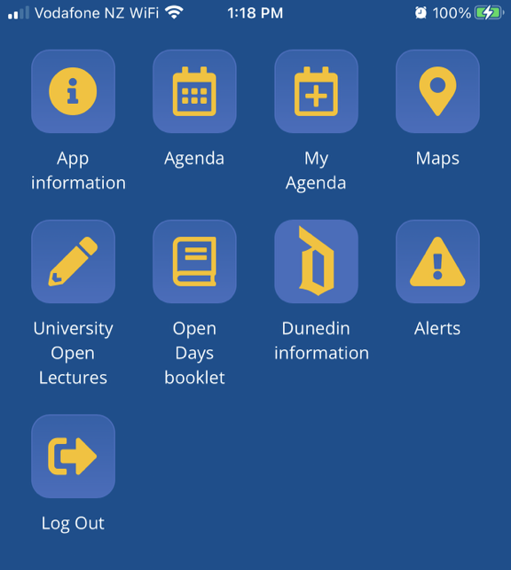

- You will now have full access to the app. Click on the information icon for instructions on creating your schedule for Tertiary Open Days 2022.

- Guest Wi-Fi will be available on campus.

- Please contact events@otago.ac.nz if you have any questions or issues with any of the above instructions.

