Make Life Simple with our SchoolApp
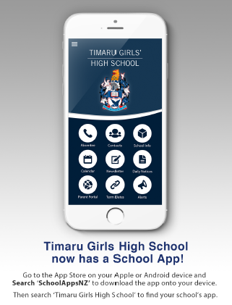

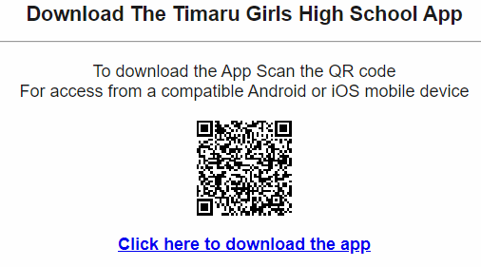

Make Life Simple with our SchoolApp

