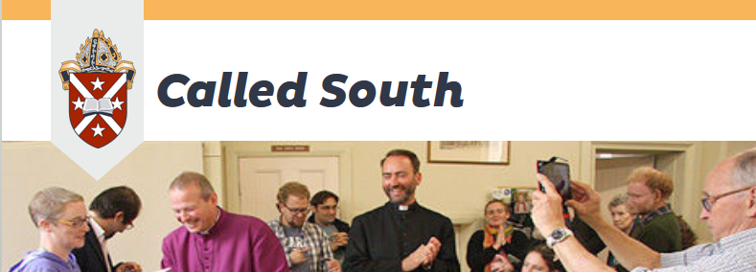
Responding to God's call in Otago and Southland

We see ourselves as responding to God’s Call in Otago and Southland:
Faith Communities
reading the Bible, praying,
living out the life of Jesus Christ

TRAINING DAY REGISTRATION FORM
Saturday 26 February 2022 10am – 12 noon by ZOOM

This Training Day is open to anyone in the diocese who is interested in attending, but it is recognised as an essential part of the Licenced Lay Minister annual training requirements.

REGISTRATIONS MUST BE RECEIVED BY FRIDAY 18 FEBRUARY. There is no registration fee.
Please email to annegover@xtra.co.nz

Please register me for this Zoom Training Day. You will be sent the link for this Zoom Meeting.

You may choose to attend this training at your own home or join a group from your church and attend at your church or one of your homes.

NAME:
ADDRESS:

EMAIL:
HOME PHONE:
MOBILE:
NAME OF PARISH, REGIONAL DEANERY OR LOCAL CHURCH:

WORKSHOPS Please show your first and second choice as 1 & 2 - these will be in breakout rooms
‘New Ways of Being Church’ – Anne Van Gend

‘Leading Extended Communion – Theology and Practice’ – Michael Godfrey

‘Unexpected Young Guests – How to engage with children when you aren’t expecting any’
- John Graveston
‘How to find and use Youtube music in worship’ – Anne Gover

‘Pastoral Care in a Covid World’ – Vivienne Galletly

PROGRAMME FOR SATURDAY 26 FEBRUARY 2022
ZOOM 10am – 12 noon

10am Opening Worship

10.15am ‘Expectation of LLMs’ +Steven Benford

10.45am Workshops in Breakout Rooms

11.30am Notices and Sharing

11.45am Closing Worship

I look forward to seeing you at this Zoom Training Day on Saturday 26 February.

Anne Gover
Licenced Lay Minister Convenor
Dunedin Diocese

