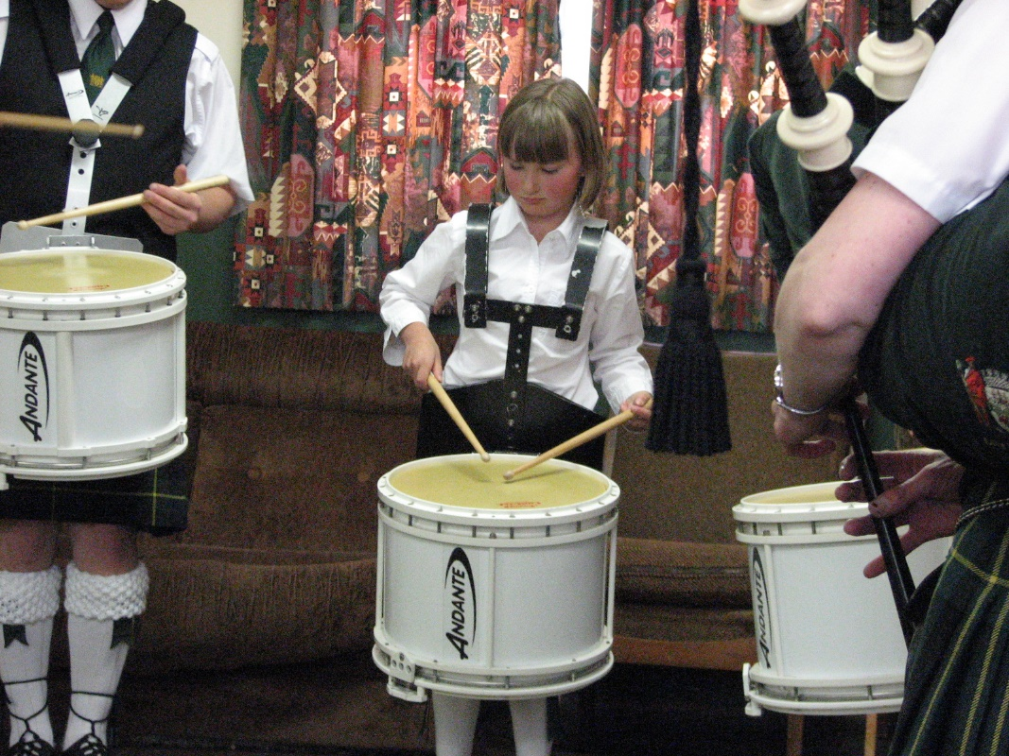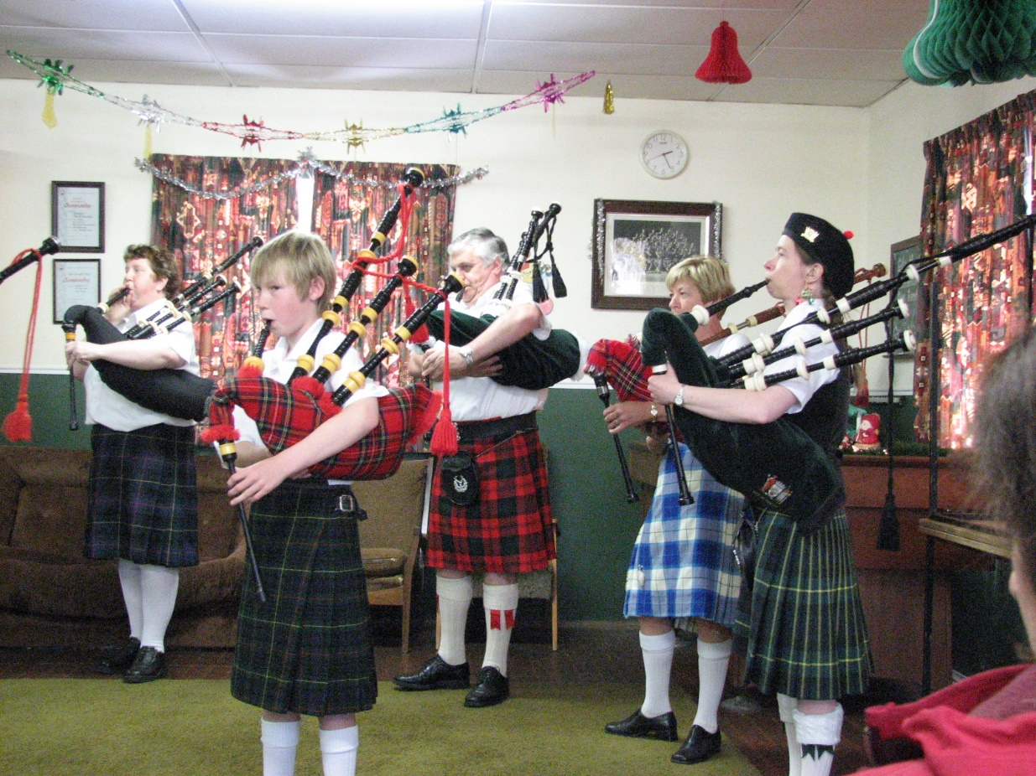

**To enrol or for more details contact:**

Mark McNoe, Text 0275 314875, or ph 489 1650, or go to [www.ospd.org.nz](http://www.ospd.org.nz)

*Classes are suitable for Primary and Intermediate School students.*

**Free Bagpipe Beginner Classes begin:**

Thursday, 18th February 2016, 4-30pm

**FREE Snare Drumming Beginner Classes begin:**

Tuesday, 16th February 2016, 5-30pm

Hi,

Can you please include this notice in your next newsletter?

We appreciate all your help!

Regards, Mark McNoe

Otago School of Piping and Drumming