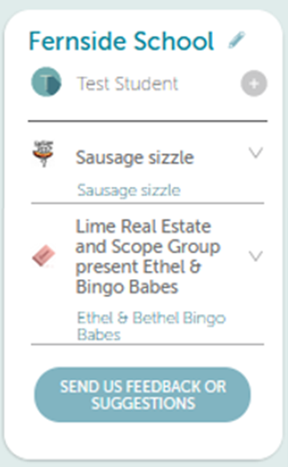
ONLINE KINDO SCHOOL SHOP

Say goodbye to paper forms and having to find cash, and hello to online purchases and payments!

We are very excited to introduce our new online Kindo school shop where you can purchase event tickets, support fundraisers and order your sausage sizzle lunch easily.
It’s open 24/7 and available soon on our school website.

Click here to go to the registration / login page of our Kindo school shop and create your myKindo family account.

myKindo app is also available to download for both android and iPhone.


Need assistance? Our Kindo helpdesk is open 8am to 4pm Monday to Friday.
Freephone: 0508 4 KINDO (0508 454 636) Email: hello@myKindo.co.nz
Online support: support.myKindo.co.nz

SAVE TIME – PAY ONLINE

