Te Taura Here Kāhui Ako – revised achievement challenges

Ko wai tatou - whom we are
A learning community that includes four kura and twelve ECEs located in and around the central city of Christchurch. We have experienced disrupted access to our services and to the city over the past nine years. One of our kura has recently returned to a central city location after being relocated to the suburbs following the Christchurch earthquakes. Another is recently established, choosing to be located close to the central city.

What makes our kāhui ako unique is the number of kura and ECEs that are could be described as non-traditional. Three of four kura have designated special character status. One is a reo Māori kura, another offers a full range of English language classes for new immigrant and refugee ākonga, while another offers an alternative pedagogical approach. One primary kura is located in the heart of an inner city transient residential area. Transitional pathways into and out of these kura and ECEs are unconventional. Ākonga transition into our education environments from throughout the city and beyond, and out into equally diverse education settings.

Six of the twelve early childhood services are new to the city, having recently been established as part of the refurbishment of the central city. Another three ECEs have special relationships with primary, secondary or tertiary providers as they are located on the sites of these institutions.. The remaining three ECEs are scattered across the city centre.

Our kura and ECEs do not have traditional geographical communities, but rather whānau communities who choose
to come to our services for adult education, whānau work or study, low cost rental reasons or to access a pedagogical approach to teaching that differs from mainstream. Enrolments in kura and ECE occur throughout the year at all year levels, for various timeframes, and often for defined purposes. This results in a transient population base.

The collective diversity of our communities is the strength of our kāhui ako.

Cultural narrative
Our kahui ako recognises the importance of the shared cultural narrative underpinning our work towards our achievement challenges. We are committed to weaving through the narrative as we move forward. Its status is recognised by the positioning of our cultural narrative hui as the first significant event as we began our work as a kahui ako.

We acknowledge Te Ngai Tuahuriri as holding mana whenua over the land of this area. Their pepeha recognises their takiwa and whakapapa:
Ko Maungatere te maunga
Our mountain, Maungatere (Mount Grey) stands above us;
Ko Waimakariri, ko Rakahuri nga awa
Our rivers – the Waimakariri and Rakahuri (the Ashley) – fl ow below;
Ko Tuahuriri te tangata
Tuahuriri is our ancestor.

Our kahui ako also acknowledges the connections and values held by current Ngai Tahu generations who have a cultural responsibility to pass on this place to future generations in better condition than it is today. The concepts of greening the city, embracing and improving the health of the water and the river, and a strong sustainability focus are reflected in our third achievement challenge focused on place-based learning.

Our vision
We want involved, invested, inspired, enthusiastic, empowered students and staff who appreciate and love their place in Ōtautahi, where everyone participates in authentic learning which contributes to the wider community and encourages sustainability for the future with a specific focus on:

- Ensuring that our Māori students experience success as Māori, led by Māori for Māori.

- Happy, safe and responsible ākonga who are positive and have a strong sense of identity and belonging in Aotearoa. A community who has the skill set to flourish, connect well with others and achieve high levels of success.
- Communities working collaboratively to contribute to our inner city environment and surrounding areas through responsible action as kaitiaki.
- Ākonga and whānau who successfully transition into our educational settings, within them and beyond them as a result of collaboration, flexible programmes, sharing of data and strong relationships with external agencies

Our journey so far

Engagement and consultation with our community
Te Taura Here o Ōtautahi Kāhui Ako grew from the foundations of collaborative relationships between inner city schools and early childhood services previously involved in a Learning Community Cluster (LCC). This cluster had been established following the 2011 Christchurch earthquakes. To make the move from LCC to a Kāhui Ako, a series of meetings with potential ECEs and schools was held during 2018 to elicit interest in Kāhui Ako membership.

The name, ‘Te Taura Here o Ōtautahi’, refers to our diverse educational kinship group all located near the centre of Ōtautahi and spanning education from early childhood to Year 14, including adult education. Just as te taura [rope] has many strands, our kāhui ako has many strands. Each strand represents one of our diverse educational institutions which bind together to form one strong rope, or community of learning. Each kura and early childhood service is unique and contributes to the whole, acknowledging both individual and collective strengths and characteristics.

At the end of 2018, Te Taura Here o Ōtautahi Kāhui Ako’s application to establish was approved and the process of consultation to develop our goals and ways of working together began.

Our membership of four kura and 12 ECEs held a series of meetings to begin visioning our work together. During the course of these meetings we asked the questions:
- Ko wai tātou–who are we, why am I here today?
- What’s in your kete? What do you bring to the kāhui ako?
- Tikanga for this kāhui ako: how will we work together?
- What are the priorities for ākonga in your setting?

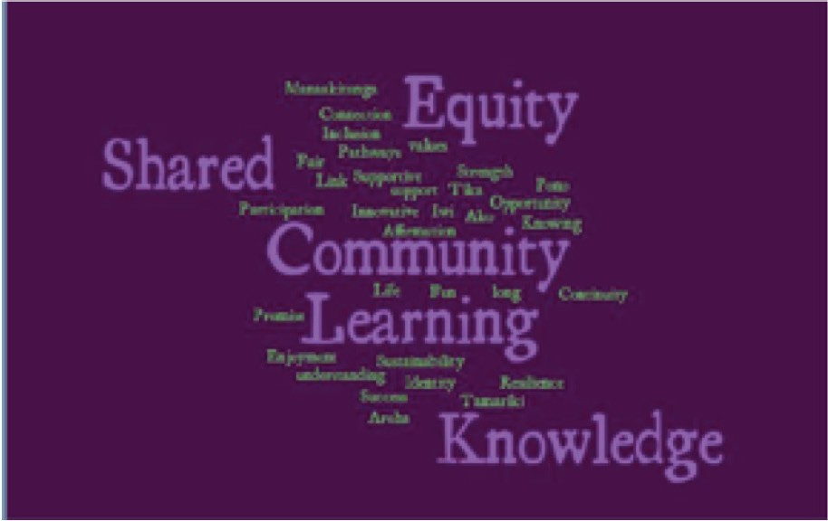
We identified common wero before finally identifying the essence of our moemoea (dream or vision) for working together. Our guiding principles emerged:
- Equity
- Sharing
- Community
- Learning
- Knowledge

Participants had conversations with kaiako, Boards/ management and others in their settings that affirmed our group’s unique characteristics and common challenges:

- Culturally Responsive Practice
- Wellbeing
- Future focused education
- Pathways

Our Community of Learning

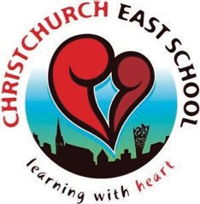
Christchurch East School
Website: www.chcheast.school.nz

Vision: Vibrant Inspirational Learning Community in the Heart of the City.

Te Puna Wai o Waipapa / Hagley College
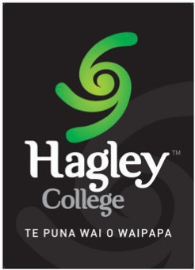
Website: www.hagley.school.nz

Vision: Lifelong learning, accessible to all.

Te Pā o Rākaihautū
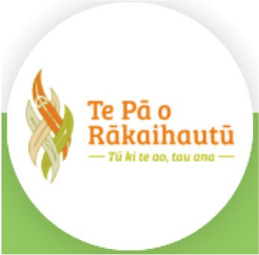
Website: www./rakaihautu.com

Vision: Tū ki te ao, tau ana

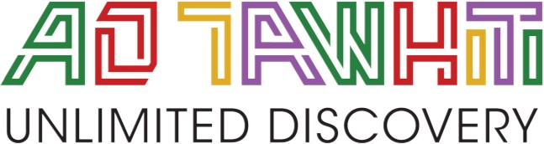
Ao Tawhiti
Website: www.aotawhiti.school.nz

Vision: A special character state school with a fundamental tenet that the child is central in directing his or her own learning so that the enthusiasm and love of learning is retained.
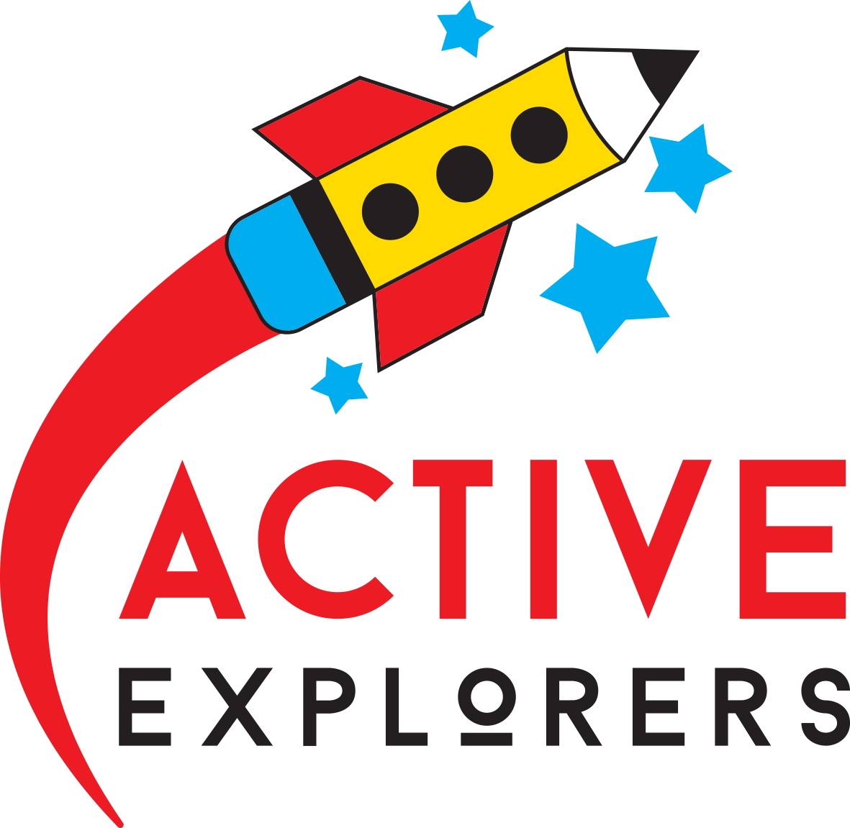

Active Explorers Central City MOE no: 45158
Website: www.activeexplorers.co.nz/locations/central-city/

Vision: As kaiako we are here to guide, support and nurture our tamariki and our community.

ARA ELC MOE no: 70431
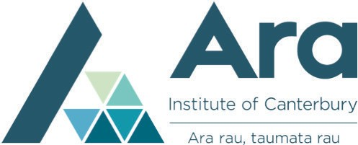
Website: www.ara.ac.nz/services-and-support/childcare/ara-early-learning-centre

Vision: Loving, nurturing and respectful relationships are at the heart of what we do.

Te PiHagley Community Preschool MOE No:70363
Website: www.hagleypreschool.co.nz 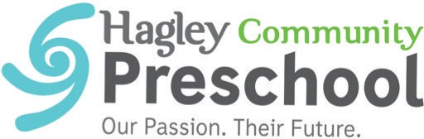
Vision: An inclusive and vibrant learning community working together to nurture the capabilities and competence of our tamariki as successful life-long learners.

BestStart Parkside MOE no:70551
Website: www.best-start.org/centres/beststart-parkside 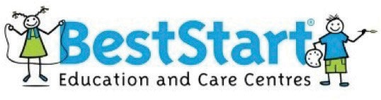
Vision: Our children are engaged, confident and capable learners with a strong sense of identity.

BestStart Salisbury Street MOE no: 70447
Website: www.best-start.org/centres/beststart-salisbury-street
Vision: Our vision is to work in partnership with families, whānau and communities to enable children to achieve their learning potential.

Co Kids MOE no: 47294
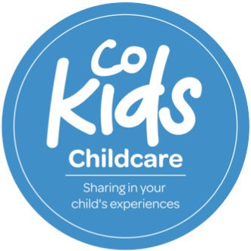
Website: www.cokids.co.nz/christchurch

Vision: To provide quality early childhood education within an innovative, creative environment that supports children’s learning and development.

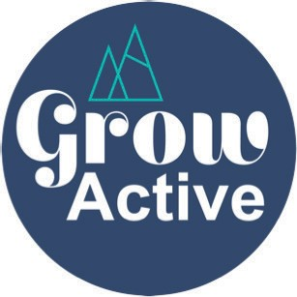
GROW ELC [Balfour / Essex / Welles]
Website: www.growactive.nz/

Vision: We are all passionate about contributing to Grow Active and its forward plans
so that we continue to create the best opportunities to enrich the lives of the children and families that attend our centres.

Rangi Ruru ELC MOE no: 70438
Website: www.rangirurupreschool.nz 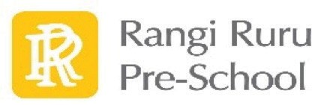

Vision: To make a positive difference to families of Rangi Ruru Preschool and the surrounding
communities by providing high quality early childhood care and education which embodies Manaakitanga, Ako and Haere Kōtui (partnership).

Millies MOE no: 47700
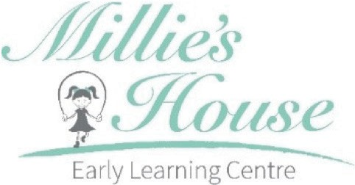
Website: www.millieshouse.co.nz

Vision: Built on the principles of Manaakitanga, Whanaungatanga, Social Competency and Communication, we believe that tamariki are competent and active participants in their own learning.

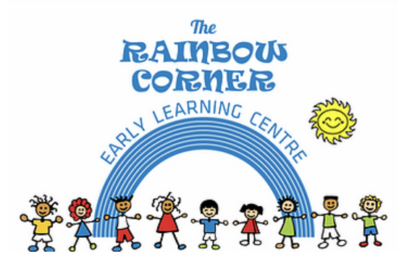
The Rainbow Corner ELE
Website: www.rainbowcorner.co.nz

Vision: The vision of our Early Childhood Education programmes is to work in partnership with families and the community. We believe in enhancing the abilities and skills of the whole child, including social, physical, intellectual, communication, and emotional (SPICE) development.

Information in support of our goals

Culturally Responsive Practice
He mahi kai takata
He mahi kai hōaka
Anything worthwhile requires great effort.
This achievement challenge is a key priority for our kāhui ako. Fundamental to this is that our kāhui ako has high expectations for ākonga Māori so they can succeed as Māori. We recognise that mana whenua guide and endorse the steps we take. We acknowledge the leadership of Mātauraka Mahaanui in guiding our kura and ECEs to be culturally responsive and to respond in authentic ways to apply “mana whenua” pedagogy and practices. We appreciate that capability to improve outcomes for Māori can be gained through planning for enhanced provision of Te Reo Māori, through strengthening productive partnerships with whānau, and through culturally based professional development that targets leading and managing for Māori learner success as Māori.
Reference: Mātauraka Mahaanui Indicators of Success

Wellbeing
The Child Poverty Action Group published a 2019 report measuring deprivation in the Canterbury region. Of interest to our Kāhui Ako is the data zone located in Christchurch Central, bordered by Hagley Avenue, Brougham St, Fitzgerald Avenue and Salisbury Street. This zone has been identified as among the 20% most deprived data zones in New Zealand in terms of crime, housing and health. The report suggests that these are issues of concern and where initiatives addressing crime, housing and health may be of greater relevance.

Reference: Annie Chiang and Associate Professor Daniel Exeter. (2019). Report prepared for Child Poverty Action Group. Retrieved: https://www.cpag.org.nz/assets/Canterbury%20FINAL.3.pdf

Future Focused Education
Future focused education is about preparing our learners to be confident connected actively involved lifelong learners who can thrive in the 21st Century. Encouraging students to look to the future by exploring such significant future focused issues as sustainability, citizenship, enterprise, and globalisation are key foci. Providing an innovative and relevant education engaging for all ākonga is our focus. Christchurch City Council’s ‘Multicultural Strategy’ 2017 – 2021 expresses the intent of making sure everyone feels welcomed and part of a richly diverse city. It includes a commitment to provide an environment we can access where we can achieve common goals and understand the importance of working together, Te Waka Eke Noa – A purpose and model – the canoe we are all part of (p.4).

Our kāhui ako’s future focused goals align with the Multicultural Strategy goals for communities to have access to Council facilities, services and resources. Our focus on strengthening place based education in settings and working collaboratively on projects will provide opportunities to explore a stronger relationship between kura, ECEs, tamariki, ākonga, whānau and the City Council. Through utilising the inner city environment our tamariki/ākonga will have access to learning about and valuing the histories of the city and its peoples, upholding the values of Ngai Tahu’s expressed by Pita Te Hori,‘kia atawhai ki te iwi/care for the people’(p.3).

Reference: Christchurch City Council (2017) Multicultural Strategy Te Rautaki Mātāwaka Rau 2017 - 2021

Pathways
The movement between learning environments of ākonga within our Kāhui Ako occurs throughout year groups for a variety of reasons as they move into new learning environments across greater Christchurch. Kaiako in this Kāhui Ako do not have the benefit of prior relationships with every kura or ECE that ākonga move between, which poses significant challenges for each and every kaiako aiming to support ākonga on their learning journey.

Transition is more complex than just helping children become familiar with the new learning environment, staff and curriculum. Research tells us that good relationships among children, teachers of all sectors, and parents/whānau are all essential to support ākonga who move from one learning environment to the next. Transition needs to be seen as a process in which ākonga are required to make ongoing adjustments over quite some time, and each will do this in their own time. When ākonga struggle at the time of transition, long term consequences can result.

“There is evidence — for example, from Wylie et al’s (2006, 2008) longitudinal Competent Learners study — that young people experiencing particular difficulties at school at the time of transition are at considerably greater risk of poorer outcomes over the longer term if their difficulties are not well recognised and addressed. Schools therefore have a responsibility to provide systems, structures and strategies that welcome and support their newest students if they are to meet Ministry of Education schooling goals concerning the provision of the best possible education pathways for all students.’ (MOE, 2010)

References: Ministry of Education. (2010). Easing the Transition from Primary to Secondary Schooling: Helpful information for schools to consider. Research and Evaluation Unit Research Division Ministry of Education ERO. (2015). Continuity of learning. National Report April 2015.
Retrieved from www.ero.govt.nz

Achievement Challenge 1:
Culturally Responsive Practice

Strategic Goal
Engaging in culturally responsive and relational pedagogy and practices to ensure that our Māori students experience success as Māori, led by Māori for Māori.

Context that informs this Achievement Challenge
- Acknowledgement of our kāhui membership including Māori Medium, and English Medium education settings.
- Kura, school, and ECE specific strategic goals, charters, and annual plans.
- Mana orite mō te mātauranga Māori as part of the NCEA change package.
- Ngāi Tūāhuriri is the papatipu rūnanga holding mana whenua over this takiwā (area).

Desired outcome

Our kāhui ako will have high expectations for ākonga Māori, and ensure the conditions for their success as Māori within our education settings.

Actions
- Engage with ākonga Māori and their whānau, and our Māori communities to develop a shared understanding of what achieving success as Māori could look like within our kura / ECEs.
- Examine what is existing good culturally responsive practice in our kura / ECEs and how we achieve positive outcomes for Māori.
- Use of the Ka Hikitia Measurable Gains framework, Tātaiako, The Hikairo Schema, and Te Kete o Aoraki as guiding documents which shape our direction and process, and inform our culturally responsive pedagogies.
- Work with kaiako to support positive change in order to provide our ākonga Māori with consistent opportunities to achieve their educational aspirations.
- Consider evolving trends, with kura / ECEs determining what they would like to strengthen and how we can support each other in this process.
- When possible, continue our work with Mātauraka Mahaanui Mana Whenua Education Facilitators to move through the indicators of success for capability in relation to achieving positive outcomes for Māori achieving education success as Māori.

Indicators of Success
- Expanding culturally responsive place based learning
- Enhancing provision for tikanga and te reo Māori learning for ākonga and staff
- Expanding how we engage with whānau, and our Māori communities, and the scope of that engagement
- Providing access to culturally based PLD, targeting ākonga Māori success
- Data shows measurable improvements in achievement and engagement.

Achievement Challenge 2:
Wellbeing

Strategic Goal
Happy, safe and responsible ākonga who are positive and have a strong sense of identity and connection in Aotearoa.

Context that informs this Achievement Challenge
Kura and ECEs hold concerns about wellbeing, increasing referrals to outside agencies, increasing enrolments with complex needs, and trends observed by in-school wellbeing and counselling teams.

Desired outcome
Our learning community will have the ability to gather, analyse and respond to information about ākonga wellbeing and build the skills and knowledge to respond appropriately.

Actions
- Gather relevant and useful information about the wellbeing of our ākonga.
- Evaluate the effectiveness of each kura / ECE's approach to well-being.
- Build relationships between external mental health services and school wellbeing services.
- Promote wellbeing as a priority in the curriculum and in everyday life.

Indicators of Success
- Increased quality of information gathering, analysis and response about wellbeing.
- Kura / ECEs are more responsive to the identified needs of our ākonga, offering additional high needs mental health support across the the kāhui ako
- Staff have access to professional learning and support to effectively use best practice well-being interventions for ākonga within their kura/ECE.
- Kaiako and ākonga wellbeing and resilience are strengthened.

Achievement Challenge 3:
Future Focused Education

Strategic Goal
Creating cross-kura opportunities to engage ākonga in future focused and innovative learning, engaging students in a curriculum that is ‘future-ready’.

Context that informed this Achievement Challenge
  - Our kāhui ako proximity to the central city enables a wealth of place-based learning opportunities which can enable a focus on Ōtautahi’s history, environment and sustainability.
  - The NZC vision is for young people to be confident, connected actively involved lifelong learners. The curriculum encourages students to look to the future by exploring such significant future focused issues as sustainability, citizenship, enterprise, and globalisation.
  - The 2020 lockdown provided opportunities for students to learn in different ways and provided us with opportunities for different future focused programme pathways.

Desired Outcomes
Kura / ECEs work collaboratively:
- to contribute to our inner city environment and surrounding areas through responsible action as kaitiaki
- to develop innovative curriculum future-focused learning opportunities.

Actions
- Build ākonga understandings of the Ngāi Tūāhuriri cultural narrative linked to Ōtautahi
- ākonga engaged with place-based learning projects. Projects can be focused on sustainability and collaborating with others giving back to the community and acting as kaitiaki Developments in curriculum and pedagogy take up future focused learning opportunities
- Ākonga engaged with innovative curriculum and future-focused learning opportunities.

Indicators of success
- Build place-based learning as an aspect of our kura and ECEs’ programmes
- Develop future focused learning opportunities, including hybrid programmes delivered both face to face and in digital formats, creating increased ākonga engagement across learning areas, including in STEM learning and other designated areas.

Achievement Challenge 4:
Pathways

Strategic Goal
Kura and ECEs have cohesive transition procedures that ensure students and whānau move seamlessly into, within and beyond our learning environments.

Context that informed this Achievement Challenge
We are different to other mainstream schools who usually have feeder preschools and schools. We are unique in that we have many preschools and schools from throughout the city feeding into and out of our learning environments. Transitional pathways into and out of our kura and ECEs are unconventional. Our kura and ECEs do not have geographical communities, but rather whānau from across Ōtautahi who come to us for varying durations and for diverse reasons, including adult education, whānau work or study, low cost rental accommodation and alternative education possibilities. Transitions into several of our kura occur at all year levels [not just at Years 1, 7 and 9]. They also occur both at conventional entry and exit times at the beginning and end of the school year as well as throughout the year, with ākonga arrive for various timeframes and for diverse purposes. These patterns are also reflected in the ECE transitions. Together, these patterns reflect a highly transient population base.

“There is evidence — for example, from Wylie et al’s (2006, 2008) longitudinal Competent Learners study — that young people experiencing particular difficulties at school at the time of transition are at considerably greater risk of poorer outcomes over the longer-term if their difficulties are not well recognised and addressed. Schools therefore have a responsibility to provide systems, structures, and strategies that welcome and support their
newest students if they are to meet Ministry of Education schooling goals concerning the provision of the best possible education pathways for all students.” (MOE, 2010)

Desired outcome
Ākonga and whānau successfully transition into our educational settings, within them and beyond them.

Actions
- Gather baseline data from ākonga, whānau and staff about transition successes/ barriers/ processes
- Inquire into/ identify best practice for successful transitions
- Explore the nature of the information that comes with transitioning ākonga, identifying useful information not currently gathered using current mechanisms
- Explore and develop successful pathways and progressions within education settings
- Use peer leadership and mentoring to improve transitions into and within kura.

Indicators of Success
- Effective communications with whānau and increased whānau involvement in transitioning pathways
- The needs of whānau and ākonga at the centre of decision-making
- Staff have rich and full information about incoming ākonga
- Improved use of information about ākonga transitioning into, within and beyond their kura /ECEs
- Effective transition procedures are developed in each kura / ECE, including a responsive induction programmes for students, whānau
- ākonga have learning pathways which create opportunities not restrictions.

Monitoring and Evaluating Progress
  - Action plan developed and updated annually
  - Review cycle: light touch annually and full review every three years.
32 Te Taura Here o Ōtautahi

A school’s Māori community is made up predominantly, but not exclusively, of the following: Tangata Whenua/Mana Whenua, all Māori staff, all Māori students and their whānau, other Māori with an active interest in the school, e.g., kapa haka tutor, kaumātua.
.

