  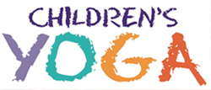
  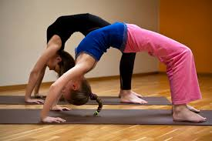
    - Term 3 2018
  Children’s yoga classes
  An excellent way for children to bring movement into their bodies, increase suppleness and learn how to quieten their minds.
  $100.00 for the 10 Week term.
  Mats and props provided. Children need to wear PE clothes and have bare feet. Contact Iyengar Yoga Dunedin via our easy to use website contact us form or call 0274 500 567 by 20 July 2018 to book your child in for the term. Demelza is experienced at working with children and creates fun and engaging classes for the children.
  
  WWW.iyengaryogadunedin.co.nz or find us on Facebook!
  Children’s yoga classes
  7 to 13 years old
  Fun classes specifically for children
  Increases self-awareness & strengthens their bodies and minds
  Term 3 2018 Wednesday 25 July – 26 September 2018
  3:30 – 4:30 pm
  Book now to secure your child's place for the term
  Wednesda
  IYENGAR YOGA DUNEDIN
  King Edward Court
  Room 211
  Stuart Street
  www.iyengaryogadunedin.co.nz
  Find us on Facebook!
  Wednesday afternoons at 3:30pm

