WHĪTAU SCHOOL BALLOT FOR OUT OF ZONE ENROLMENT

If you are living outside of a school’s zone, it is only possible to secure a place at the school if there is a vacancy. Enrolment schemes exist to ensure that numbers do not exceed the Ministry of Education property resources at
the school.
Children living outside of the school zone may apply for a place through the ballot system for each child, which will be used if there are vacancies to fill. Please complete the form below and return it to the School Office as soon as possible. We will contact you by email on the ballot date to let you know whether we are able to offer a position at our school or not.
CHILD’S DETAILS:
Legal Surname: |  |  | Male/Female: |  |  |  |  | Date of Birth:
Legal First Names: |  |  | Previous School: |  |  |  |  | Year Level:
Preferred Surname: |  |  | Preferred First Name: |  |  |  |  | Name of Early Childhood Centre:  (if attended one)
Address: |  |  | I would like my child to start at Whītau School in 2026
 |  |  | Term 1 |  |  | Term 2 | Term 3 |  | Term 4 | Term 1, 2027
Siblings Names & Date of Birth:

PARENT/CAREGIVERS DETAILS:  (Caregiver One) |  |  | PARENT/CAREGIVERS DETAILS:  (Caregiver Two)
Family Name: |  | First Name: | Family Name: |  |  |  |  |  | First Name:
Relationship to Child: |  | Contact: | Relationship to Child: |  |  |  |  |  | Contact:
Address: (if different from child) |  |  | Address: (if different from child)
Email Address: |  |  | Email Address:
PRIORITY | CRITERIA |  |  |  |  |  |  |  | PLEASE TICK YOUR PRIORITY
1 | First priority must be given to any applicant who is accepted for enrolment in a special programme run by the school. (This priority category does not apply at Whītau School. The school does not run a special programme approved by the Secretary for Education.) |  |  |  |  |  |  |  | This does not apply  to Whītau School
2 | Second priority must be given to any applicant who is the sibling of a current student of Whītau School;
3 | Third priority must be given to any student who is the sibling of a former student of Whītau/Linwood North School;
4 | Fourth priority must be given to any applicant who is a child of a former student of Linwood North School
5 | Fifth priority must be given to any applicant who is either a child of an employee of the Board of the school or a child of a member of the Board of the school
6 | Sixth priority must be given to all other applicants
IF YOUR CHILD QUALIFIES UNDER PRIORITY 2 – 5 PLEASE COMPLETE THE APPROPRIATE SECTION

Section 11G(1) Education Act 1989

Name of Current Sibling(s) attending Whītau School:

Name of Sibling(s) who previously attended Whītau School: |  |  |  | Dates Attended:
Name of Former Student who previously attended Linwood North School: |  |  |  | Years Attended:
Name of Board Employee or School Board Member:

REASONS FOR REQUEST FOR AN OUT OF ZONE ENROLMENT

Please tell us about your child and your family and why you wish to be enrol your child at Whītau School
SIGNED: |  |  |  |  | DATE:

Whītau School Enrolment Scheme dates for 2026
Four ballot days but at each ballot you can only enrol children for the next term
We advertise in Week 6 and complete the ballot process in Week 10 of each term, a term in advance of enrolment.

Term | Application deadline  3 pm on the following days | Ballot Date
For children who wish to enrol in Term 1, 2026  26 January – 02 April | Wednesday  15 October 2025 |  | Friday  17 October 2025
For children who wish to enrol in Term 2, 2026  20 April – 03 July | Wednesday  11 March 2026 |  | Friday  13 March 2026
For children who wish to enrol in Term 3, 2026  20 July – 25 September | Wednesday  27 May 2026 |  | Friday  29 May 2026
For children who wish to enrol in Term 4, 2026  12 October – 18 December | Wednesday  19 August 2026 |  | Friday  21 August 2026
For children who wish to enrol in Term 1, 2027  28 January – 09 April | Wednesday  14 October 2026 |  | Friday  16 October 2026

Note: The enrolment procedure for Term 1 of any year is governed by legislation that requires schools to have the closing date for applications…..’No later than 15th October’ and that the ballot must be carried out by 30th October.
All students who live within the geographic home zone described below and shown on the below map shall be entitled to enrol at the school. Addresses on both sides of boundary roads are included unless otherwise stated.
- From the intersection of Woodham Road and Pages Road
- South West on Pages Road (North East side only) to Buckleys Road
- South West on Buckleys Road (North East side only) to Norwich Street
- North West on Norwich Street to Worcester Street
- South West on Worcester Street to the intersection with Linwood Avenue
- From the Linwood Avenue / Worcester Street intersection South West to Olliviers Road
- South West on Olliviers Road to Hereford Street
- West on Hereford Street to England Street
- North on England Street to Armagh Street
- West on Armagh Street to Trent Street
- North on Trent Street to Woodham Road
- East on Woodham Road to Avonside Drive
- North on Avonside Drive to Morris Street
- East on Morris Street (south side only) to intersection with Avonside Drive
- Across the Avon River to 29 Dallington Terrace then south east to Johanna Lane

- South East on Johanna Lane to Gayhurst Road
- North East on Gayhurst Road to Glenarm Terrace
- East on Glenarm Terrace (South side only) to Locksley Avenue
- South on Locksley Avenue to the Dallington Bridge
- South over the Dallington Bridge to Avonside Drive
- North East on Avonside Drive to Kerrs Road
- South on Kerrs Road to Wainoni Road
- North East on Wainoni Road to Pannell Avenue (including Wainoni Road to Cuffs Road)
- South on Pannell Avenue to Wildwood Avenue
- South on Wildwood Avenue to Kerrs Road (including Lyn Christie Place and Odie Place)
- South on Kerrs Road to Woodham Road
- East on Woodham Road to Pages Road.

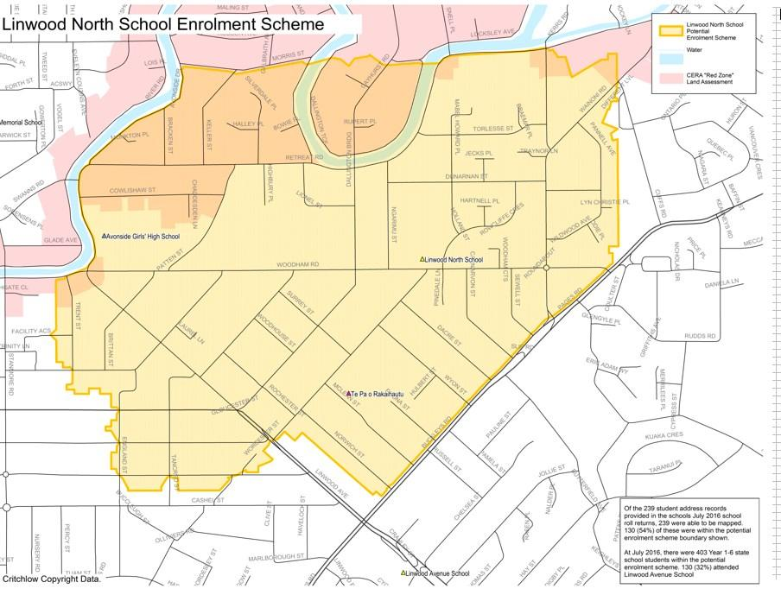
Proof of residence within the home zone will be required.

