eLearning Student User Agreement for Banks Avenue School
JUNIOR MODULE STUDENT USER AGREEMENT OVERVIEW 2021


Child’s Name: _________________________________________________________________________ 2021 Class: ______________________
Digital technologies and devices like iPads and computers are tools that can help us learn at school in all sorts of ways. We can look at interesting things online, talk to people, create new ideas, and learn how to do different things on apps and websites.
When we use digital technologies, we need to learn how to keep ourselves safe, and make good choices in ways we behave when we are online. At Banks Avenue School we call this being a ‘digital citizen’. Good digital citizens help to make our school a safe and positive place for everyone.
This agreement shares what Banks Avenue School does to help make learning online safe, and what we need to do. It is not always easy to understand everything about online spaces, because there are so many things to use and explore, and that’s why it’s important that we all try to make it as safe as possible.
BANKS AVENUE SCHOOL’S ROLE
This section outlines the school’s approach to digital technology use and online safety.
Banks Avenue wants to help you learn in the best ways we can, and keep you safe at school.
We will do this by:
- helping you to know what you need to do to keep safe online
- helping you to know what to do if it you are worried or upset by anything or anyone online
- making sure we have learning times at school where you can find out more about keeping safe online and safe ways to use your device or computers
YOUR ROLE
This section outlines the rules for using digital technology in school and as a member of the school community
We want our school to be a place that is safe and friendly, where we can learn, play and explore. To do this we need everyone to choose safe, careful, and fair ways of using devices and online spaces. As a digital citizen this means you will:
- Keep it kind. When you are online, think about others and talk or share in a kind way. Use your HEART Online values to help guide your behaviour for all of your digital learning.
- Keep it to yourself. Keep your passwords and information about yourself or other people safe and private.
- Keep it careful. Think carefully about what you share and make sure it’s something you are proud of and would be happy sharing with someone else face to face.
- Keep it real. Not everything you see online is real. It might look or sound real, but some things are made up or fake, so be careful to check or ask a teacher if you’re not sure.
- Keep it honest. When we copy or use words, pictures and ideas from the internet, we need to make sure we share these things in the right way and follow the rules for sharing things that don’t belong to us.
- Keep it fair. Make sure you check with others if it is okay to record them, or share photos or videos with them in it. They should have a say in what happens to things that go online if they are in them.
- Keep it responsible. If you bring your own device to school or are using a school device, use it in ways, and at the times that your teacher says it is okay to.
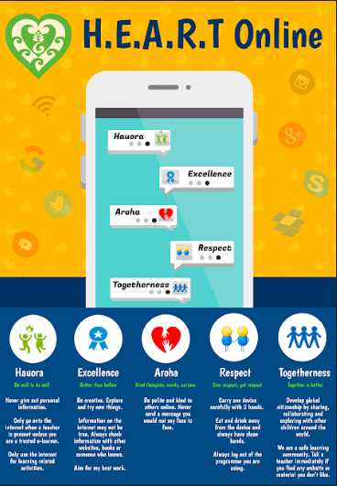
WHEN THINGS GO WRONG ONLINE
This section outlines how students can seek support and help
Even when people try to do the right thing, sometimes things go wrong. If you or somebody you know does something online that isn’t okay maybe by accident or on purpose, your teachers at Banks Avenue will help you to sort it out. If you see things online that make you feel worried or upset, your teachers at Banks Avenue will help you sort it out. The important thing is to tell a teacher or another adult you trust.
Online bullying. Online bullying is not okay at our school at any time. If somebody is saying mean or hurtful things about you or somebody else online, talk to a teacher or trusted adult. They will help you with what to do. Don’t delete or hide the messages or pictures because these are important to show what has been happening. Turn your screen off and then go tell a teacher or trusted adult.
Report a problem. If you see something online that you don’t think should be there, tell a teacher or a trusted adult at school as soon as you can. This is really helpful, and means we get to fix the problem quickly. The school will look and see how to fix it, and take away the problem.
Online safety support. Netsafe helps people to be safe online. They can help you or your family if you are having problems online. They have free, private help for you and your family for any online safety problems, and they are there to help seven days a week.
You can get hold of them on the phone 058638723, or their website at netsafe.org.nz
JUNIOR SCHOOL STUDENT SHARED UNDERSTANDINGS & EXPECTATIONS
- I know about the ways I should use digital devices and online spaces at school for learning.
- I know that I should be kind, careful and responsible when using devices, and when I go online, and this is the same for the devices that school owns, or if it is my own device that I bring to school.
- I know that if I behave in ways that are not safe online, or kind or responsible, that this is not okay at Banks Avenue School. There may be some actions that my school might have to take, such as not being able to use school devices or devices I bring from home to school.
- I understand and agree to use digital technology and the internet at school safely and for learning, whether it is on a school device or one I have brought from home.
JUNIOR SCHOOL STUDENT SHARED UNDERSTANDINGS & EXPECTATIONS
- I know about the ways I should use digital devices and online spaces at school for learning. I know that I should be kind, careful and responsible when I use devices, and when I go online.
- I know that if I behave in ways that are not safe online, or kind or responsible, that this is not okay at Banks Avenue School. There may be some actions that my school might have to take, such as not being able to use technology at school.
Child’s Name ___________________________________________________________________________________________________ 2021 Class _____________________________________________

Signed ____________________________________________________ Date ______________________
PARENT / WHĀNAU / GUARDIAN DECLARATION
This section should be completed by relevant whānau as our school policy is that we would like parents/guardians to be aware of this agreement and to have taken the time to discuss this with your child:
- I know that if my child makes choices or behaves in ways that don’t align with this Student User Agreement there may be consequences or outcomes that the school will talk about with me.

Name _____________________________________________________
Signed ____________________________________________________ Date ______________________

Once signed, this document is to be returned to the drop box so the office staff can note it’s return in eTap. It will then be handed on to your child’s class teacher where it will be stored in their Cumulative Record File. NB: This information is available on SchoolDocs and on our school website.

