Important Safety Information
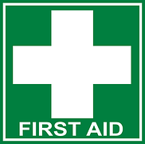
A first aid kit is located ______________________________________
For urgent medical care, dial 111.
The nearest health care or emergency centre is _________________________
The nearest defibrillator is at: _______________________________________

In an emergency (fire/earthquake):
Person in Charge: __________________________________
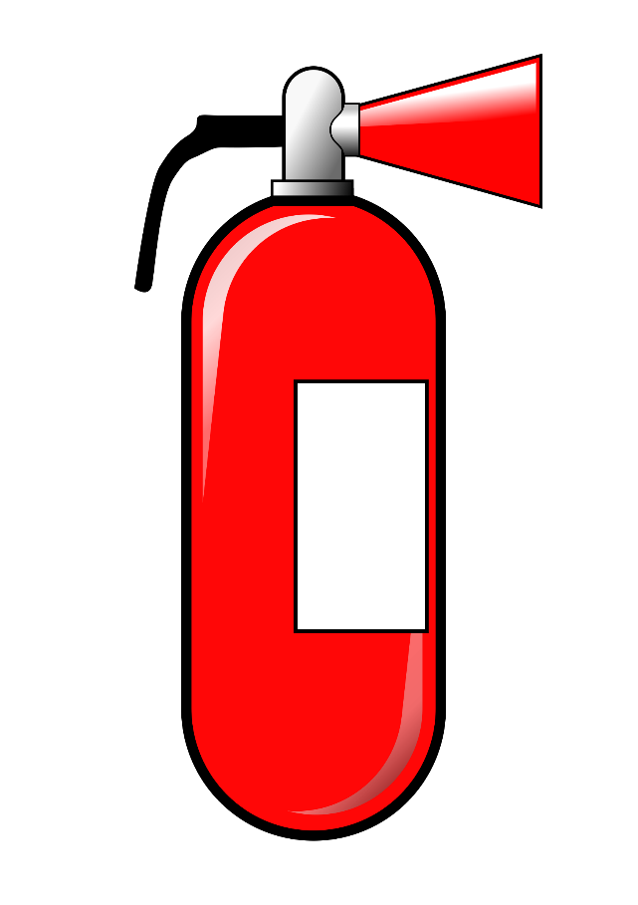
During earthquake: drop, hold and cover/protect yourself until shaking has ceased. Follow instructions of any person in charge about what to do next.
Fire
Method of alarm (manual alarm system, other method)
__________________________________________________
Location of fire extinguisher and/or fire blanket:
__________________________________________________
Do not attempt to put out a fire unless you know what to do.
Location of fire exits (look for nearest exit sign):
__________________________________________________
Designated Assembly Area: ___________________________

Hazards Warning
The following may pose hazards for younger children or vulnerable adults. Ensure that anyone at risk is not left in this area unattended:




