Assessment Calendar on SchoolBridge – Parent/Caregiver View
The Assessment Calendar on School Bridge will allow you as a Parent/Caregiver to see the internal assessments that your child is completing. The calendar is filled only with the assessments for your child’s timetabled classes.
- From the SchoolBridge home page, click Assessment Calendar. This will bring up a monthly
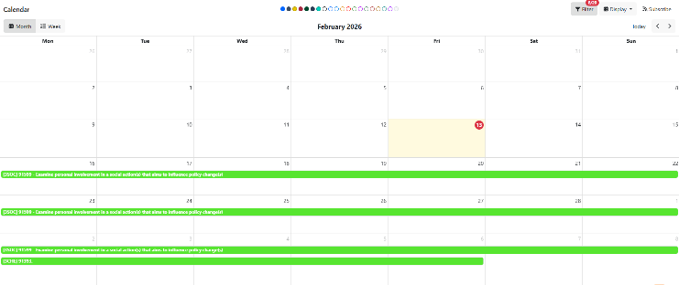
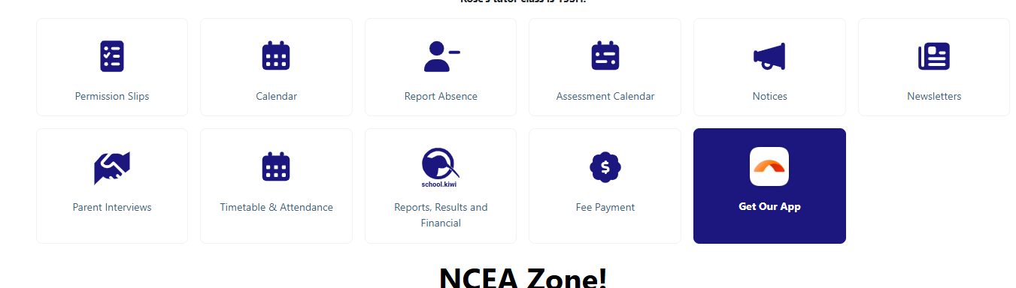
- calendar that will be populated with the internal assessments your child is completing.

In here you can:
View the calendar by month or by week | 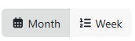
Filter the calendar (please note, not all these elements are being used by the school) |   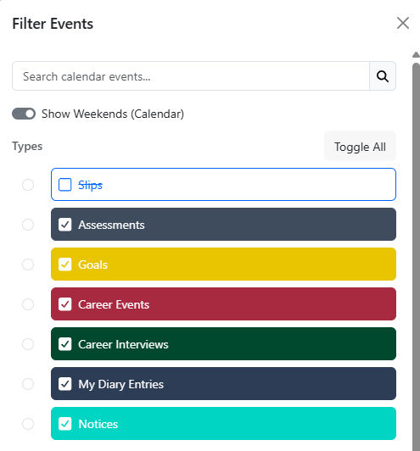
Chage the display view to either:  - The full calender (viewed by month)  - A Term calender (either viewed by column, grid or list) | 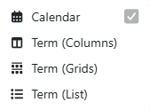
Subscribe – this allows you to add the calendar to your own calendar app

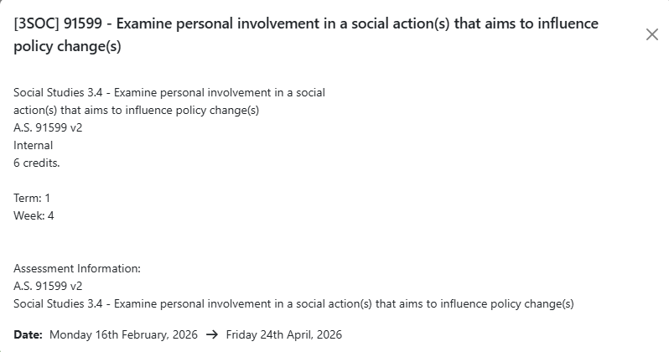
Clicking on an individual assessment will also provide you with different information, including
- The class code
- Full name of the standard
- Credits
- Start date and due date of the assessment
- Any other information the teacher of the subject may have provided

