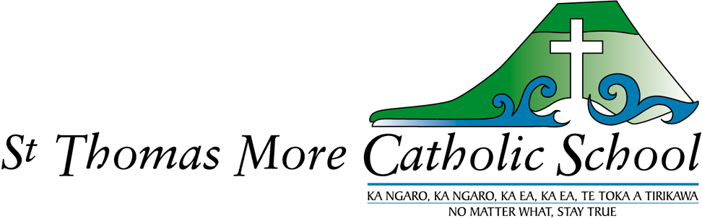
Annual Implementation Plan 2025-2026
Mission: We are Christ’s body in this world – Head, Heart and Hands.

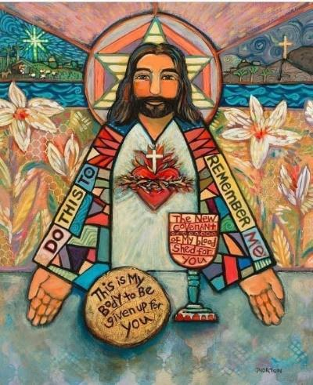
Review
Pp 3-4 | 2024 Student progress and achievement
Pp 5-7 | 2024 Action Plan – reviewed
 | Annual implementation plan 2025-6
Pp 8 | Action Plan 2025
Pp 9-11 | Supporting Documentation 2025-2026

“Christ has no body now on earth but yours.”
St. Teresa of Avila.

Progress and achievement of the student population from Year 2-6 in 2024.
Reading : 88% of students are at or above the expected band of achievement for curriculum level.
Writing: 77% of students are at or above the expected band of achievement for curriculum level.
Mathematics: 75% of students are at or above the expected band of achievement for curriculum level.
The target cohort identified from the 2023 data was Year 4 (2024).
- 30 % of the Year 4 cohort arrived in Aotearoa/New Zealand in 2023.
- 30% of the Year 4 cohort are English language learners.
- It is apparent that this group has made significant progress in reading and writing supported by the structured literacy programme which was followed in 2024.
- The introduction of the structured mathematics programme in 2024 has begun to make a difference. Achievement will continue to lift as students become more familiar with specific mathematical language and as they gain confidence in an environment with no surprises.
- Small group teaching; a focus on oral language, discussion and vocabulary acquisition; additional teacher aide time are factors which have contributed to accelerated achievement.
What did we do in 2024 to accelerate learning for the Year 4 cohort?
After considering the staffing available for 2024 the leadership team decided to maximise learning for the students who needed the most support by reducing the ratio of teacher to students to 1: 14 ensuring that each student would have more one-on-one time with their teacher. This meant that three learning groups operated in the Year 4-6 area of the school during Term 1 as well as three home groups.
Students moved between teachers so that extension could be provided for students who were achieving above the expected level and those working towards the expected level.
Additional teacher aide hours were allocated to support the students in the Year 4-6 team and four places were made available to provide SPELD lessons to individual students for 2024 (three were funded by the school). The SPELD tutor committed to assessing the students and planning a programme which supported the classroom teacher.
Structured literacy and structured mathematics and associated pedagogy became established throughout the school in 2024 and professional development offered through the Kahui Ako to all teachers in literacy and maths provided fresh perspectives. Resources e.g. decodable books, prime maths student books were purchased to provide teachers with the tools they needed. Subscriptions to platforms (iDEAL and Prime Maths) were provided to support teachers in their planning and assessment tasks.

Results for Student population in Reading, writing and mathematics at the end of 2024.

Which cohort will be monitored in 2025?
The target cohort identified from 2024 data is Year 3 i.e. Year 4 (2025) in writing and mathematics
- This cohort has four students who had SPELD support last year for dyslexia.
- The introduction of Writer’s toolbox and the combination of iDEAL spelling/reading are expected to accelerate learning for Year 4 (2025).
- Providing extra teacher aide support to reduce group sizes specifically when learning in core subjects (writing and maths) is timetabled will also accelerate learning.
- 2025 is the second full year of PR1ME MATHS has been taught. Students are familiar with language and specific mathematical vocabulary used in the programme.
- Learning basic facts/multiplication will add to quicker recall and improve problem solving.

Review of 2024 Action Plan.
2024 Action Plan: to achieve 80% at or above the expected milestones in reading, writing and mathematics.
The results were: 88% in reading; 77.6% in writing and 75% in mathematics. The results for 2024 were very similar to 2024 apart from mathematics where there was a 6% negative shift in results. The new Maths curriculum has raised the bar in terms of achievement and we are implementing these changes.
Curriculum delivery | How did we plan to achieve this? | What actually happened?
Religious education | PLD to support teachers implementing the new curriculum.  Be involved in the sacramental programme.  Experienced tagged teachers supporting new teachers.  Connecting families with the church through ceremonies, liturgies, welcome assemblies and events.  Funding of release time/ course fees to enable teachers to complete courses from Te Pukenga i.e. upskill in Old and New testament studies. | Regular staff meetings : K.Joblin and D.Porter (RE adviser)  Board members volunteered to support students in the sacramental programme.  DRS supported new untagged teacher.  Regular Friday Mass invitations; community celebrations supported by a small parent group.  5/6 teachers participated in Scripture Course- Gospels and the new testament.
Reading and Writing | Structured literacy PLD). Modelling, moderating and writing in real contexts will be ongoing.  SPELD lessons for dyslexic students.  Teacher only days and observations to entrench ‘science of learning’. ‘science of learning’.  Resources to support iDEAL programme. | Regular staff meetings and workshops including ASCs from Rotorua.  School funded SPELD lessons weekly throughout the year (4 students)  TOD : Writer’s toolbox.  Within school teacher was coached by the across school teachers – Kahui Ako so that the WST could share regular staff meetings with our teachers.
Mathematics | Clear learning progressions.  Focus on fast and accurate recall of basic facts, number knowledge  and simple operations at all year levels.  Teachers following the plans and lessons from the Prime Maths programme/  on line hub;  students using materials and student books.  Regular assessments and adjustments to grouping as needed. | The learner first – teacher only day at the beginning of the year for all staff members. Regular zoom meetings throughout the year- supporting teachers to trial new learning in class. Question and answer sessions with other school communities enabled teachers to hear practical suggestions, encouraged discovery.
Te Reo, ANZ History | Continue developing Te Reo Level 1 for whole school- repeated twice during the year.  Kapa haka on line lessons – including waiata, kupu, phrases to back up Level 1 development.  Participation in Kahui Ako Ahurei in Rotorua. | D.Manning (Maori Achievement Collaborative advisor) visited teachers for staff meetings to support confidence in the use of te reo Maori. D.Manning also visited classrooms every three weeks and taught students word games and maths games in Maori appropriate to their level of understanding and fluency.
Healthy Active Learning - Hauora | PLD offered to all staff – after school workshops.  HAL instructors coming into school to support development of playground games,  guided games by senior students.  The junior teachers worked closely with HAL activators to integrate new learning with other curriculum areas. | The junior school did surveys regarding playing at interval and lunch- what sorts of games and equipment do you want to use in your break times?  Equipment was purchased through donations and funding from competitions supported by school families. A parent working bee painted new games on the area next to the Adventure playground. New games were introduced to the senior classes- HAL recreation instructors came to school to grow leadership in the senior school and worked on developing the senior students’ confidence through coaching i.e. abilities/strategies needed to encourage younger children to participate and learn new games.
2024 Action Plan
Reviewing operations | How did we plan to achieve this? | What actually happened?
Consultation and policy review  To ensure that clear lines of communication are maintained between all stakeholders in our school community. | Review cycle followed as advised by Schooldocs.  Parent consultation evenings to discuss strategic direction and to share policies- how are we tracking against goals?  How do we collaborate with whanau to strengthen the home/school partnership.  Putting attendance at the centre of the conversation – improving understanding of the need for regular daily attendance to achieve good educational outcomes. | Review of policies was advertised in the school newsletter. Low levels of uptake from parent community. The board reviewed policies directly related to governance of the school. The board set two strategic goals as part of the Hautu review.  Teachers prepared evenings for parents however the turnout was small.  Whanau meeting arranged at the beginning of the year led by M.Thomas. Parents were very interested in the construction of the waharoa; lessons from kapahaka online and MAC; and the planned Ahurei in Rotorua.  Attendance has been the focus of several newsletters and letters to homes. Teachers have mentioned attendance at both parent/teacher meetings. Regular Average attendance per term: 74%; 58%, 67%, 75%. Term 2 was a challenging term with such significant numbers of students absent due to illness and overseas family holidays in term time. The question was raised whether having swimming instruction in Term 2 meant that there were more coughs and colds? We can compare in 2025 when swimming is shifting to Term 1, the summer term.
Human resources  To ensure that staff are treated in an equitable manner and that the board are good employers. | Support teachers through transitions as staffing entitlement changes in response to roll changes.  Support career advancement through growing leaders.  Ensure that morale, health and safety, areas of concern and the matters on top are shared with people who have the responsibility to make changes. | The need for changes in staffing included employment of a teacher to cover maternity leave in 2025 on a fixed term contract. The Within school key teacher attended maths workshops, literacy development days and zoom meetings throughout the year to ensure that staff meetings were relevant, informative and useful to all teachers. The board supported staff through extra study days, responding to concerns in regards to environment and funding for teacher aid hours in the junior and middle school.
Review teams  To ensure that the operation of the school adheres to legislative and Diocesan requirements. | Internal Special character review: growth of knowledge (from four areas in review). Use questions developed by the review teams.  Using ERO inquiry question: consistency (how this improves outcomes for students). Apply this to structured literacy and numeracy introduction/changes in achievement levels.  Review Maths- how can we achieve consistency of teaching and learning in our school? | Rather than reviewing areas defined by the Special Character review document the teaching team focused on adopting the new Faith Curriculum To Tatou Whakapono using clips and digital resources from the curriculum to plan and improve understanding in the use of new resources.  The ERO focus “consistency” connects with the Kahui Ako strategic plan and the new curriculae developed by the Ministry. Throughout 2024 teachers researched, trialled and put into practice the ‘science of learning’ principles in literacy and maths. Review, review, review; I do, you do, we do; building on what has gone before; spiral teaching and learning- have been adopted in most classes. Further development, coaching, workshops, digital resources will be needed to bring everyone on board. This is part of the three year plan ( 2025-2028) gaining momentum in our Kahui Ako schools.
Personnel | How did we plan to achieve this? | What actually happened?
School board.  School Board members are able to contribute to the effective governance of STMC School through increased knowledge and understanding of their role. | Upskill in finance matters and employment matters through attendance at NZSTA workshops. Goal: at least one per board member a year.  Update the Strategic plan by 1st March 2024.  Involvement in the Faith based Kahui Ako – familiarise the board with the strategic plan, membership and value added for St Thomas More.  Ensure Hautu recommendations are actioned, reviewed and updated. | Individual board members have participated in face-to –face and on line learning modules provided by NZSTA. These modules have been particularly useful.  With the new principal beginning at the start of Term 2 (2025) there will be time to reflect on the strategic plan and to modify areas which will become more of a focus with new personnel in place.  The continuation of Te Reo Maori throughout the school, the design of the waharoa, consultation with iwi, the work of the Maori achievement advisor with the board and initiatives involving whanau; have resulted in greater understanding and practical examples of St Thomas More School community honouring Te Tiriti and being more active treaty partners. Supporting the Deputy Principal to complete a year of study in Te reo Maori has been a positive step for the school going forward..
Staff  Members of the staff are able to contribute to the achievement of school goals through continuous upskilling and personal growth in all aspects of their job | Workshops and training to inform practice when teaching students with learning challenges.  Professional learning about the new revised NZ curriculum and the Common Practice Model.  Modelling, mentoring and meetings which inform and build confidence in the use of the iDEAL model for structured literacy.  Lead teachers provide assistance with the adoption of the new Faith curriculum at the Y1-2 level.  Staff hui- moderating and consistency of assessment.  Review job descriptions and responsibilities. Allocate fixed term units with consultation – staff. | Systems have been established which ensure that students who have learning needs are identified quickly, monitored, assessed and provided with the supports needed. This is achieved through good lines of communication within the school and with parents. The personnel involved in supporting students, teachers and families are: the Learning support co-ordinator from Aquinas College, Resource teachers of learning and behaviour, speech therapists, psychologist and the Principal/SENCO.  This group meets regularly and specific pathways lead to accessing services to meet the needs of students.  Teachers have spent time unpacking the new ‘revised’ literacy and mathematics curriculae. It will take time to develop templates, frameworks, assessment tools and units however we have begun this process.  Fixed term units were assigned for environmental studies/Kapa haka and digital education/PE.
Finance and Property | How did we plan to achieve this? | What actually happened?
Maintenance of property  To provide a safe and attractive environment in which to work for staff and students through a cycle of repair and maintenance. | Working bees to maintain the exterior of the school and the school grounds.  Complete cyclical maintenance – exterior of the staffroom and administration painting.  Cleaning of shade sails completed.  Chemwash exteriors.  Additional artworks at the front of the school – design a waharoa for entrance. Arrange funding to complete this project.  Repairs to the adventure playgrounds completed. | Volunteers and working bees were effective ways to keep the exterior of the school and the school grounds tidy e.g. staining the seating in the front of the school, keeping the orchard and school edible gardens composted and watered throughout the year.  The administration block was painted in January 2024. The outside of the buildings was chemwashed regularly and the windows were cleaned as well. The shade sails weren’t cleaned however- which is a job for 2025.  The design of the waharoa was completed and a funding application was successful – the Diocese are going to support construction of the waharoa.  Extensive repairs were completed on the adventure playgrounds – the PTFA covered the cost of this.
Capital works | Dependent on Diocesan property report expected June, 2024 | Property report wasn’t completed. Diocesan report expected in 2025.
Health and Safety
To ensure that students, staff and all members of the school community are emotionally and physically safe while at school. | Complete Healthy Active Living surveys – akonga and kaiako surveys online. Results to inform planning for physical activity in the playground e.g. new equipment.  Board pastoral care committee to complete surveys and interviews with staff to determine actions to improve health and safety at work.  Evacuation procedures practiced as planned (Schooldocs guidelines) for Fire, Tsunami, earthquake, reverse evacuation (lockdown)  Hearing and vision testing.  Dental treatments arranged twice a year- Arataki dental nurses.  Compliance schedule monitored, annual check on fire and emergency systems.  Air conditioning systems maintained.  Adventure playground maintenance completed by June, 2024.  Fund flu vaccinations for staff.  Pastoral care committee active and aware of people or groups that need assistance in our school community. | The HAL team worked with K.Duncan to plan for additional equipment ( sandpit equipment for the juniors, sports equipment for the courts and fields). An application was successful- which provided the funds for a wide range of equipment including a mud kitchen.  The board met with staff to talk about morale and wellbeing. Attention was drawn to the need for more classroom support and funding for classroom consumables because teachers were purchasing items they needed from their own personal funds.  Evacuation procedures were practiced including evacuation due to tsunami. A trial of the tsunami safety walk was completed- in 20 minutes two classes were able to evacuate to the top of the Baypark flyover safely and this pathway was accepted as the best solution.  Hearing and vision testing identified new students who needed further assessment.  Dental nurse appointments were sent out to parents from the clinic and this system worked smoothly.  Air conditioning checks were done throughout the year however the cost of replacement meant that two units were decommissioned.  Adventure playground inspection was completed and repairs done as required.  Flu vaccinations were provided to staff that requested it.  The secretary co-ordinated support for families who needed to access meals, foodbank boxes and visits. Parents were every supportive of families who needed a little extra. Attendance dues applications were supported by the school and parish.

Action Plan for 2025.
Our main goals are:
- To actively encourage the improvement of attendance through messaging, activities within school and in co-operation with the parent community.
Why? It is proven that attendance is linked with achievement. We want our students to have the best opportunities to grow their learning and improve their achievement. Sequential learning is dependent on regular structured lessons with the minimum of breaks/gaps.
- To teach the new Faith curriculum ‘ To tatou whakapono’.
Why? The new curriculum has been developed for students Year 1-6 and teachers have access to fantastic resources which will bring faith alive and provide stimulating, meaningful lessons which will shape their knowledge about our school’s special character.
- To adopt the ‘High impact teaching practices’ identified by our Kahui Ako as the key to teaching and learning. In 2025 our school will be making the first step in a three step plan – learning about the research; seeing in action; adopting and coaching. The senior leadership team will be working alongside Kahui Ako Across Schools co-ordinators to fully understand how to implement these new approaches in our school.
Why? It is by changing the way we teach that students will grow their learning in structured literacy and mathematics.
- To strengthen the relationships we have with mana whenua enabling our students to more fully understand tikanga, te reo Maori and Matauranga Maori.
Why? St Thomas More Catholic School community is actively supportive, aware and is an enduring Tiriti partner. Whatever we can do to prepare our students for life after school is essential to them becoming progressive, open minded adults living in Aotearoa/New Zealand.

This plan is only a beginning. With the arrival of a new principal time is required to consult, to build a framework, to decide how these goals are going to be achieved and how they are measured.

Supporting Documentation 2025
Key school documentation that informs the St.Thomas More Catholic School Strategic and annual implementation plans.
Curriculum:
- New Zealand Curriculum Framework
- Literacy Learning progressions, Action plans and Outcomes Reviews
- Associated Guidelines (Schooldocs)
- School Assessment Schedule
- Reporting to the BOT on student achievement
- Te Paetukutuku – Guidelines for Culturally responsive Schools. Ngai Te Rangi (2013)
- Te Whanake ki Tauranga Moana – Kahui Ako and iwi partnership (2020-23)
- Ngai Te Rangi Paritaha Model (2023)

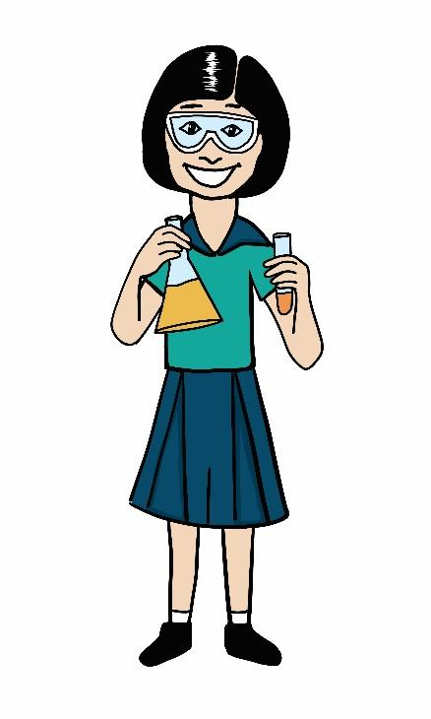
Finance:
- Auditors Report – Annual report (Copy available on website)
- SUE Reports
- Annual Budget and Monthly accounts
- Associated policies, guidelines and procedures (Schooldocs)
- 10 Year Cyclical Maintenance Plan
- Asset registers.

Health and safety:
- Evacuation procedures
- Associated policies, guidelines and procedures (Schooldocs)
- Accident and medical Register
- Compliance Schedules
- Diocesan property inspection reports
- Building Warrant of Fitness – completed by the Diocesan agents.

Human resources:
- Job descriptions/Appraisal Documents
- Personnel and Curriculum Guidelines (Schooldocs)
- Performance agreements/Employment contracts
- Administration handbook
- School Parent Information Booklet
- Accident and medical register
- Staff professional development plan.


Kahui Ako – Rotorua Faith based Community of Learning.
- Memorandum of Agreement
- Strategic Planning
Property:
- 10 year Cyclical Maintenance Plan
- School Insurance – Crombie Lockwood
- Associated Guidelines including Health and Safety Procedures (Schooldocs)
- Compliance Schedules
- Evacuation Procedures
- Emergency Management Plan
- Capital Works schedule- CISO

Special Character:
- Religious Education ‘Faith’ Curriculum
- Proprietor’s appointees’ annual report to the Bishop.
- Newsletters, Diocesan magazine.

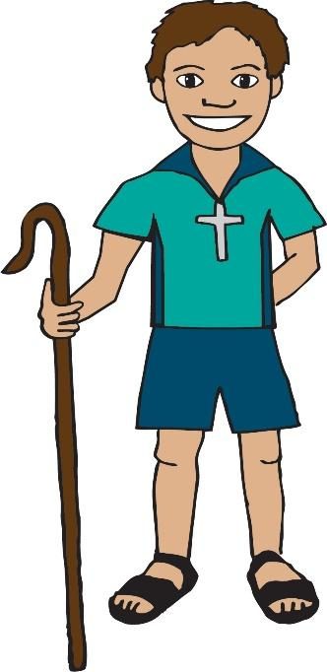
Christ has no body but yours, no hands, no feet on earth but yours.
Yours are the eyes with which he looks compassionately on this world.
Yours are the feet with which he walks to do good.
Yours are the hands, with which he blesses all the world.
Yours are the hands.
Yours are the feet.
Yours are the eyes.
You are his body.
Christ has no body now on earth but yours.
Amen.
St. Teresa of Avila

