World Vision term 1 newsletter

The World Vision group at Timaru Boys’ High School has gone from strength to strength since 2024. With such a successful 2025, the once small group of students is now being well led by the following boys: Oli Black, Harry Bradley, Liam Bridson, Zach Brookland, Ollie Burton, Archie Fenn, Thomas Crawford, Daniel Heffernan, Riley Horstmann, Heath Wheeler, Myles Wheeler and Toby Winter. The boys have been busy with their planning since December. Last year we raised a massive $7861 for people in the Solomon Islands. This year the boys have set a very ambitious goal of raising $10000 for the people of the Solomon Islands.

After our huge success last year, we were very fortunate to have Daniel Heffernan selected to attend the World Vision Leaders for Change summit in Auckland. This was a fantastic opportunity where he got to attend four days of global education learning about world injustice, how the Solomon Islands is being affected by global warming, how to lead our schools in New Zealand in World Vision as well as how to get our communities involved. Another incredible experience for Daniel was talking to real people experiencing first hand the poverty of the Solomon Islands as well as being able to learn from the youth ambassadors and many World Vision staff about how we can make a difference. It was a transformative experience that helped to give Daniel the essential knowledge, skills and tools needed to help lead the Timaru Boys’ High community with this year’s 40 Hour Challenge.
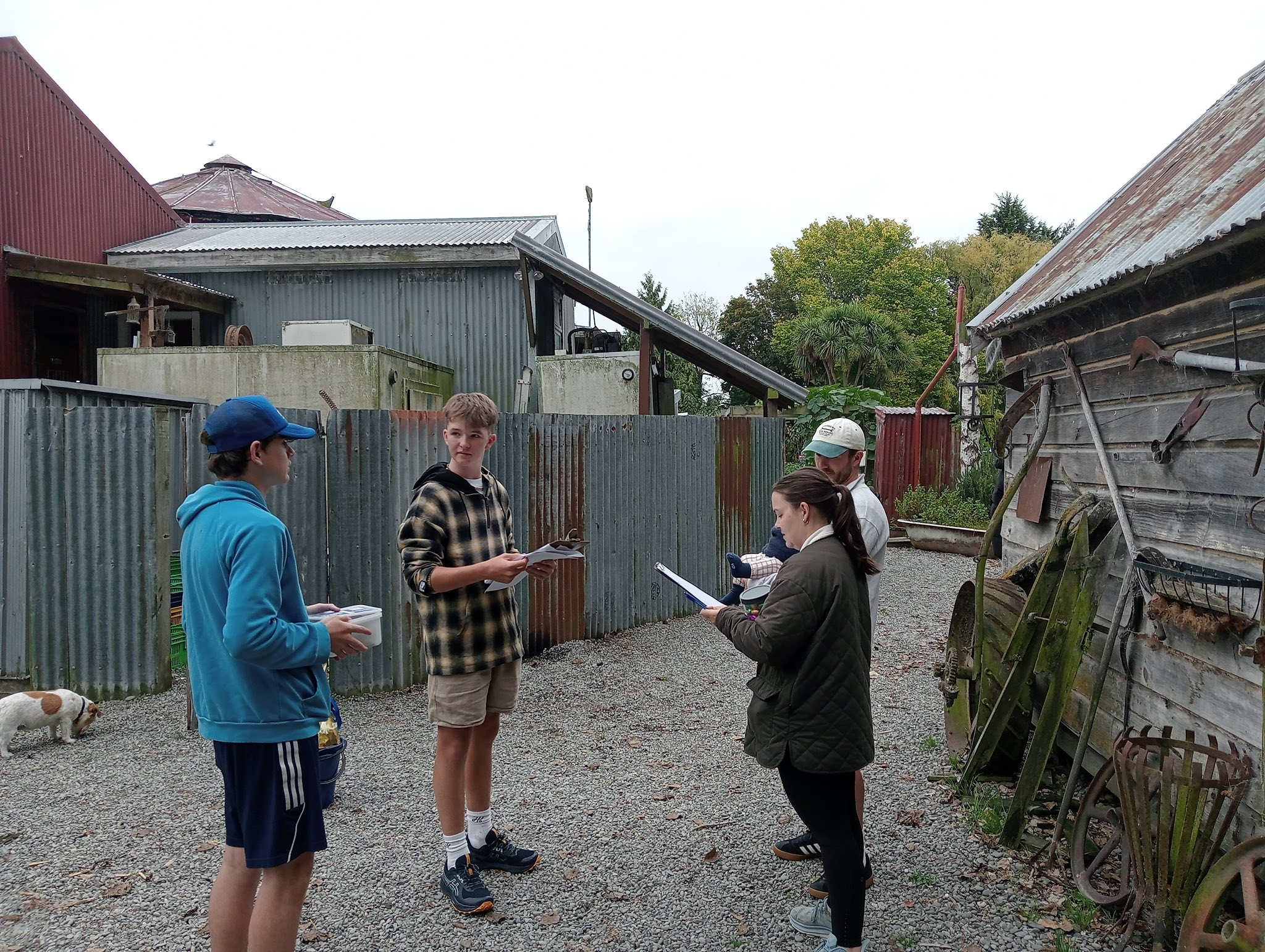

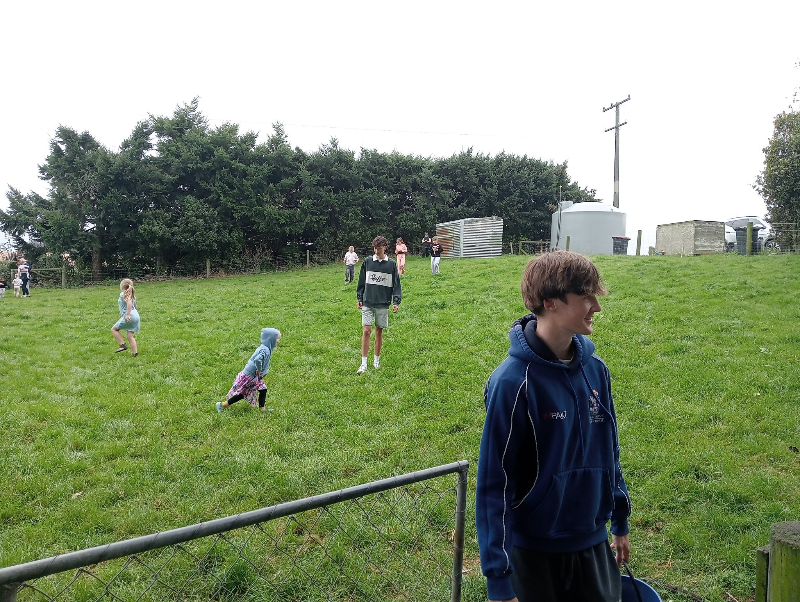
Our first fundraising event for the year was an Easter Egg Hunt out at the Shearers Quarters in Temuka on Sunday 29th March. This was well attended by members of the public and the boys managed to raise an amazing $508 from this event. It was a really enjoyable event by all and thanks must go to Liam Bridson, Myles Wheeler, Heath Wheeler, Daniel Heffernan, Archie Fenn and Oli Black for helping to run the event. These six boys represented us really well and reflect what we stand for and who we are at Timaru Boys’ High School. Special thanks must go to the Shearers Quarters, especially Carl Black, for organising and supporting the event.
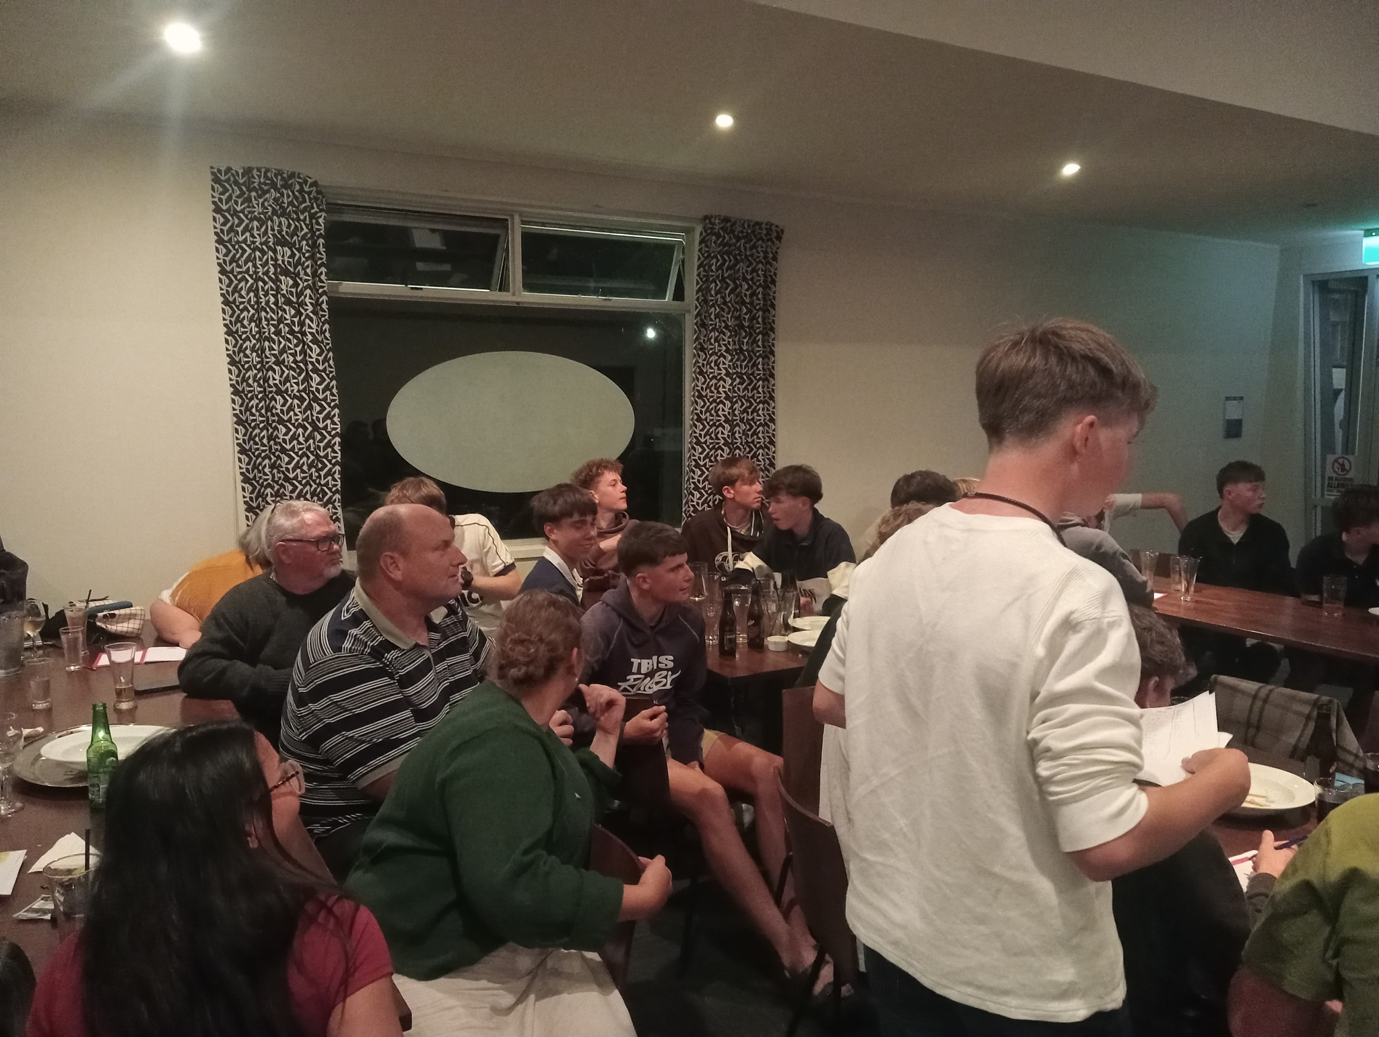
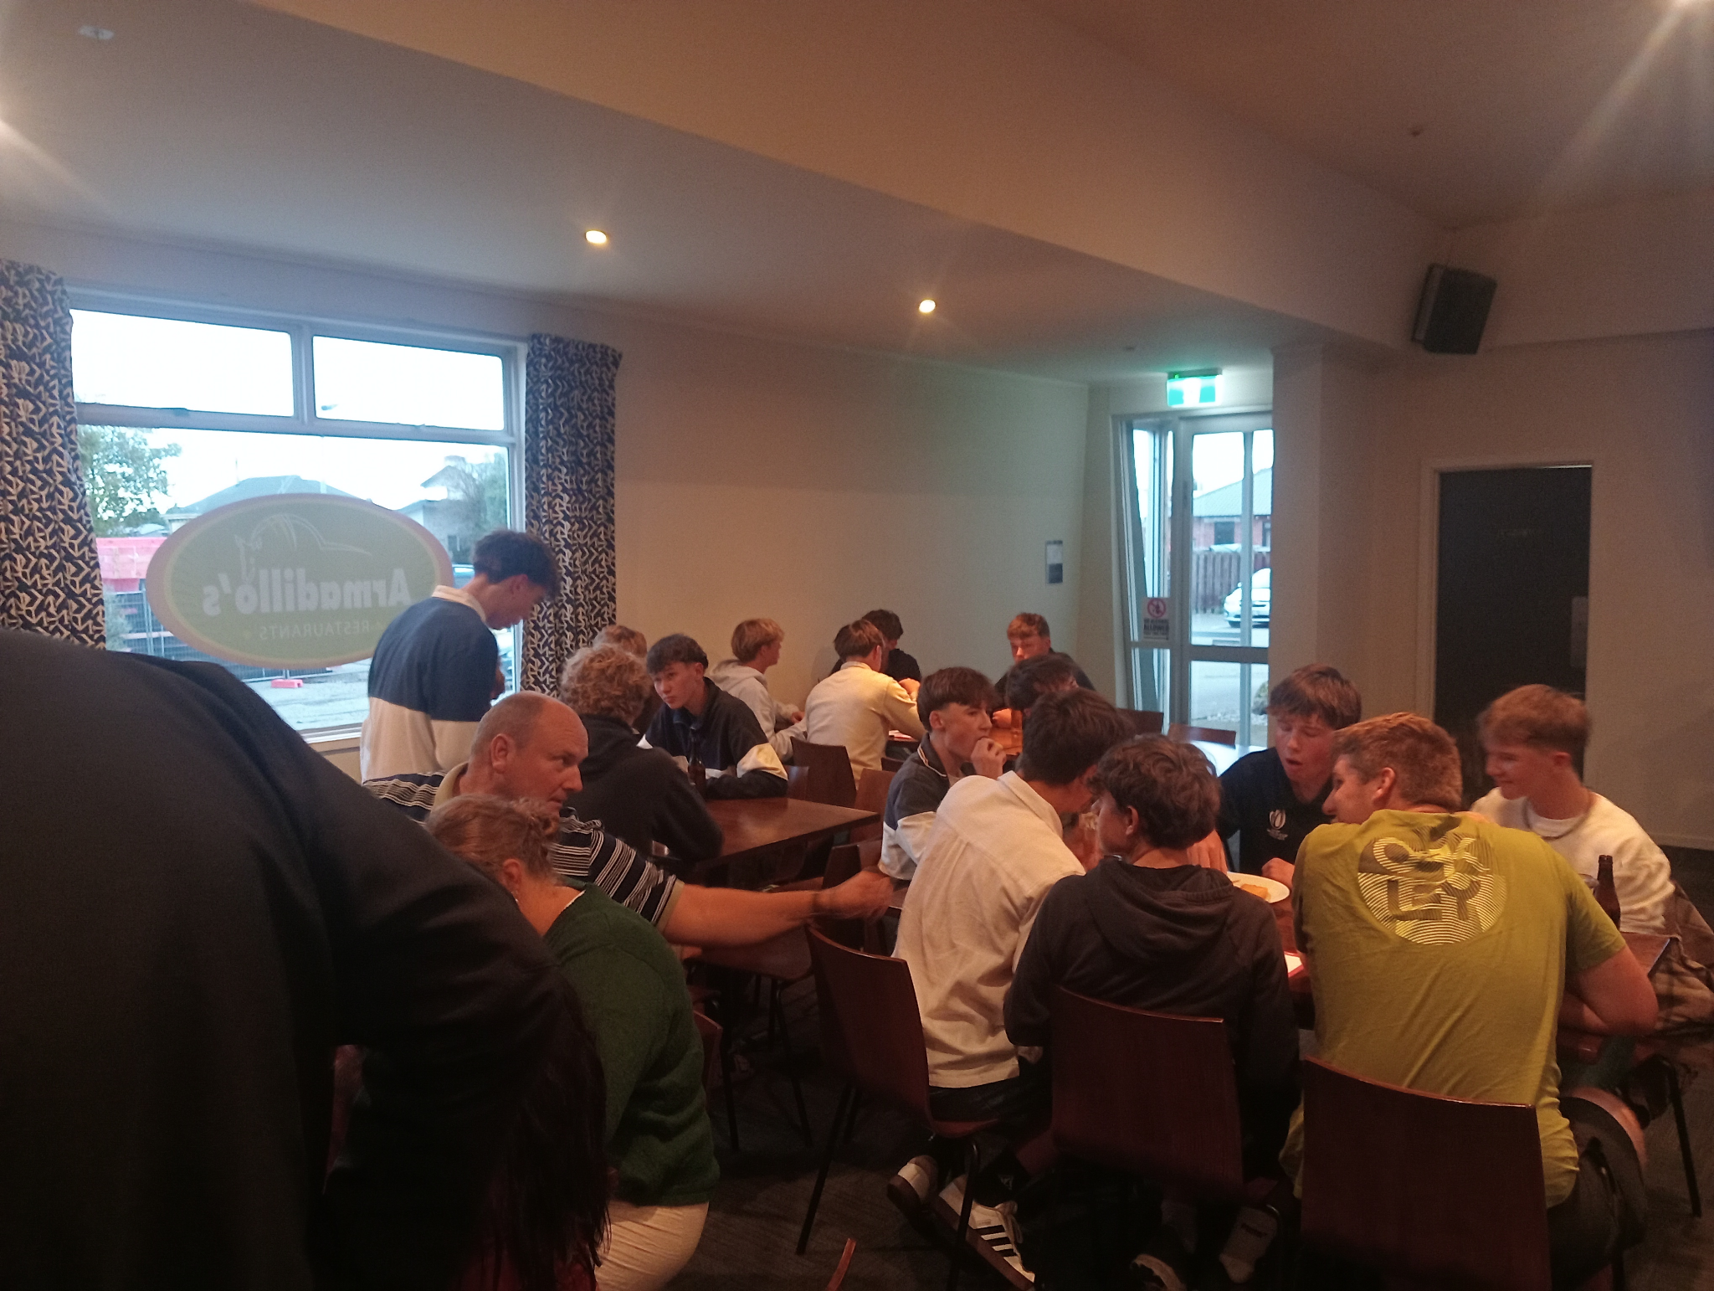

With such a successful start, our next fundraising event was our quiz night down at Richard Pearse on the 30th March. An amazing turnout of boys (especially year 12s) as well as a number of staff and even parents were in attendance. With 51 people present, the energy was high, the competition was fierce, and most importantly, it was all for a great cause. From this event, we managed to raise a huge total of $1168, which was $368 more than last year. This brings the boys near to $4000 prior to the challenge which is an incredible achievement.

We have more events lined up in term 2 such as the World Vision Conference in Christchurch, a junior social, a BBQ fundraiser, a mufti day fundraiser and the big event out of all of them: the 40 hour challenge from the 19th - 21st June. Well done to all the boys involved as they are really doing us proud as a Boys’ High community.

If you want to donate to this cause, you can at https://fundraise.worldvision.org.nz/fundraisers/timaruboyshighschool . Any contribution, no matter how big or how small, will make a huge difference in the lives of thousands.

