Referral Criteria Guidelines for lower GI investigations:

FIT for Symptomatic, Colonoscopy, Computed Tomography (CT) Colonography and CT Abdominopelvic

2026

Contents
1. Purpose 4
1.1 Patients not covered by these criteria: 4
1.2 Equity 4
1.3 Single point of entry 5
2. Key Definitions 5
2.1 Fitness for investigation 5
2.2 Clinical Frailty Scale 6
2.3 PR bleeding and benign anorectal causes 7
2.3.1 Conditions Not Classified as PR Bleeding 7
2.4 Symptom duration 8
2.5 FIT terminology and thresholds 8
2.5.1 Symptomatic FIT thresholds (ng/mL buffer) 9
3. Referring a Patient for Further Bowel Investigation 9
4. Assessment and Pre-Referral Requirements 10
4.1 Initial Clinical Assessment 10
4.2 Frailty and Fitness for Investigation 10
4.3 Pre-Referral Investigations 10
4.3.1 Routine tests before referral for FIT for symptomatic/colonoscopy/ CTC 10
5. FIT for Symptomatic 12
5.1 Entry Criteria 12
5.2 When to Bypass FIT Testing 13
5.3 Indications for FIT 13
5.3.1 FIT as a Triage Tool 13
5.3.2 FIT Sampling and Interpretation 13
5.3.3 FIT and Safety-Netting 14
5.4 FIT Results 14
5.5 PR Bleeding with a negative FIT result 15
5.6 Safety Netting with a negative FIT result 15
5.6.1 Minimum follow-up standard 15
5.6.2 If a patient represents, consider 15
5.6.3 Repeat testing rules 16
5.6.4 Not lost to follow-up process requirement 16
6. Choosing Between Colonoscopy, CT Colonography (CTC), CT A/P 16
7. Who NOT to Refer for Further Bowel Investigations (FIT, CTC, Colonoscopy) 17
8. Appendices 19
8.1 Medications that may influence FIT results or bowel symptoms 19
8.2 FIT for symptomatic, colonoscopy and CTC triage 20
8.3 8.3 Choosing Between Colonoscopy, CT Colonography (CTC) and CT Abdomen/Pelvis 28
8.4 PR Bleeding 29
9. Surveillance Notes 30
10. Family History of Colorectal Cancer 30
11. Personal History of Polyps 30
12. Comments for Services 31
13. References 31

Purpose
Te Whatu Ora | Health New Zealand should provide access to FIT for symptomatic, colonoscopy or computed tomography colonography (CTC) or CT abdominopelvic (CT A/P) for appropriate patients.
These criteria are designed to cover the indications for referral for bowel investigation (FIT for symptomatic, colonoscopy or CTC or CT A/P).
For patients falling outside these criteria, referrers should consider referral for a first specialist assessment (FSA) to gastroenterology, surgery, geriatrics, general medicine or radiology.

Patients not covered by these criteria:
- Patients with established inflammatory bowel disease requiring urgent colonoscopy for ongoing assessment, who would usually be managed as inpatients or under the care of a specialist.
- Inpatient or acute presentations (including Emergency Department or acute assessment unit presentations) managed via acute surgical or gastroenterology inpatient pathways.
- Asymptomatic patients who receive colonoscopy for surveillance or screening or have a recommendation from NZ familial gastrointestinal cancer service.
- Patients with a high probability of metastatic disease with unintended wight loss and several symptoms/signs or initial investigations best investigated with CT CAP or other diagnostics (ref national CRR criteria - CT CAP criteria)
- FIT tests which have been undertaken privately will not be accepted as these have not been validated by Te Whatu Ora | Health NZ. If the patient orders a private test, they are responsible for the outcome of the test and arranging a private colonoscopy if positive.

Equity
To ensure the new symptomatic FIT guidelines do not exacerbate existing inequities in bowel investigation access (FIT for symptomatic, colonoscopy, CTC or CT A/P), we must address critical issues highlighted by pilot data. This showed reduced return of kits by Māori and Pacific patients which was compounded by rurality (reduced lab/postal access) and rising travel costs. Variation in implementation of essential equity interventions in the pathway.
Failing to address these factors will inherently disadvantage at-risk populations—specifically Māori, Pacific, and rural patients (GCH classification 2 and above)—who face widening health disparities due to lower test return rates. As a result, this process would function as a negative equity initiative, worsening existing disparities.
Recommendations:
- Allocate dedicated funding to engage priority populations.
- Identify and mitigate barriers to test completion.
- Establish priority-population completion as a KPI, with accurate data monitoring of participation and quarterly reporting to a monitoring group (e.g., Local Endoscopy User Group, Clinical Leaders, and Service Managers).

Single point of entry
There should be one clear point of entry and triage for bowel investigation referrals so departments can work together and deliver the best outcomes for patients. Key working relationships and processes are vital between gastroenterology/general surgery and radiology.
Notes:
- Few symptoms in primary care practice have greater than 5 percent positive predictive value for colorectal cancer (CRC).
- Appropriate access for gastrointestinal (GI) investigation is highly ranked as a quality indicator.

Key Definitions

Fitness for investigation
Fitness encompasses the patient’s ability to complete bowel preparation, tolerate sedation/anaesthesia, and derive meaningful benefit from downstream treatment that aligns with goals of care. Life expectancy, clinical frailty, comorbidities and factors affecting investigation and safety should be considered.
Fitness for investigation incorporates frailty-modified investigation choice, whereby the type and urgency of investigation may be adjusted according to the patient’s Clinical Frailty Scale (CFS) for those over 65 years, balancing diagnostic benefit against procedural risk, burden, and likely downstream treatment.
It is intended that the frailty score will be used throughout the colorectal pathways from early diagnosis, treatment and surveillance in Aotearoa New Zealand.
Frailty does not determine eligibility for assessment alone, but may influence whether colonoscopy, CT colonography, alternative imaging, or conservative management is the most appropriate approach.

Clinical Frailty Scale
Frailty levels 1–9 with traffic-light interpretation are used to guide investigation choice and stopping rules for those over 65 years. This is a validated scale developed by Dalhousie University and provides an indication of how well a patient will cope with the preparation and procedure requirements for colonoscopy. If your patient falls into the 7-8 group referral to Geriatric and for the 9 group to Palliative care for advice or assessment is recommended.
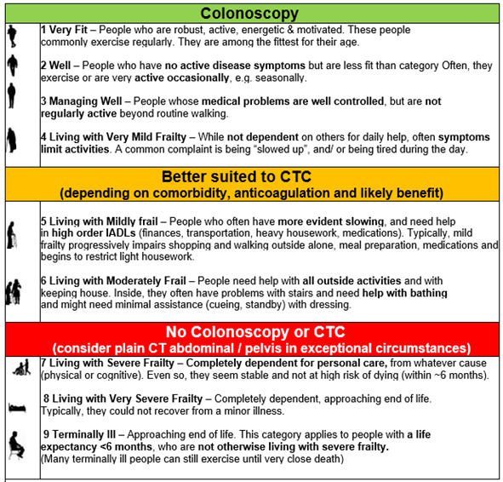

PR bleeding and benign anorectal causes
Refer to the PR bleed flowchart in section 11.4
Overt rectal bleeding does not exclude a patient from FIT testing. However, those with rectal bleeding where there are clear benign anal causes found on examination by the referring clinician with exclusion of concerning pathology, should be excluded from having a FIT unless bleeding persists despite treatment
PR bleeding refers to any visible blood passed from the anus/rectum, occurring:
- During a bowel motion
- After a bowel motion
- Independently of bowel motions
PR bleeding may be described by the patient as:
- Blood on toilet paper
- Blood coating the stool
- Blood dripping into the toilet bowl
- Blood mixed through the stool (bright red, maroon, or darker red)
- Passage of blood clots per rectum

Conditions Not Classified as PR Bleeding
The following do not meet the definition of PR bleeding:
- Melaena
- Black, tarry stools
  - Suggests an upper gastrointestinal source until proven otherwise

- Occult blood only
- No visible blood
  - Detected by FIT (Faecal Immunochemical Test)

    - Benign anorectal causes
Benign anorectal causes excluded should be applied as a minimum assessment standard, not as a requirement for absolute diagnostic certainty.
A focused anorectal assessment has been performed, at minimum:
- visual perianal inspection, and
- digital rectal examination (DRE) (if available anoscopy/proctoscopy).
If no benign anorectal condition is identified that adequately explains the bleeding, OR a benign anorectal condition is present but the bleeding is not fully explained by it (e.g., blood mixed in stool, persistent/recurrent bleeding), OR bleeding persists or recurs despite appropriate treatment of the suspected benign anorectal cause then the patient should be referred for a FIT for symptomatic test if appropriate.
Examples of “benign anorectal causes”:
- haemorrhoids (especially clearly “outlet-type” bleeding),
- anal fissure (typically painful bleeding)

Symptom duration
Altered bowel habit is generally defined as looser and/or more frequent stools for ≥6 weeks or recent onset constipation / difficulty going to the toilet or sense of incomplete evacuation not resolving with simple laxative use (within 6 weeks of referral).

FIT terminology and thresholds
- FIT (faecal immunochemical test) measuring faecal haemoglobin (f-Hb)
- FIT is quantitative; higher f-Hb indicates higher probability of CRC and other bleeding bowel pathology.
- In this guideline, results are reported as ng/mL buffer (see Units below).

Symptomatic FIT thresholds (ng/mL buffer)
- High positive FIT: >750 ng/mL buffer (~80% of CRC: number needed to scope ~3, FIT Result 6%)
  - Meaning: High f-Hb; identifies patients at high risk of colorectal cancer.
  - Default action: Urgent colonoscopy (or CTC if more appropriate).
- Low positive FIT: 50–750 ng/mL buffer (~1% of CRC: NNS ~30, FIT Result 14%)
  - Meaning: Elevated f-Hb; increased CRC risk, but not in the “high positive” band.
  - Default action: Non-urgent colonoscopy (or CTC if more appropriate).
- Negative FIT: <50 ng/mL buffer (<10% of CRC: NNS ~300, FIT Result 80%)
  - Meaning: Very low f-Hb; indicates very low risk of colorectal cancer.
  - Default action: No automatic colonoscopy/CTC solely to exclude CRC; manage according to likely diagnosis and safety-netting.

Referring a Patient for Further Bowel Investigation
When referring a patient for further investigation, the referrer should:
- inform the patient what these potential tests might be
- ensure they are willing to undergo further tests/ procedures
- consider the ability of the patient to tolerate both the bowel preparation and the procedures if appropriate
- consider whether the patient being referred will benefit if they are frail, have multiple co-morbidities or advanced malignancy (generally referral implies they are well enough to tolerate further treatment)
- be aware that adequacy of bowel preparation and patient or other factors can impact the quality of a colonoscopy so please re-refer a patient for bowel investigation if you are concerned (If the patient has had a colonoscopy or CT colonography in the preceding five years, the “miss” rate of lesions >1 cm following a well performed colonoscopy or CT colonography is approximately 6 percent). An endoscopist will ensure that there is a clear indication to repeat the procedure (and will consult a radiologist where needed).

Assessment and Pre-Referral Requirements

Initial Clinical Assessment
All patients must undergo:
- Full clinical history and examination, including:
- Medication or supplement changes affecting bowel habit Refer to appendix 1 for full list of medications
- Dietary changes
- Prior upper GI surgery (e.g. cholecystectomy)
- Appropriate abdominal and anorectal examination (where indicated)

Frailty and Fitness for Investigation
Frailty should be assessed using the Clinical Frailty Scale (CFS) for patients over 65 years. Definitions and assessment principles are detailed in Sections 2.1 & 2.2.

Pre-Referral Investigations
These investigations fall into a core set and symptom directed set. They are used to (a) avoid inappropriate colonoscopy/CTC where another diagnosis is more likely (e.g., infection, coeliac, pancreatic insufficiency), and (b) route patients to the correct pathway (suspected IBD vs suspected CRC vs functional issues)

Routine tests before referral for FIT for symptomatic/colonoscopy/ CTC
Core set:
- FBC (Hb, MCV, platelets)
- Ferritin if anaemia suspected/confirmed.
Note: If an urgent “do not wait for FIT” override applies (e.g. palpable mass, suspicious imaging, acute obstruction) do not delay referral for these tests. See Bypass FIT for more information.

Tests that should be symptom-directed (not blanket requirements)
Test | Orden When | Don’t use routinely | Action Note
Stool PCR | Acute diarrhoea, infectious features/exposures, high-risk host | Chronic IBS-like symptoms without infectious trigger | Should not delay urgent referral if red flags
Faecal Calprotectin | Suspected IBD / chronic diarrhoea; IBD vs IBS discrimination | Constipation predominant symptoms | Follow local lab algorithm.
Coeliac serology | Chronic diarrhoea/malabsorption; unexplained ID/IDA | Constipation-predominant symptoms | Follow local lab algorithm
Faecal elastase | Malabsorption suspected / pancreatic risk factors | Constipation-predominant symptoms | Use to redirect workup when positive
CRP (C-relative protein) | Inflammatory pathology is plausible (diarrhoea/ abdominal pain/ systemic symptoms)
Further information
Tests that should be symptom-directed (not blanket requirements)
- Stool PCR/ enteric pathogen testing – when appropriate
Order when infectious diarrhoea is plausible e.g.
- Acute diarrhoea (often <14 days), fever, severe illness/ dehydration
- Travel/ outbreak exposure, foodborne cluster, childcare exposure
- Immunocompromised/ high risk host
- Recent antibiotics/ healthcare exposure (incl. C. difficile per local approach)

- Faecal calprotectin (FC) – when appropriate
- Diarrhoea-predominant symptoms ≥ ~6 weeks or recurrent
- No clear infectious trigger
- IBD features (nocturnal symptoms, urgency, mucus, systemic symptoms)
- Exclude factors that will falsely elevate FC e.g. NSAID
FC is not routinely indicated for constipation-predominant presentations or as a blanket add on to all accepted CRC referrals, it is most useful when IBD is being considered

If FC is borderline/ indeterminate 50-150mcg repeat FC once after 4 weeks before referral, after addressing confounders (recent infection, NSAIDS, ± PPI use per local policy)
- Coeliac serology – order when:
  - Chronic diarrhoea/ bloating/ malabsorption is possible, and or:
  - Unexplained iron deficiency (IDA) where coeliac disease is plausible

- Faecal elastase – only if malabsorption suspected
  - Order faecal elastase when pancreatic exocrine insufficiency is plausible (e.g. steatorrhoea/ bulky oily stools, marked weight loss, pancreatic disease history, pancreatic surgery, high clinical suspicion).
  - Do not require faecal elastase as routine pre-colonoscopy test

FIT for Symptomatic
Refer to appendix 2 for triage pathway including FIT for Symptomatic.
Entry into the FIT pathway assumes that the Assessment and Pre-Referral Requirements outlined in Section 4 have been completed, including clinical assessment, frailty/fitness review, and consideration of pre-referral investigations.

Entry Criteria
This pathway applies to adults presenting with lower gastrointestinal symptoms, including but not limited to:
- PR bleeding (as defined in Section 2.3)
- Change in bowel habit
- Unexplained weight loss in conjunction with one of the above symptoms
- Abdominal pain in conjunction with one of the above symptoms
- Suspected colorectal pathology
- Post appendicitis >50 yrs
- CT proven complicated diverticulitis disease
- Unexplained iron deficiency anaemia (IDA)

When to Bypass FIT Testing
Refer for urgent colonoscopy or CTC or clinical assessment as clinically appropriate when any of the following apply:
A. Known or high radiological suspicion of colorectal cancer
- Known CRC, or
- Imaging already reports a lesion suspicious for CRC (e.g., colorectal mass/stricture suspicious for malignancy).
B. Suspicious lesion on examination
- Palpable rectal mass on DRE, or visible suspicious rectal/anal lesion on inspection/proctoscopy.
C. Acute/unstable presentation (refer directly for surgical assessment)
- Suspected large bowel obstruction, perforation, severe sepsis, or another acute surgical/ED scenario (not suitable for FIT-based triage).

Indications for FIT
FIT is the default test for access to lower GI investigation and should be used to inform triage/priority in most symptomatic presentations. Currently it is accessed through secondary care but will be moving into the primary care setting.
FIT may be requested in patients who:
- Would be considered fit for further investigation if FIT is positive, and
- Have ongoing lower gastrointestinal symptoms where FIT-supported triage is appropriate.
- Have had a negative FIT through the National Bowel Screening Programme but have bowel symptoms as listed above.
- Young adults (<40 years)

FIT as a Triage Tool
- FIT is used to inform urgency and prioritisation of investigation.
- FIT is a screening tool and must not be used as a stand-alone rule-out test.
- Clinical judgement overrides FIT results where concern for significant pathology remains.

FIT Sampling and Interpretation
- FIT should be collected and processed according to laboratory protocols.
- FIT terminology, units, and thresholds used in this guideline are defined in Section 2.5.
- Interpretation of FIT results and downstream actions are described in section 5.4

FIT and Safety-Netting
- A negative FIT reduces but does not eliminate colon cancer risk completely. The diagnostic accuracy: comparable to international studies at 91% sensitivity and 83% specificity and negative predictive value = 99.6 %
- All patients undergoing FIT-based triage require safety-netting see Section 5.6

FIT Results
Interpretation of FIT results should be read in conjunction with the FIT terminology and threshold definitions in Section 2.5, which sets out the criteria for high positive, low positive, and negative FIT results. Responsibility for the interpretation and follow-up of FIT results rests with the clinician who ordered the test.
Refer to the Lower GI Investigations pathway appendix 8.2
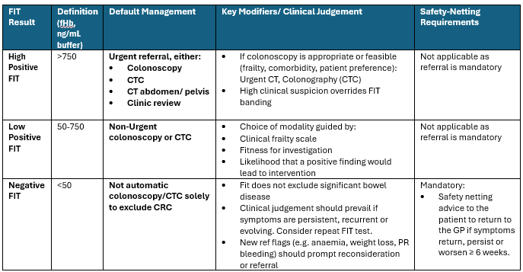

PR Bleeding with a negative FIT result
Refer to section 2.3 for guidance on the management of PR Bleeding within the FIT Triage Pathway
- FIT may be used in patients with PR bleeding only if:
  - Benign anorectal causes have been appropriately assessed and excluded and
  - There are no urgent referral features
- Patients should be treated for PR bleeding with conservative management
- If persistent or recurrent outlet-type bleeding with suspected benign anorectal disease should be considered for PR Bleed Clinic/ surgical outpatient referral, rather than FIT-based triage or if a FIT is negative with PR bleeding.

Safety Netting with a negative FIT result
Safety-netting advice to the patient is mandatory to avoid missed CRC or other significant pathology and to ensure timely re-entry to investigation if symptoms persist or evolve and should be provided by the person who orders the FIT for Symptomatic test.

Minimum follow-up standard
If the patient is not accepted for further bowel investigations (or is deferred/discharged back to primary care):
- The patient will be encouraged to return to their GP or primary care, if their symptoms return, persist or worsen for more than 6 weeks.

If a patient represents, consider
- Weight (objective measurement where possible)
- FBC (haemoglobin ± indices/platelets)
- Ferritin/iron studies where IDA is suspected or previously present
- Reassess medication/exposures (e.g., NSAIDs) and comorbidity/frailty (if this affects modality choice)
- Persistent watery diarrhoea: try eliminating causes and treating. Consider microscopic colitis (elimination and treatment e.g. medication changes, coeliac, FODMAPS, infections, trailing loperamide). If symptoms are persistent >6 weeks despite elimination and first line treatment (loperamide) refer to secondary care for review.
Information should be provided to the patient to return urgently if any of the following occur:
- Worsening symptoms or failure to improve as expected
- New or recurrent rectal bleeding
- Escalating abdominal pain with obstructive symptoms
- New red flags (e.g., weight loss, anaemia symptoms, palpable mass)

Repeat testing rules
- In those with an initially negative/low FIT, repeat FIT can be considered if concerning symptoms persist, recur, or evolve after 6 weeks. A positive second FIT should trigger reprioritisation. Any further FIT within 12 months is unlikely to provide benefit.
- Repeat borderline/marginal faecal calprotectin once before referral where FC is used for suspected IBD/diarrhoea pathways (See section 4)

Not lost to follow-up process requirement
- If the patient cannot be contacted or repeatedly DNAs and symptoms are ongoing, escalate per local policy (clinical review, MDT discussion, re-referral as appropriate). If a high priority population (Māori, Pacific, Dep 8-10 or an identified disability) local established pathways should be used to reach patients.
All patients managed without investigation should receive:
- Clear advice on symptoms that should prompt re-presentation
- Explicit instruction that symptom persistence or progression warrants reassessment regardless of prior FIT result.

Choosing Between Colonoscopy, CT Colonography (CTC), CT A/P
Refer to appendix 8.3 for flowchart
Colonoscopy
- Therapeutic or diagnostic intervention may be required (high likelihood of polypectomy/biopsy/haemostasis), or direct mucosal treatment planning is needed.
- Consider colonoscopy if CTC shows polyps 10-20mm for patients <80 years old and >20mm for all patients based on frailty and fitness to tolerate colonoscopy and surgery. For patients with larger polyps and non-obstructing tumours with severe frailty consider referral for advice for surgery and or geriatrics.

CTC
- Colonoscopy risk is high (e.g., frailty score >5 or significant comorbidity / anaesthetic risk), or colonoscopy is contraindicated/unfeasible.
- Consider CTC or CT A/P in older age with positive FIT, where the balance of benefit/harms favours a less invasive test (≥80 year olds and/or those with a frailty score 5-6 with positive FIT), particularly if endoscopic therapy is unlikely to be pursued even if pathology is found.
- Although a patient may be fit for colonoscopy, if they are on anticoagulation or DAPT that carries risks if stopped immediately, a CTC may be useful to look at the colon to assess if and when a colonoscopy should be performed.
CT A/P
- Consider CT A/P or a CT CAP before targeted colonic investigation when:
  - Significant constitutional/systemic features (e.g., marked weight loss, systemic illness) suggest broader pathology beyond the colon (intra-abdominal malignancy, inflammatory, vascular, hepatobiliary, pancreatic, etc.).
  - There is a palpable abdominal mass.
  - There is a possible obstruction/acute abdomen picture, where acute CT is the correct first-line investigation (then proceed to colonoscopy/CTC depending on findings/fitness).
  - Document explicitly if the CT is being ordered for symptom assessment and colon obstruction rather than “CRC exclusion”.

Who NOT to Refer for Further Bowel Investigations (FIT, CTC, Colonoscopy)
Not accepted
- Irritable bowel syndrome (may require specialist assessment)
- Constipation as a single symptom
- Abdominal pain without any other clinical symptoms
- Decreased ferritin aged <50 years with normal haemoglobin
- FOBT
- Post appendicitis <50yrs and those >50yrs who have a CT A/P able to clear the colon of malignancy
- CT-proven diverticulitis without suspicious radiological features

Frailty score is used to decide fitness for bowel preparation, insufflation, positional changes, sedation/rescue intervention, and whether findings would realistically lead to treatment.
Frailty Score 7-9 (Severely Frail and Terminally ill)
- Do not refer for colonoscopy or CTC.
- Consider referral or discussion with Geriatrics or Palliative care.
- Consider CT A/P for symptom assessment only (e.g., obstruction, perforation, abscess, other urgent alternative diagnoses), only if the result would change management (including palliative management). Manage with goals-of-care discussion, symptom control, and safety-netting.
- Escalation only by exception: If there is a specific, realistic downstream intervention the patient would accept and tolerate, discuss case-by-case with gastro/colorectal + radiology.
Frailty Score 5-6 (Mild-moderately frail)
- CTC is the preferred investigation unless there is a documented strong rationale for colonoscopy (e.g., high likelihood of needing endoscopic therapy and patient is fit enough to undergo it).
- Colonoscopy requires explicit documentation of:
  - ability to complete prep,
  - procedural tolerance (incl. sedation risk),
  - and that a positive finding would lead to intervention.
If CTC is not feasible (e.g., unable to tolerate bowel prep/insufflation), revert to CT for symptom assessment only (not a “CRC rule-out test”).

Appendices

Medications that may influence FIT results or bowel symptoms
These medications will not prevent a patient from receiving a FIT, rather they are noted to indicate that they may potentially be a cause of bowel changes. Some supplements such as magnesium also can cause significant urgent diarrhoea.
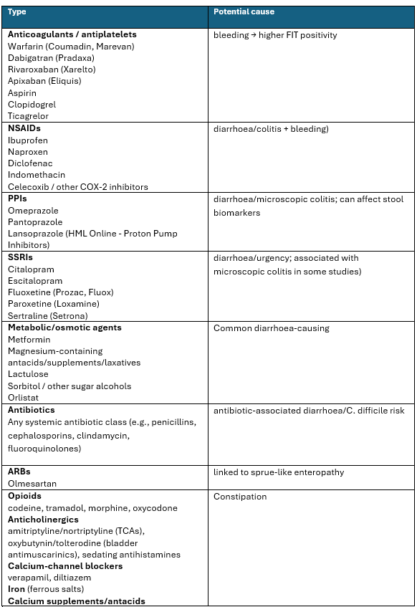
Refer to Health Pathways for the full list

FIT for symptomatic, colonoscopy and CTC triage
Open the pathway and hover over the appropriate option, hold down Ctrl +click at each decision point to proceed to the next step. For optimal viewing, set View → One Page.
Lower GI Investigation Pathway

Colonoscopy preferred when:
FIT is high positive and the patient is suitable for colonoscopy (e.g., FIT >750 ng/mL buffer → urgent colonoscopy per your pathway terminology).
Therapeutic intervention may be required (high likelihood of polypectomy/haemostasis) or direct mucosal treatment planning is needed.
Rectal bleeding where direct mucosal assessment is needed and patient is fit for colonoscopy.
Persistent diarrhoea where mucosal disease is suspected, especially persistent watery diarrhoea where biopsies may be required (e.g., to assess for microscopic colitis)
CTC and CT preferred when:
*Colonoscopy risk is high (CFS 5-6) or significant comorbidity/anaesthetic risk), or colonoscopy is contraindicated/unfeasible.
Older age with positive FIT, where the balance of benefit/harms favours a less invasive test (“many ≥80-year-olds with positive FIT”), particularly if endoscopic therapy is unlikely to be pursued even if pathology is found.
Service/capacity constraints make CTC the appropriate alternative investigation within the FIT triage pathway (as modelled/used in NZ service pathways).
Do not use CTC if the main clinical question requires biopsy (e.g., suspected microscopic colitis) or immediate therapy.

Symptom-directed - (should not delay cancer suspected referrals):
- Stool PCR (acute diarrhoea/infectious features)
- Faecal calprotectin (suspected IBD / chronic diarrhoea; repeat once if borderline)
- Coeliac serology (chronic diarrhoea/malabsorption or unexplained ID/IDA)
- Faecal elastase (malabsorption/pancreatic risk)
- CRP if inflammatory pathology plausible (or routine if your service standardises)
- Check no dietary changes, new medications/ supplements or prior GI surgery
Symptomatic adult - needing access to FIT for symptomatic, Colonoscopy or CTC

Order/Confirm pre-referral tests
FBC (Hb/MCV/platelets)
Ferritin if anaemia suspected/confirmed

Assess clinical frailty score (CFS)

CFS 7-9
CFS 1-4
&
<80yrs

CFS 5-6
or
>80yrs

Click the appropriate CFS scale above

Clinical Frailty Scale 1-4 and <80 years
Does the patient have known or radiologically
suspected colorectal cancer

Suspicious lesion on examination

*refer to Bypass guideline

Yes
No

Proceed to FIT Pathway
Click here
Or
No
Acute/ unstable presentation?
Urgent access to Colonoscopy

Yes
Refer directly for urgent surgical assessment

Click to return to start
FIT Results (CFS 1-4 & <80years)

FIT High Positive
>750

FIT Low Positive
50-750

>750
Negative FIT

No automatic colonoscopy

Manage likely diagnosis as appropriate & mandatory safety netting – click here

Urgent Colonoscopy
within 2 weeks
Non - Urgent Colonoscopy
within 6 weeks

Click to return to start
Clinical Frailty Scale 5-6 and >80 years

Does the patient have known or radiologically
suspected colorectal cancer

Suspicious lesion on examination

*refer to Bypass guideline

No
Yes

Or
Acute/ unstable presentation?
Urgent access to CTC
Proceed to FIT Pathway
Click here
No

Yes
Refer directly for urgent surgical assessment

Click to return to start
FIT Results Clinical Frailty Scale 5-6 and >80 years

FIT High Positive
>750

Urgent access to CTC
FIT Low Positive
50-750

>750
Negative FIT
Non - Urgent CTC

No automatic CTC solely to exclude CRC

Manage likely diagnosis as appropriate & mandatory safety netting – click here

If CTC shows polyps or cancer click here

Click to return to start
Clinical Frailty Scale 7-9

No Colonoscopy
Consider CT Abdominal/Pelvis for symptom assessment only if it would change management
Safety netting / goal of care – click here
Consider referral to geriatrics/ palliative care management for advice

Click to return to start
CTC Shows Polyps or Cancer

CTC Shows Cancer
CTC Shows polyps

<10mm no colonoscopy
10-20mm for patients <80 consider colonoscopy
>20mm consider colonoscopy for all patients, if appropriate
*Staging, MDM and then surgery

Click to return to start
Mandatory Safety Netting
- A negative FIT reduces but does not eliminate colon cancer risk completely. The diagnostic accuracy: comparable to international studies. at 91% sensitivity and 83% specificity and negative predictive value
= 99.6 %
- All patients undergoing FIT-based triage require safety-netting

Safety Netting with a Negative FIT result

Safety-netting advice to the patient is mandatory to avoid missed CRC or other significant pathology and to ensure timely re-entry to investigation if symptoms persist or evolve and should be provided by the person who orders the FIT for Symptomatic test.

Minimum follow-up standard
If the patient is not accepted for further bowel investigations (or is deferred/discharged back to primary care):

The patient will be encouraged to return to their GP or primary care, if their symptoms return, persist or worsen for more than 6 weeks.

If a patient represents, consider
- Weight (objective measurement where possible)
- FBC (haemoglobin ± indices/platelets)
- Ferritin/iron studies where IDA is suspected or previously present
- Reassess medication/exposures (e.g., NSAIDs) and comorbidity/frailty (if this affects modality choice)
- Persistent watery diarrhoea: try eliminating causes and treating. Consider microscopic colitis (elimination and treatment e.g. medication changes, coeliac, FODMAPS, infections, trailing loperamide). If symptoms are persistent >6 weeks despite elimination and first line treatment (loperamide) refer to secondary care for review.

Information should be provided to the patient to return urgently if any of the following occur:

- Worsening symptoms or failure to improve as expected
- New or recurrent rectal bleeding
- Escalating abdominal pain with obstructive symptoms
- New red flags (e.g., weight loss, anaemia symptoms, palpable mass)

Repeat Testing Rules
- In those with an initially negative/low FIT, repeat FIT can be considered if concerning symptoms persist, recur, or evolve after 6 weeks. A positive second FIT should trigger reprioritisation. Any further FIT within 12 months is unlikely to provide benefit.
- Repeat borderline/marginal faecal calprotectin once before referral where FC is used for suspected IBD/diarrhoea pathways

Not lost to follow-up process requirement
If the patient cannot be contacted or repeatedly DNAs and symptoms are ongoing, escalate per local policy (clinical review, MDT discussion, re-referral as appropriate). If a high priority population (Māori, Pacific, Dep 8-10 or an identified disability) local established pathways should be used to reach patients.

All patients managed without investigation should receive:
- Clear advice on symptoms that should prompt re-presentation
- Explicit instruction that symptom persistence or progression warrants reassessment regardless of prior FIT result.

Click to return to start

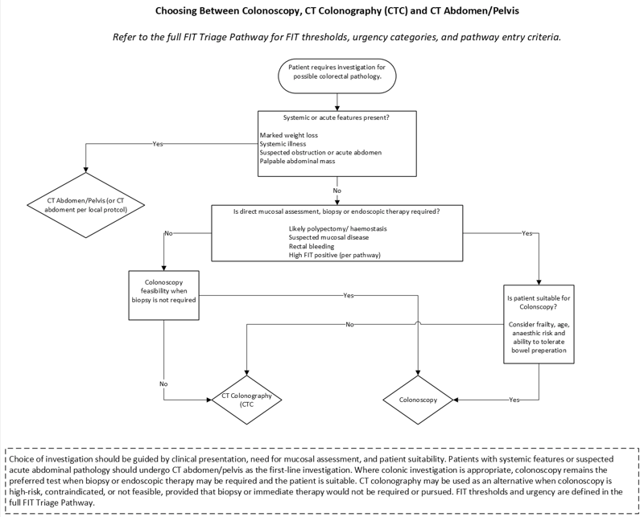
8.3 Choosing Between Colonoscopy, CT Colonography (CTC) and CT Abdomen/Pelvis

PR Bleeding

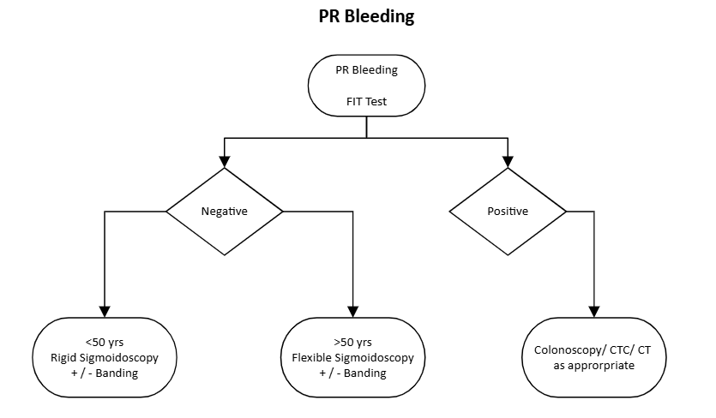

Surveillance Notes
(Refer to below guidelines)
Updated Surveillance Recommendations for Individuals with a Family/Whānau History of Colorectal Cancer (2023)
Updated Polyp Surveillance Guidelines (2024)
Updated Inflammatory Bowel Disease Surveillance (2025)

Family History of Colorectal Cancer
Refer to the Update on Surveillance Recommendations for Individuals with a Family History of Colorectal Cancer in section 9

Personal History of Polyps
Refer to the Update on polyp surveillance guidelines 2020 NBSP edits 2024 in section 9.

Comments for Services
- The indication of iron deficiency anaemia requires a haemoglobin level below the local reference range in association with a low ferritin level.
- Menstruation is the commonest cause of iron deficiency anaemia in women – for women aged less than 55 years a menstrual history should be obtained prior to referral. Coeliac disease and urinary loss should also be excluded.
- Patients who meet the ‘two-week category’ at referral are considered to have high suspicion of cancer and are included in the 62-day Faster Cancer Treatment measure.
- All patients with a confirmed cancer diagnosis, including incidental diagnosis or as a result of a ‘six-week category’ investigation, are included in the 31-day Faster Cancer Treatment measure.
- Initially, prioritisation within the routine category referrals may still occur at a service level.
- Patients with atypical presentations outside these criteria may require colonoscopy, CTC, CT A/P or CT CAP usually following specialist referral.
- Patients requiring urgent colonoscopy for suspicion or assessment of inflammatory bowel disease would usually be inpatients or under the care of a specialist.
- Few symptoms in primary care practice have a greater than 5 percent positive predictive value for colorectal cancer (CRC).

References
- Archer S, Ball C, Scott M, et al. 2021. Two-stage triage of suspected colorectal cancer using faecal immunochemical testing, CT and clinical features. Frontline Gastroenterology 12:476–484.
- Astin M, Griffin T, Neal RD, et al. 2011. The diagnostic value of symptoms for colorectal cancer in primary care: a systematic review. British Journal of General Practice 61(586): e231–43.
- Bailey SER, Abel GA, Atkins A, Byford R, Davies SJ, Mays J, et al. Diagnostic performance of a faecal immunochemical test for patients with low-risk symptoms of colorectal cancer in primary care: an evaluation in the South West of England. Br J Cancer. 2021;124(7):1231–6.sed in consensus statement
- Bissett I & Saw KS, Triage Optimisation in Patients with Symptoms Suspicious of Colorectal Cancer sighted in M. Evans et al. (eds.), Coloproctology Springer (2024)

- Burgess N, Hourigan, L, Zanatu et al. (2017). Risk Stratification for Covert Invasive Cancer Among Patients Referred for Colonic Endoscopic Mucosal Resection: A Large Multicenter Cohort. Gastroenterology. Sep;153(3):732-742.e1. PMID: 28583826 DOI: 10.1053/j.gastro.2017.05.047
- D’Souza N, Delisle TG, Chen M, et al. 2020. Faecal immunochemical testing in symptomatic patients to prioritize investigations: results from the NICE FIT study. Gut 69:1601–1611.
- D’Souza N, Abulafi M, et al. 2020. Faecal immunochemical test is superior to symptoms in predicting pathology in patients with suspected colorectal cancer symptoms referred on a 2-week-wait pathway: a diagnostic accuracy study. Gut 69:1510–1518.
- Falvey J, Whiteley L, Bissett IP, et al. 2024. Faecal immunochemical test (FIT)-based prioritisation of new patient symptomatic cases referred for colorectal investigation. New Zealand Medical Journal 137:45–58.
- Falvey J, Whiteley L, Levin S, et al. 2023. Incorporating faecal haemoglobin measurement using the faecal immunochemical test (FIT) in the referral, triage and prioritisation pathway for patients with colorectal symptoms. New Zealand Medical Journal 136(1587).
- Goddard AF, James MW, McIntyre AS, et al. 2011. Guidelines for the management of iron deficiency anaemia. Gut 60(10): 01309-16. Epub 11 May 2011.
- Hunt R, Gerrard C, Abulafi M, et al. 2022. Duplicate quantitative faecal immunochemical testing to improve sensitivity for colorectal cancer in symptomatic patients. BMJ Open 12:e056603.
- John RA, Falvey JD, Bissett IP, et al. 2022. Improving early detection of colorectal cancer in Aotearoa New Zealand: how do the direct access criteria perform? New Zealand Medical Journal 135(1557).
- Johnstone MS, MacLeod C, Digby J, et el. (2022). Prevalence of repeat faecal immunochemical testing in symptomatic patients attending primary care. Colorectal Dis. Dec;24(12):1498-1504. doi: 10.1111/codi.16240. Epub 2022 Jul 18. PMID: 35776684; PMCID: PMC10084108
- Johnstone MS, McSorley ST, Steele RJC, et al. 2021. Combining faecal immunochemical testing with full blood count reliably rules out colorectal cancer in a symptomatic patient referral pathway. International Journal of Colorectal Disease 36:1927–1936.
- Maeda Y, Din S, St John A, et al. 2021. Quantitative faecal immunochemical testing and CT to triage urgent colorectal referrals: decision-tree modelling study. BJS Open 5(1):zraa048.
- Miller J, Din S, Clark D, et al. 2021. Service evaluation of a COVID-adapted colorectal cancer diagnostic pathway using quantitative faecal immunochemical testing and CT. BMJ Open Quality 10:e001234.
- Monahan KJ, Bradshaw N, Dolwani S, et al. 2022. Faecal immunochemical testing in patients with signs or symptoms of suspected colorectal cancer: a joint guideline from the ACPGBI and BSG. Gut 71:1939–1962.
- Monahan KJ, Davies MM, Abulafi M, et al. 2022. Faecal immunochemical testing (FIT) in patients with signs or symptoms of suspected colorectal cancer (CRC): a joint guideline from the Association of Coloproctology of Great Britain and Ireland (ACPGBI) and the British Society of Gastroenterology (BSG). Gut 71:1939–1962.
- Mowat C, Digby J, Strachan JA, et al. 2020. Faecal haemoglobin concentration thresholds for reassurance and urgent investigation of colorectal cancer based on a faecal immunochemical test in symptomatic patients. Annals of Clinical Biochemistry 57(4):316–325.
- Mowat C, Steele RJ, Strachan JA, et al. 2015. Faecal haemoglobin and faecal calprotectin as indicators of bowel disease in patients presenting to primary care with bowel symptoms. Gut 64:132–139.
- New Zealand Guidelines Group, Ministry of Health. 2009. Suspected Cancer in Primary Care: Guidelines for investigation, referral and reducing ethnic disparities.
- New Zealand Guidelines Group. 2012. New Zealand 2012 Guidelines: Guidance on surveillance for people at increased risk of colorectal cancer.
- Pin-Vieito N, Zarraquiños S, Cubiella J, et al. 2021. Faecal immunochemical tests safely enhance rational use of resources during assessment of suspected symptomatic colorectal cancer in primary care: systematic review and meta-analysis. Gut 70:1750–1757.
- Rockwood K, Theou O. Using the Clinical Frailty Scale in Allocating Scarce Health Care Resources. Can Geriatr J. 2020 Sep 1;23(3):210-215. doi: 10.5770/cgj.23.463. PMID: 32904824; PMCID: PMC7458601.
- Saw KS, Bissett IP, Parry S, et al. 2025. Faecal immunochemical test to triage patients with possible colorectal cancer symptoms: insights from the New Zealand FIT for Symptomatic Pilot. Frontiers in Gastroenterology.
- Saw KS, Bissett IP, Parry S, et al. 2025. Faecal immunochemical test to triage patients with possible colorectal cancer symptoms: insights from the New Zealand FIT for Symptomatic Pilot. Frontiers in Gastroenterology 4:1622258. doi:10.3389/fgstr.2025.1622258.
- Saw KS, Liu C, Xu W, Varghese C, Parry S, Bissett I. Faecal immunochemical test to triage patients with possible colorectal cancer symptoms: meta-analysis. Br J Surg. 2022 Feb 1;109(2):182-190. doi: 10.1093/bjs/znab411. Erratum in: Br J Surg. 2022 Jun 14;109(7):644. doi: 10.1093/bjs/znac073. PMID: 34907419; PMCID: PMC10364725.
- Tolley J, Williams JG, James M, et al. 2021. A novel triage pathway incorporating faecal immunochemical testing and CT imaging for urgent suspected colorectal cancer referrals. British Journal of Surgery 108:110–117.
- Turvill J, Aghahoseini A, Sivarajasingham N, et al. 2021. Faecal immunochemical testing for suspected colorectal cancer in primary care: diagnostic accuracy and pathways. British Journal of General Practice 71(704):e123–e130.
- Widlak MM, Neal MD, Daulton E, et al. 2017. Diagnostic accuracy of faecal biomarkers in detecting colorectal cancer and adenoma in symptomatic patients. Alimentary Pharmacology & Therapeutics 45:354–366.

NZ familial gastrointestinal cancer service https://www.healthnz.govt.nz/hospitals-services/services-support/new-zealand-familial-gastrointestinal-cancer-service
Monahan KJ, Davies MM, Abulafi M, et al. Faecal immunochemical testing (FIT) in patients with signs or symptoms of suspected colorectal cancer (CRC): a joint guideline from the Association of Coloproctology of Great Britain and Ireland and the British Society of Gastroenterology. Gut. 2022. doi:10.1136/gutjnl-2022-32798
Rockwood K, Theou O. Using the Clinical Frailty Scale in Allocating Scarce Health Care Resources. Can Geriatr J. 2020 Sep 1;23(3):210-215. doi: 10.5770/cgj.23.463. PMID: 32904824; PMCID: PMC7458601.
Link to be inserted to HealthPathways for haemorrhoids and anal fissure.
Link to HealthPathways to be provided.
Standards for Individuals Performing National Bowel Screening Colonoscopy in New Zealand 2021
Johnstone MS, MacLeod C, Digby J, Al-Azzawi Y, Pang G, Watson AJM, Strachan J, Mowat C, McSorley ST. Prevalence of repeat faecal immunochemical testing in symptomatic patients attending primary care. Colorectal Dis. 2022 Dec;24(12):1498-1504. doi: 10.1111/codi.16240. Epub 2022 Jul 18. PMID: 35776684; PMCID: PMC10084108.

