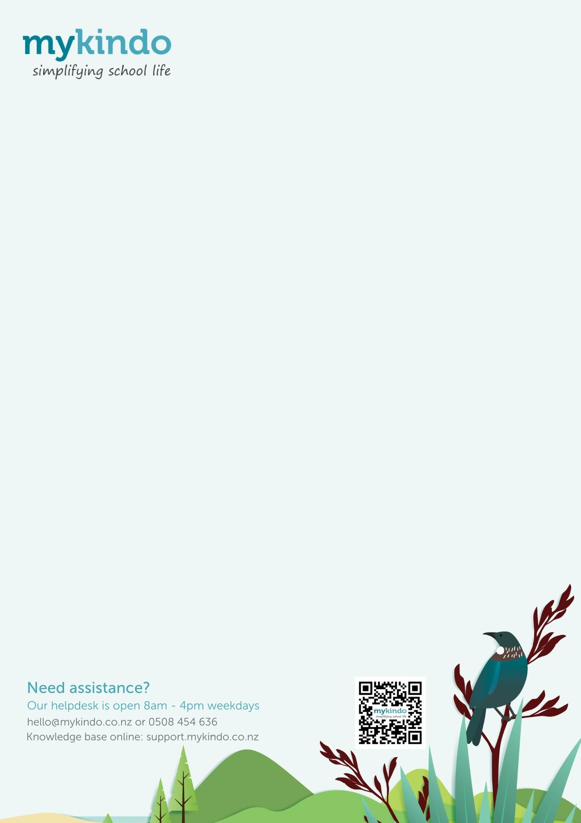
Getting started with myKindo

This is now our preferred method of payment, and we encourage all our families to sign up!
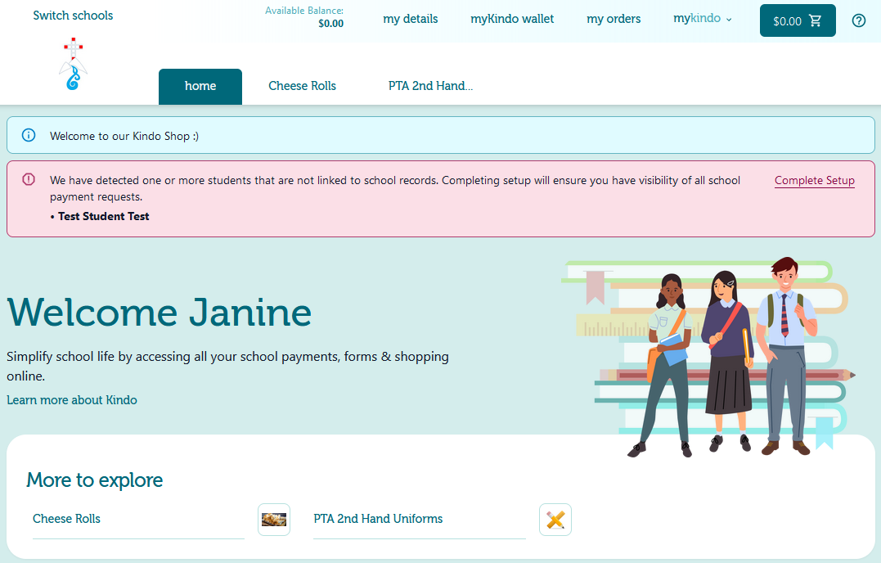
Simply enter in the same email address your school has on file.

New to myKindo? Use the QR Code below or go to https://shop.tgcl.co.nz to set up your myKindo account.

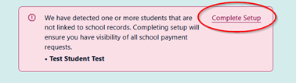
Already have an ezlunch or myKindo account? Use the QR Code below or go to https://shop.tgcl.co.nz.
Go to the ‘my details’ page to update your information and your child(ren)’s details.
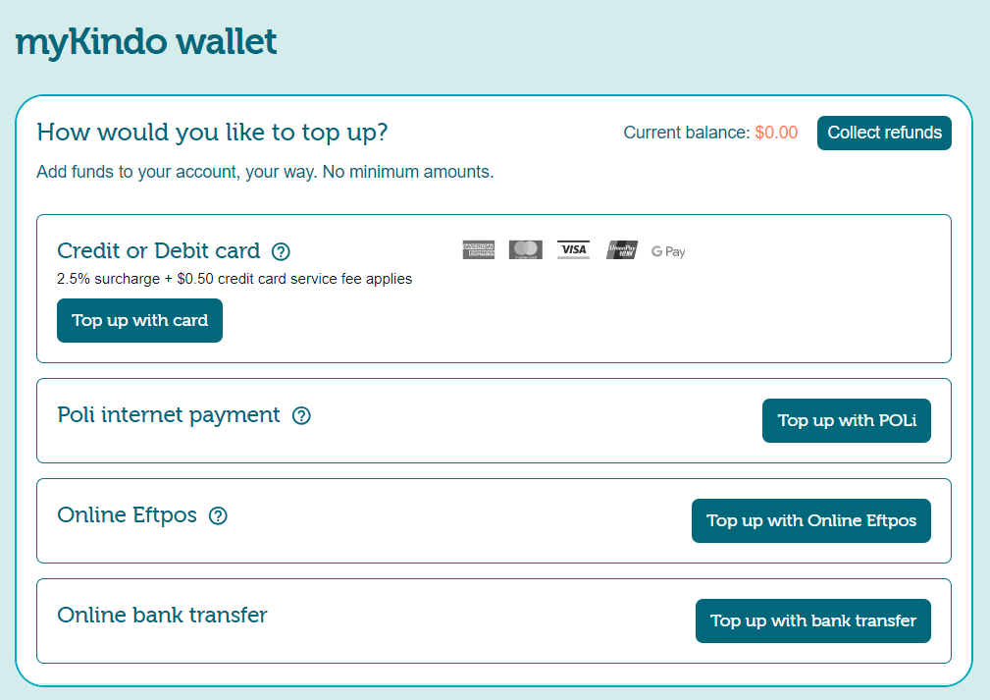
Choose complete setup (if needed) to access your personalised account.

PAYMENT
There are a range of methods you can choose to top up your account, and this can be done at the checkout, or by selecting the ‘myKindo wallet’ at any time.

SHOPPING

Personalised payment can be paid in full by clicking ‘add to cart’ or make a part payment by changing the amount in the white box (if available) before clicking ‘add to cart’.

Choose your shop item/s and add them to your cart. Some items will need you to select a student’s name. Once you have made all your purchases, click on your Cart then go to Checkout. Review your cart, top up your account if needed, and then simply click Complete Order and you’re done!

Your order will automatically go through to the school, and you will receive an
email receipt confirming your top up and/or purchase(s)!

