The Oamaru Multisport Club presents:
Fun Walk-Run / Duathlon Series – November 2024

Fun walk/run: 2.5km (1 lap), 5km (2 laps),10km (4 laps)
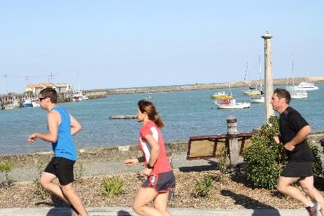


Duathlon:
Off the Couch: 2km Walk-Run / 4km (1 lap) Bike / 0.5km Walk-Run
Weekend Warriors: 2km Run / 12km (3 laps) Bike / 2.5km Run
(all distances are approximate)
Dates: Wednesdays – 13, 20, 27 November 2024
Time: 6.00pm (Registration 5.30pm; Briefing 5.45pm)
Venue: Oamaru Harbour Playground, Friendly Bay.
Entry Fee: Adults: $10 per event or $20 for series; Students: $5 per event or $10 for series
Enter: www.sporty.co.nz/oamarumultisportclub or on the day
Contact: Adair Craik 021-309-439 / Diane Talanoa 021-08150688


ENTRY FORM – Events: FUN WALK/RUN or DUATHLON
Wednesday Nov 13th 2024 @ 6pm Wednesday Nov 20th 2024 @ 6pm
Wednesday Nov 27th 2024 @ 6pm

Venue: Friendly Bay, Oamaru Harbour *Note that the start, transitions, and finish are all at the harbour
Registration is at Oamaru Harbour at 5.30pm. You may enter online, OR post this form to Diane Talanoa (4 Stoke St, Oamaru)) OR enter on the day (no late fee).
Race briefings will be held at the harbour 5:45 pm. Start time 6pm. Prize Giving will be held after the final event on Wednesday 27th November 2024
Enter online: www.sporty.co.nz/oamarumultisportclub
For further information please contact: Adair Craik 021-309-439 or Diane Talanoa 021 08150688 oamarumultisportclub@gmail.com

ENTER ONLINE or here with ENTRY FORM - Entry Fee: Adults $10 per event or $20 for the series; Students $5 per event or $10 for the series. TEAMS: per person fee also applies to each team member.

Please tick Fun Walk/Run 1 lap (2.5km), or 2 laps (5 km), or 4 laps (10km)

Duathlon – Off the Couch (2k/4k/0.5k)

Duathlon – Weekend Warriors (2k/12k/2.5k)

Date/s: Nov 13th Nov 20th Nov 27th

TEAM ENTRY (duathlon only): INDIVIDUAL ENTRY (fun run and duathlon):

Team Name:………………………………. Name:……………………………….

Contact Person:……………………………. Address: …………………………………...

Address: …………………………………... Phone:……………………………………...

Phone:……………………………………... Email:……………………………………...

Email:……………………………………... Category: Open Vet (40+)
Secondary school Primary school
Names:
Cyclist:…………………………………….. Students only: Age: ……………………………

Runner/s:……………………………………. School: ………………………..

Email:……………………………………
RULES OF ENTRY
All competitors enter solely at their OWN RISK. The ORGANISERS WILL NOT BE LIABLE for any loss or damage to competitor’s equipment. The DUATHLON event may consist of individuals or teams.
Competitors who WITHDRAW from any event must NOTIFY THE RACE DIRECTOR as soon as possible.
Race Marshals reserve the right to withdraw a competitor if they believe the competitor’s health is at risk.
Equipment must meet safety standards and be in good working order. Running shoes must be worn on the run.
All roads are open to the public. The road traffic rules apply to all competitors throughout the event.
WAIVER:
I, my next of kin, or any other representative, hereby release and discharge the event organisers, their agents, directors, volunteers, employees, sponsors and any other party associated with the event of any liability, financial or otherwise, which may arise, whether by negligence, from any direct or indirect loss, injury, or death which may be sustained by me, or any other party associated with me, for my intended or actual participation in the event or its related activities.
Signed: ……………………………………Signed: ……………………………………Signed: …………………………………

