
Knox Church Children’s Choir
Does your child like to sing?
We welcome children from year 2 to year 9. The Knox
Church Children’s Choir is the longest continuous running
children’s choir in Dunedin and has a history of
supporting young musicians to develop their talents. Knox
welcomes people of all faiths as well as those of no faith.
What do we do?
Junior choristers rehearse on Wednesdays from 5pm to
6.30. They sing in church on the third Sunday morning
each month, as well as special services such as weddings,
Easter and Christmas.
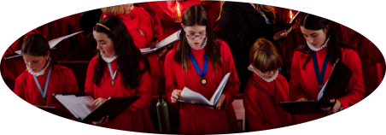
Activities include voice training, learning choir music, music theory, and exploring the church.
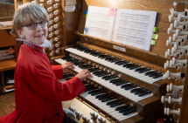
The choristers work on
internationally recognised education
programme, Voice for Life to earn
badges and ribbons. Some choristers
sit Trinity College London grade
examinations, with many achieving
outstanding results. Choristers can
also apply to learn the organ.
Choristers enjoy movie and pizza
activity days in the holidays.
Who runs the programme?
Sara Brown, MA, PGCE, MusB (Hons), ATCL, Examiner for Trinity College London. Sara is a music educator with extensive experience working with children and choirs.
Karen Knudson QSM, MA, MusB (Hons), LTCL, Organist and director of the Knox Church Choir. Karen has a wealth of experience in choral music and has worked with many young choirs in Dunedin.
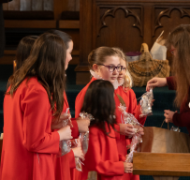
When and where?
Wednesdays from 5 pm to 6.30 pm.
The Gathering Area
Knox Church
449 George Street
Dunedin
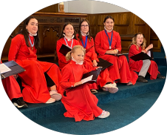
What to bring?
A water bottle and warm,
comfortable clothes your child can
move about in.
How much does it cost?
This music education programme is
provided free of charge.
Sign up at: https://tinyurl.com/Knox-Junior-Choir-2026
Or email Sara: kelpiebrown@gmail.com if you have any questions.

