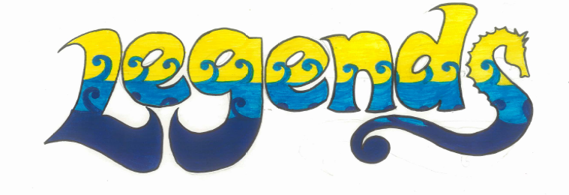
South New Brighton School
Stationery List 2019 Year 5/6
ITEMS | Looks Like | Number Required
Workbook 1B5 | 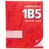 | 3
40 Pocket Clear File  Previous years one may be used if still in good condition  104140 | 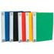 | 1
My literacy book- office Max | 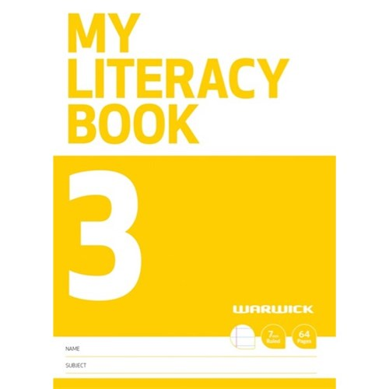 | 1
School Pad 9B5 | 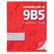 | 1
My maths book - officeMax | 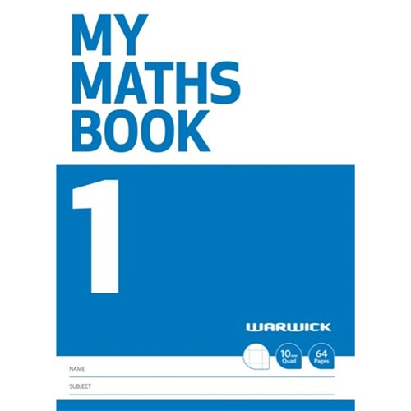 | 1
Clever Kiwi Activities Book | 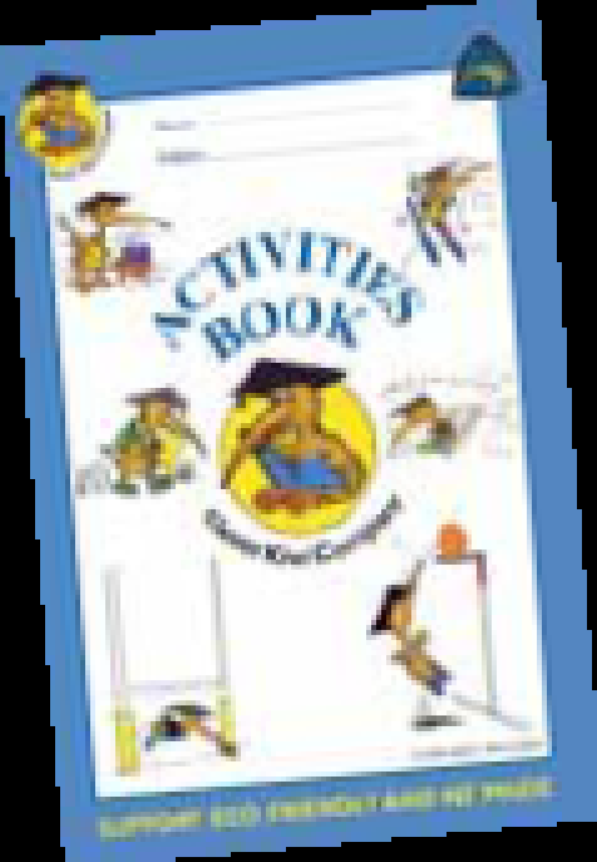 | 1
AMOS Glue Sticks  Large – hard white glue, not liquid  Previous years one may be used if still in good condition | 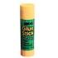 | 3
Colouring Pencils and Felt pens  Previous years one may be used if still in good condition | 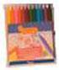 | 1 small packet of each
Ruler Non Bendable Non metallic 30cm  Previous years one may be used if still in good condition | 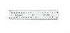 | 1
HB Pencils  Previous years one may be used if still in good condition | 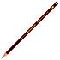 | 4
Blue or Black Biros BIC pens are fine  Previous years one may be used if still in good condition | 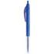 | 2
Highlighters 4 colour pack  Previous years one may be used if still in good condition | 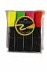 | 1
Pencil Case  Previous years one may be used if still in good condition | 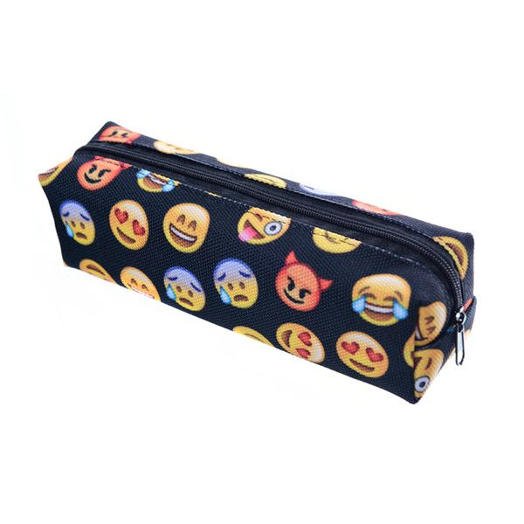 | 1
Rubber  Previous years one may be used if still in good condition | 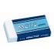 | 2
Ear phones  Previous years one may be used if still in good condition | 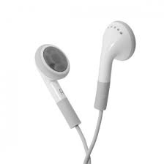 | 1
Whiteboard Markers  1 pack of black or blue. | 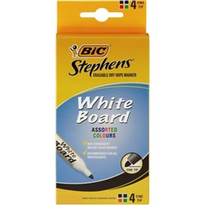 | 1
Black Vivid Markers | 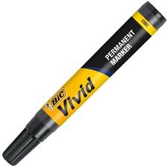 | 2
Please when you are buying the items make sure they are of good quality, then they will not need to be replaced as often!
Please remember:

- Swimming togs, towel and bags must be named
- Please also label school clothing, lunch boxes and drink bottles
- All children must have a named drink bottle

Thank you for helping your child to be prepared and ready to start school on Day 1.

