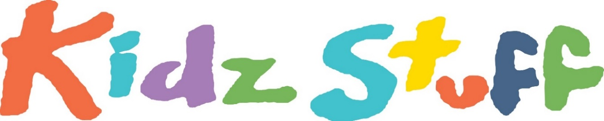

Theatre for Children Inc

**The Producers of *‘Badjelly The Witch* present:**

**“Jessica BoPeep!”**

**Written by Amalia Calder**

**Directed By Shannon Friday**

**When: 7th July – 20h July 2018.**

**Monday - Friday 10am & 11:30am**

**10am shows only on Saturdays!**

Throw on your woolly jumpers these school holidays and join KidzStuff for an adventure of discovery.

Jessica has not only lost her sheep, but whilst out trying to find them, she has now lost herself too.

How can she protect her sheep? Will anybody help her? Do you remember the way home? And who is that strange kid with the tail?

Bo Peep is full of fun characters, silly songs, valuable life lessons and did we mention a talking dog?

So, polish your hooves and clippity clop all the way to the Tararua Tramping Club to help

***Jessica Bo Peep -*** find her sheep

**Tickets $10.50 pp**, **Children under 2 Free**

**$7 Special Opening Preview, Saturday 7th July 2018!**

**Bookings:  www.eventspronto.co.nz/KidzStuff**

Contact: Amalia Calder

027 271 7351 / [kidzstuffnz@gmail.com](mailto:kidzstuffnz@gmail.com)

Media Release: For Immediate Release