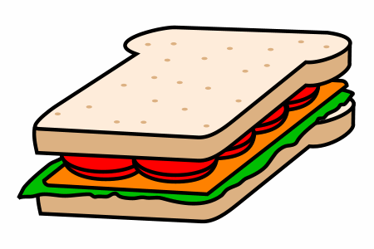
This Photo by Unknown Author is licensed under CC BY-SA
Tuck Shop Menu
Fresh rolls and sandwiches $3.50
Rice Balls $3.00
Rice Paper Rolls $4.00
Mince and Vegetable pie $2.50
Hash Brown $1.00
Lasagne Topper $3.00
Pizza $2.00
Chicken Burger $4.00
Sticky Rib Roll $4.00
Noodles $2.50
Hot Dog $2.50
Fruit Smoothie $3.50
Juicie $1.50


A selection of snacks, fruit and drinks is also available daily.

