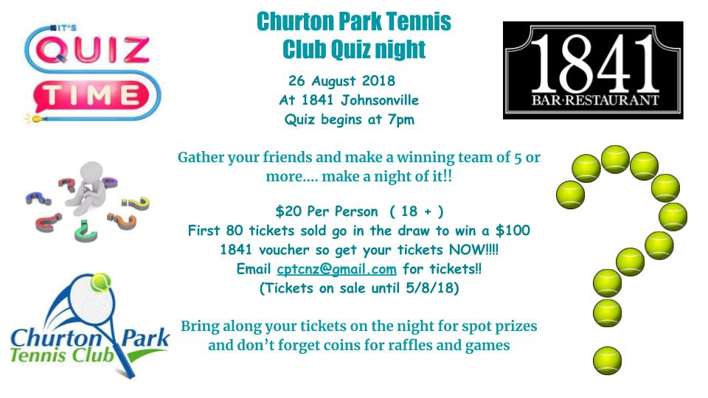

Share Link below with friends for first 80 tickets sold to go into draw.

[CPTC Quiz Fundraiser Ticket Purchase Link](https://form.jotform.co/81682909856877)

--

Kind Regards

Jeff Reid

**CPTC President**<http://www.churtonparktennis.co.nz/>