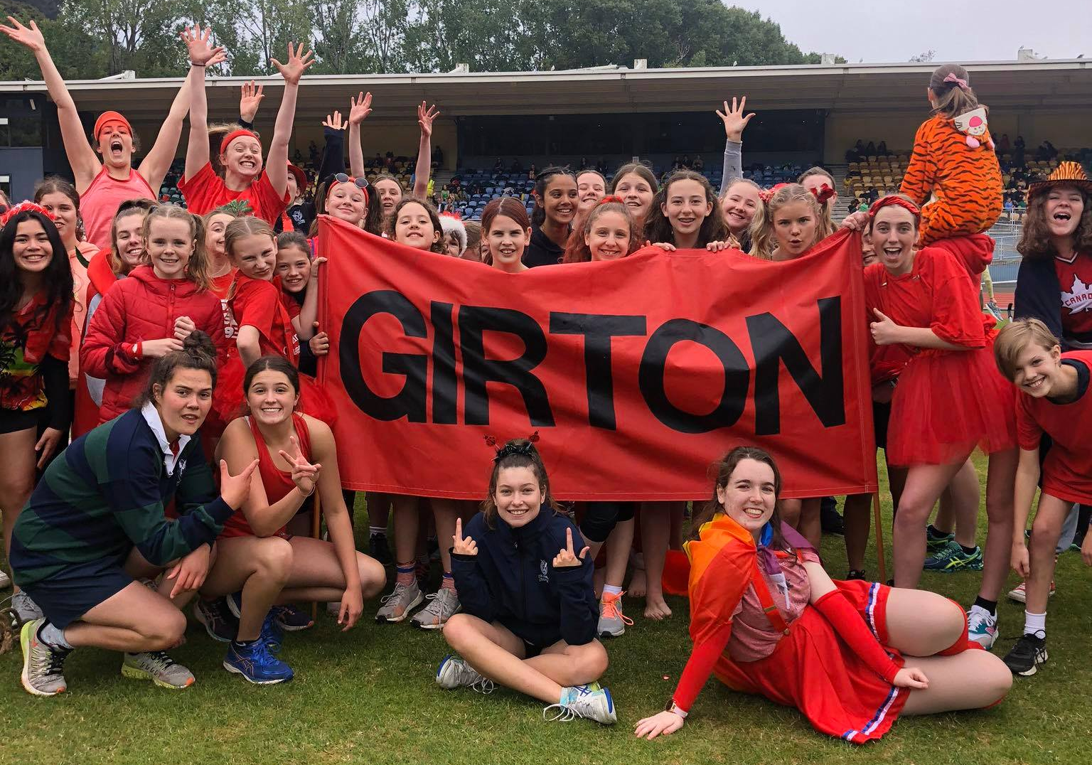
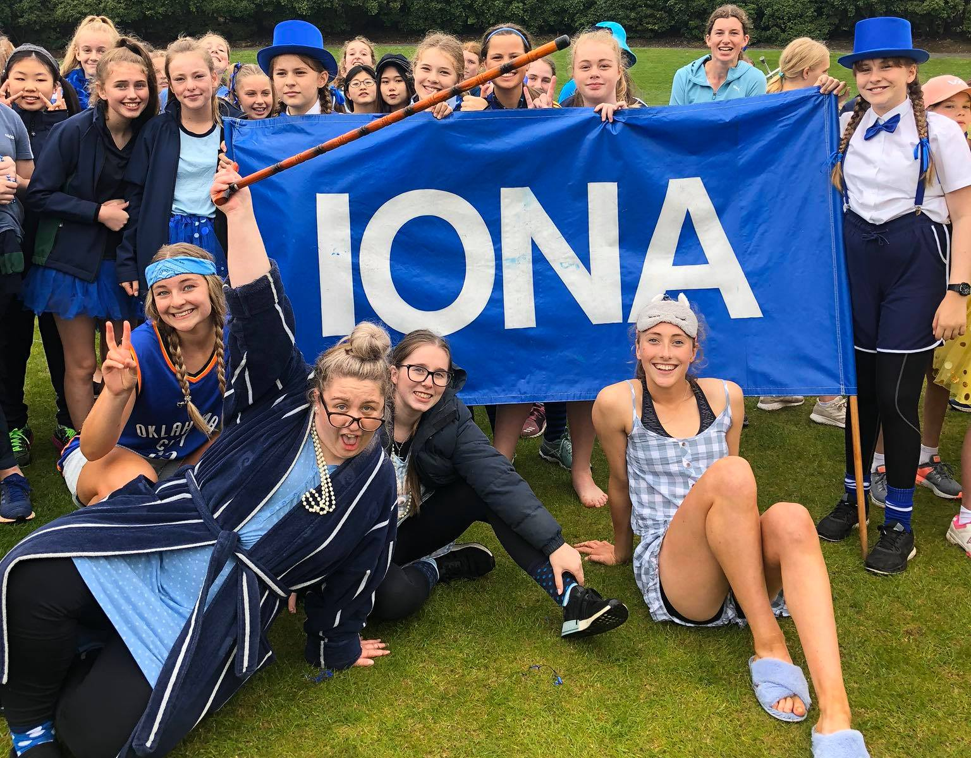
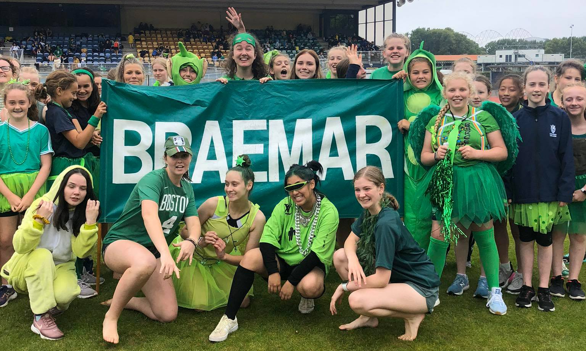
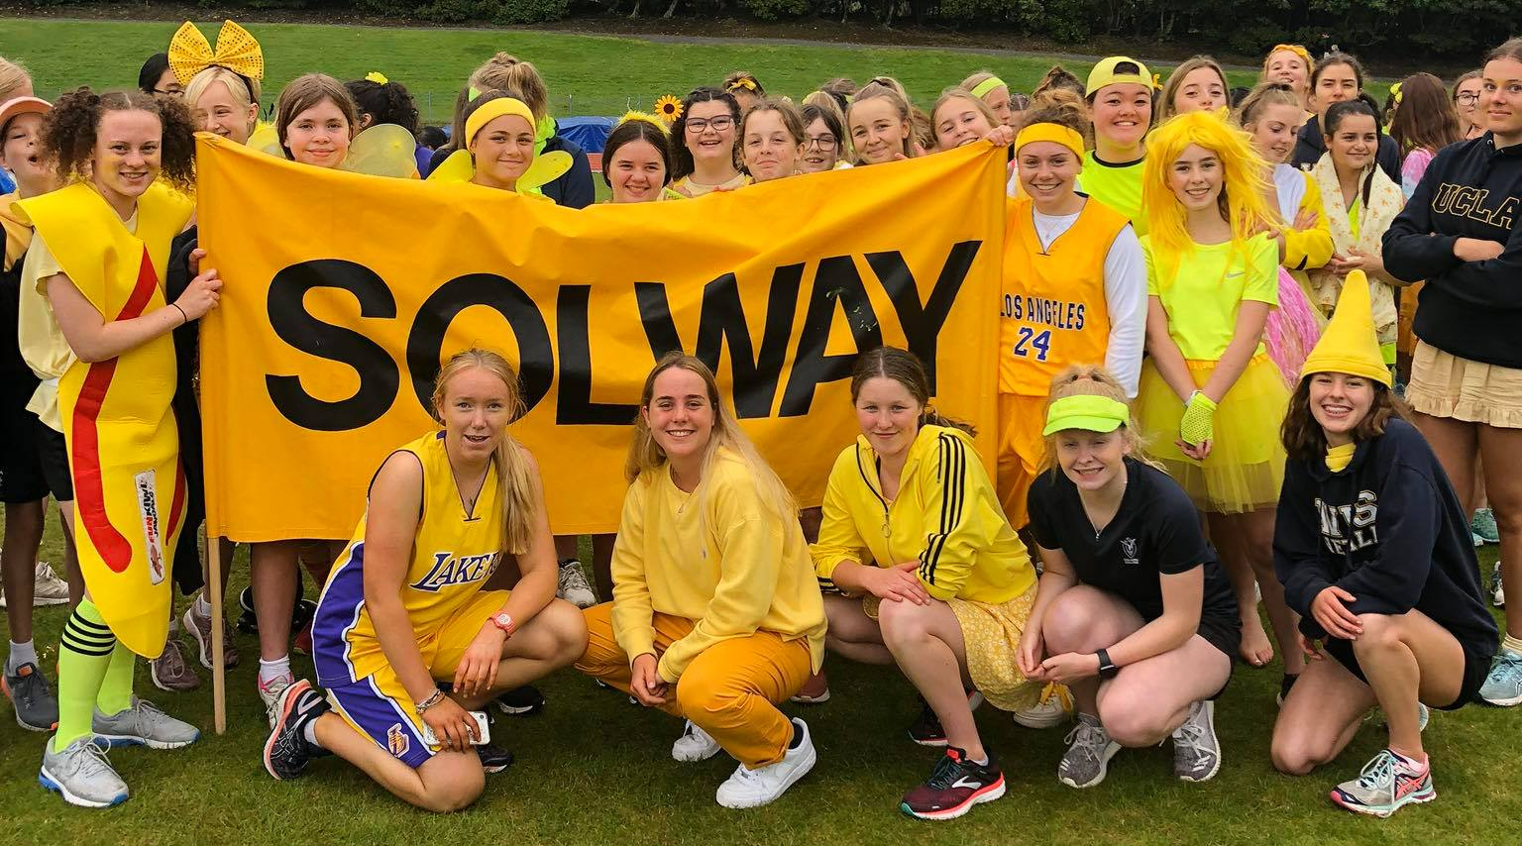
Columba College Athletics Sports Day
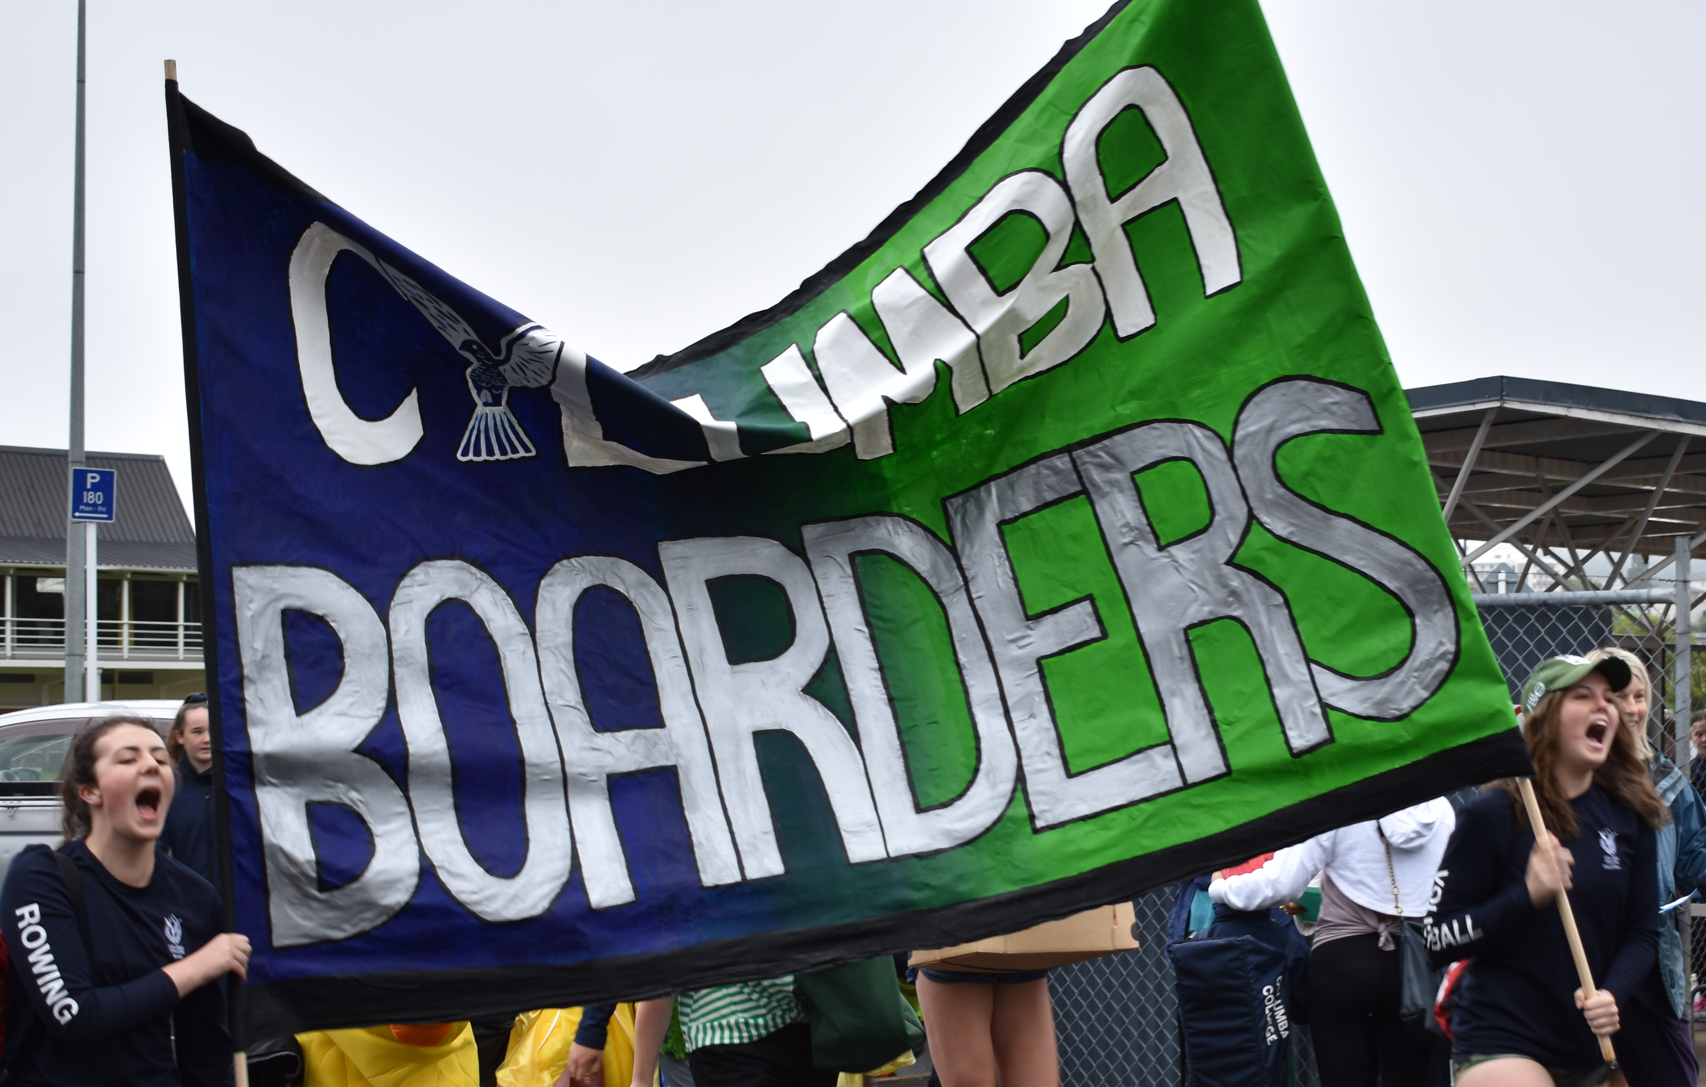
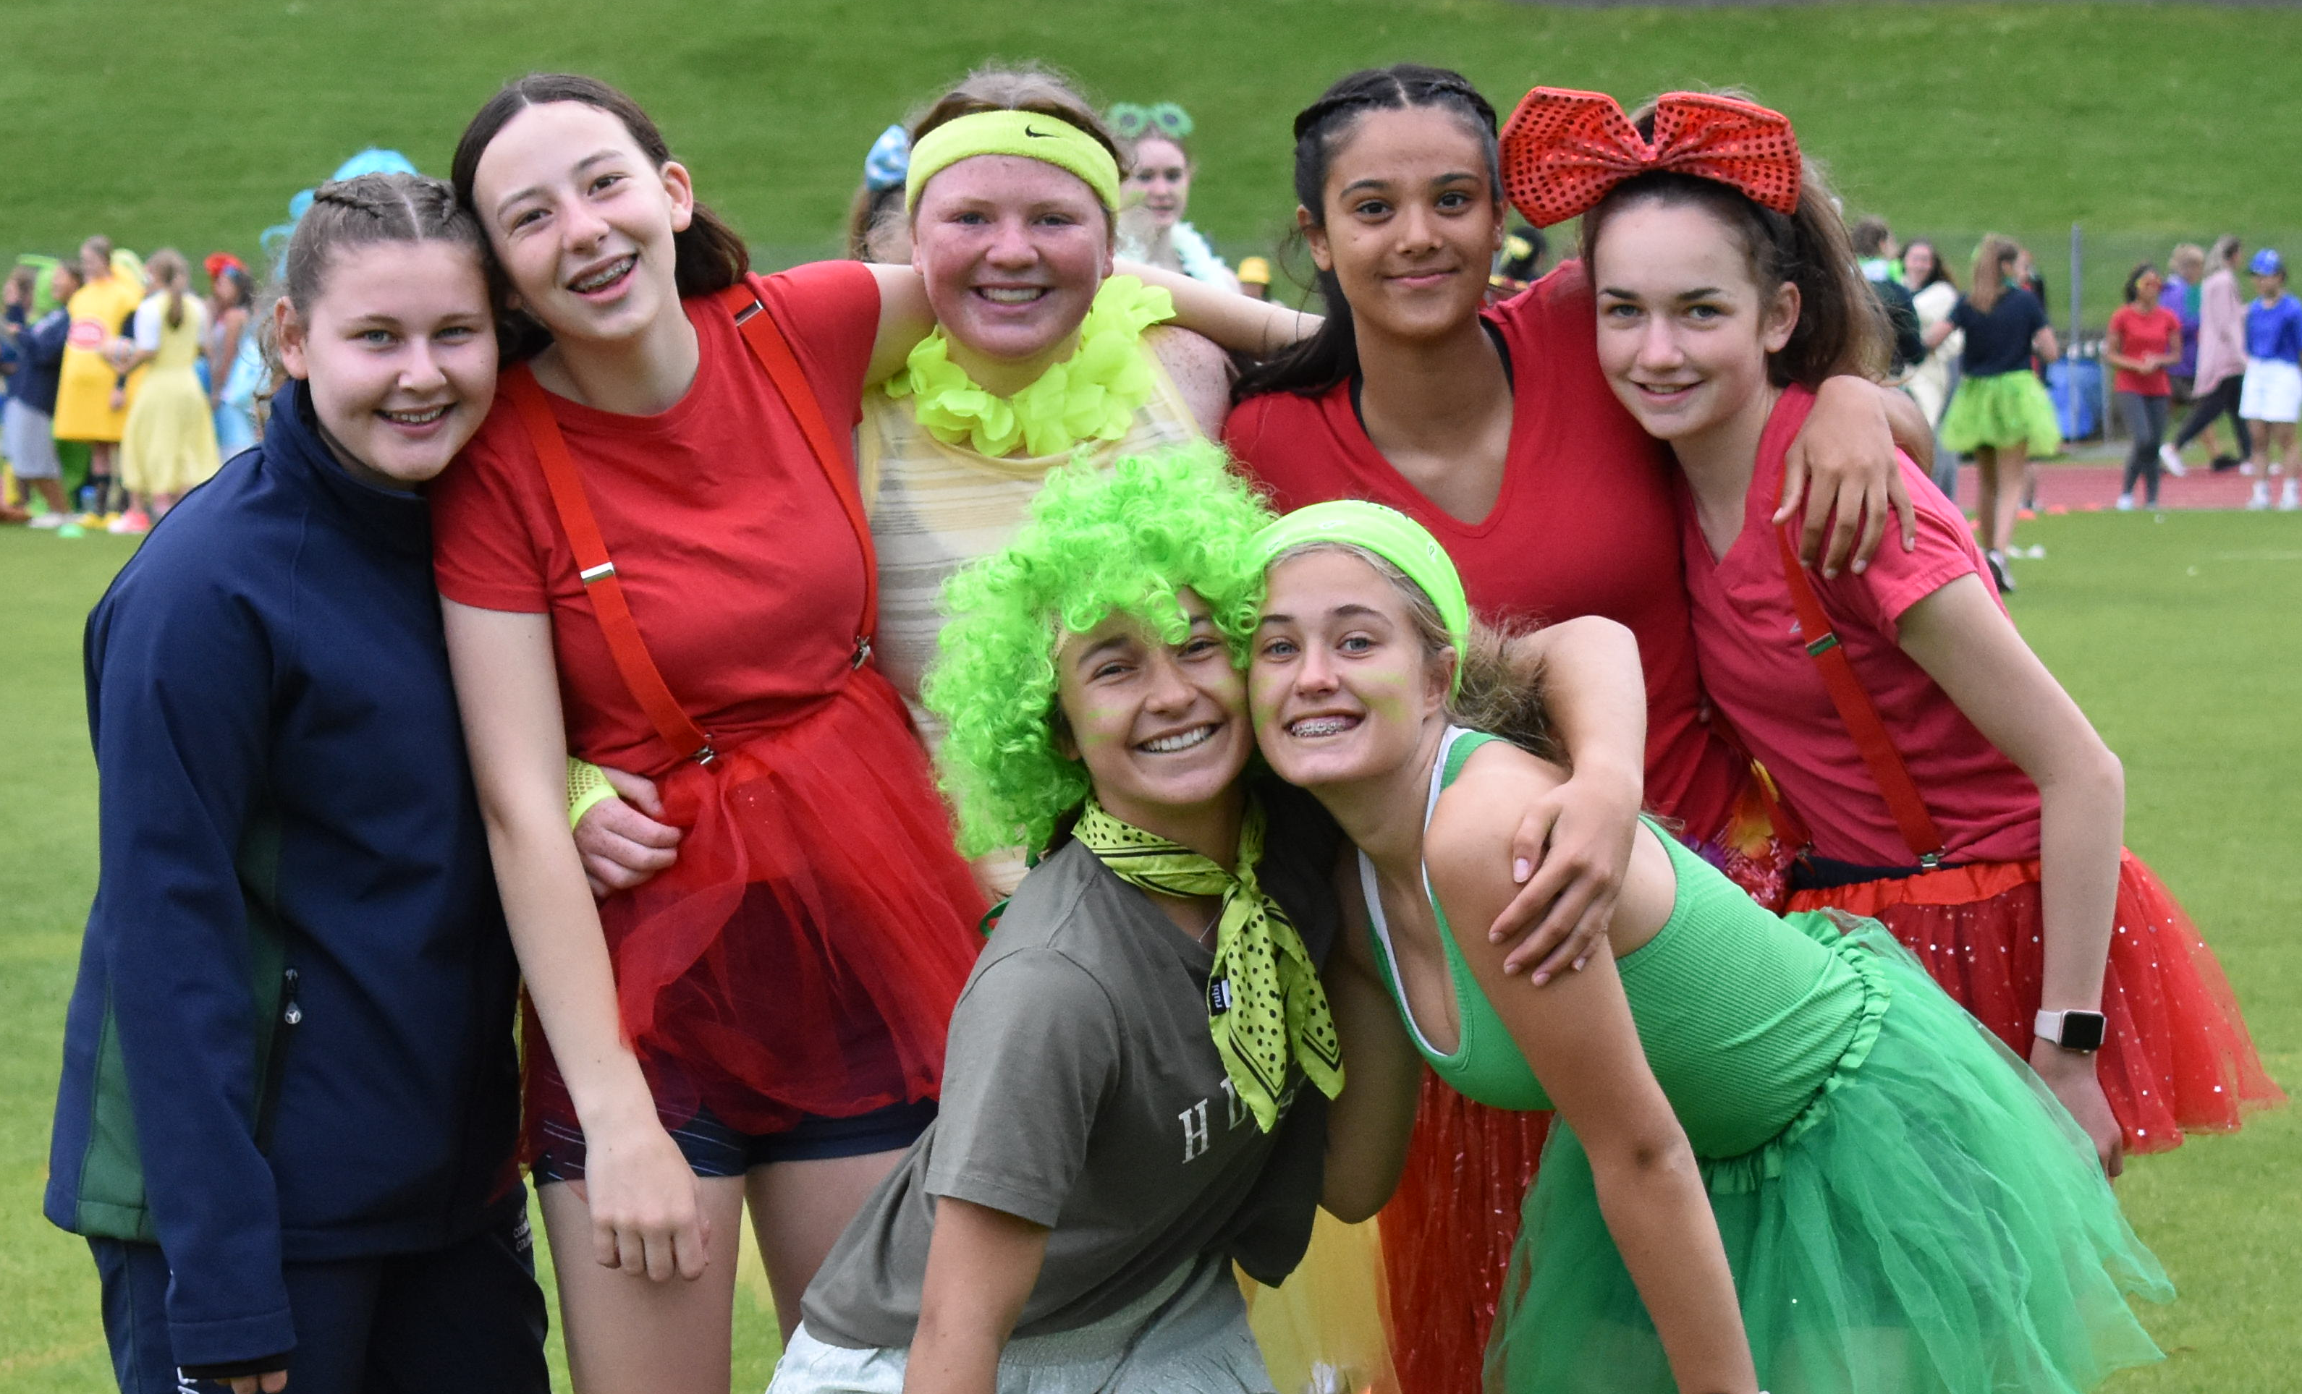
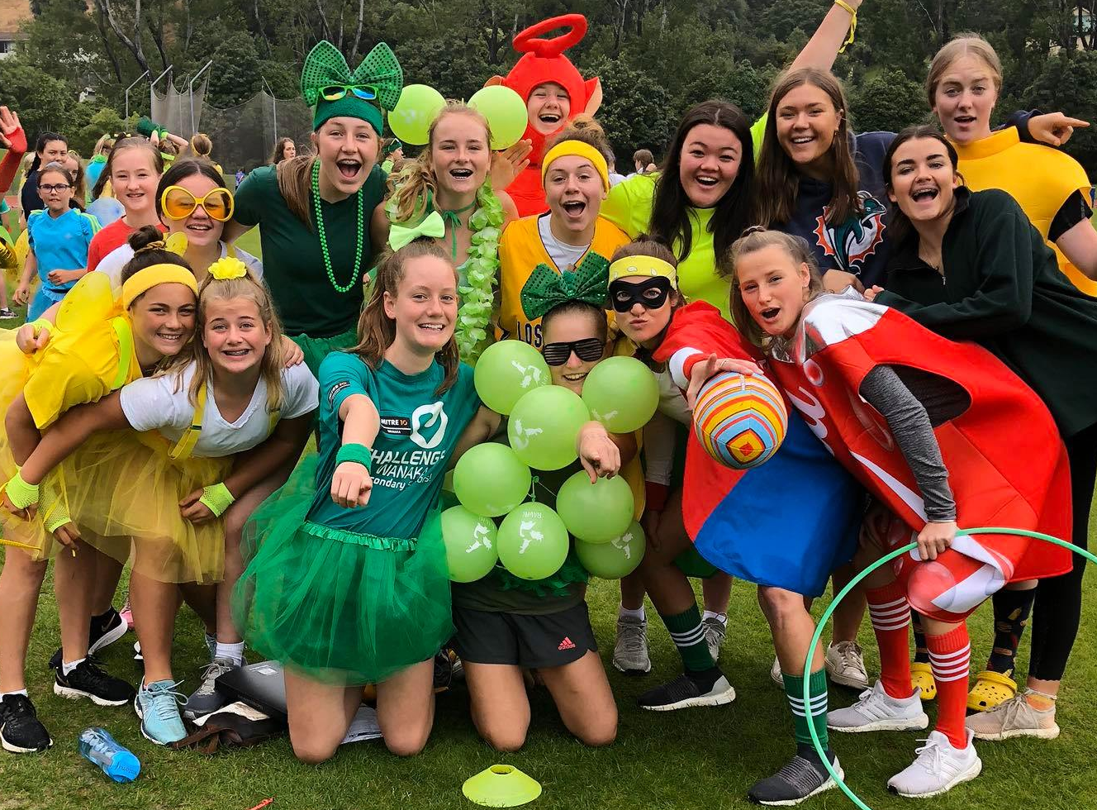
8.30am – 3.00pm
Monday 8 March, 2021
Postponement Day – Tuesday 9 March 2021
Caledonian Sports Track – Logan Park Drive

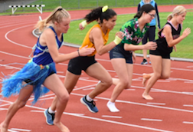
COLUMBA COLLEGE 2021 YEARS ZERO TO THIRTEEN ATHLETICS SPORTS

OFFICIALS

MEETING MANAGERS, TRACK
and FIELD REFEREES Miss D. Turnbull, Mrs C. Sinclair, Mrs R. Gemmill and Mrs E. Harris

ANNOUNCER Mrs C. Sinclair

CHIEF TIMEKEEPER Mr A. Everett

OSSA ENTRIES Mr S. Tagg

TIMEKEEPERS / PLACE TRACKERS Ms Corkhill, Mrs C. Cheyne, Mrs S. Casbolt

SPRINT TIMER Mr P. Turner (Sports Council Chairman)

MARSHALL Mrs A. Wafer and Mrs A. Bishop (Yr 7-13) + Mrs M. Hogg (Yr 0-6)

STARTER Mrs L. Piebenga (Yr 7-13)

RECORDERS Trackside: Mrs S. Bishop and Ms J. Armstrong-Homan
Grandstand: (Computer) Mr J. Chambers
House Points: Mrs C. Jones-Sexton

DRONE Mr B. Duckett

HIGH JUMP Mr A. Moore and Mr J. Scott

LONG JUMP/TRIPLE JUMP Ms A. Togneri, Ms C. Gardiner (Pit #1)
Mr G. Potter, Mr G. Corbishley (Pit #2)

DISCUS Mr S. Doran and Mr A. Sparrow (#1)
Mr A. Barlow and Miss A. Wilson (#2)

SHOT PUT Ms I. Bercinskas and Ms C. Hillier

FRISBEE THROW Mrs R. Steel

HIT WICKETS Mrs J. Lach

SOCCER DRIBBLING Ms I. Ding

RUGBY PASS Mr J. Hayden

TURBOJAV Mrs S. Dixon

PAIRS BALANCING Ms. T Andrews

INTER-HOUSE FORM EVENTS House Captains

HOSPITALITY (upstairs in the grandstand) Mrs J. MacLeod

FIRST AID First Aid Solutions

PHOTOGRAPHY Mr S. Shaw

ABSENCES, CLEAN UP and GATE SECURITY Mrs S. Graves

BBQ Prefects
JUNIOR SCHOOL TEACHERS Monitor and Help Junior Students Throughout Tabloid Events
GENERAL INSTRUCTIONS

1. Where a field and track event clash, please report to the field event and make arrangements with the official, then go back to the track event, compete and return immediately to the field event.

2. The "Fun Events" are available all morning. You earn House points by competing.

E.g. Rugby pass - 1, 2, 3 points
Frisbee throw - 1, 2, 3 points
Hit wickets - 1, 2, 3 points
Turbojav throw - 1, 2, 3 points
Soccer dribbling - 1, 2, 3 points
Pair balancing – 1, 2, 3 points

3. The Inter-House Relays (8 x 50 and 4 x 100) and the Inter-House Form events will be organized by the Sports Prefects, House Captains and Deputies.

Sports Prefects: Jorja Dinan and Brianna Horne
Braemar: Grace Macbeth
Girton: Phoebe Ozanne
Iona: Jenna Paterson
Solway: Siena Snow

Contact your House Captains or Sports Prefects if you have any questions.

4. House Points

Heats and Finals 1st = 10 2nd = 6 3rd = 4
Relays 1st = 20 2nd = 15 3rd = 10
New Record 10 points for House – not towards individual Championship

Individual Championship Points (Finals only)

1st = 10 2nd = 6 3rd = 4

The events which count for Individual Championships are the finals of all track events and high jump, long jump, discus and shot put.

5. When there are several heats for a track event, the EIGHT girls with the fastest times will compete in the final.

6. Support your friends and House. Try something new, by getting involved and have a fun, happy day!

7. Best dressed – Judged and Facilitated by Sports Captains and House Prefects throughout the day!

PROGRAMME OF EVENTS

8.15 am Staff Report.
8.30 am Roll call by form teachers (in front of the grandstand).
8.40 am Students to assemble in the center of the ground for a House March Past.

Field Events  9.00 am:  1. Primary Long Jump Under 12  2. Junior High Jump Under 14  3. Senior Shot Put Over 16  4. Senior Discus Under 16  9.30 am:  5. Primary Long Jump 12 & over  6. Junior Shot Put Under 14  7. Intermediate High Jump Under 12  8. Senior Discus Over 16  10.00 am:  9. Junior Long Jump Under 14  10. Intermediate Shot Put Under 15  11. Senior High Jump Under 16  12. Primary Discus 12 & Over  10.30 am:  13. Junior Discus Under 14  14. Intermediate Long Jump Under 15  15. Senior Shot Put Under 16  16. Senior High Jump Over 16  11.00 am:  17. Primary High Jump 12 & Over  18. Intermediate Discus Under 15  19. Senior Long Jump Under 16  20. Primary Shot Put Under 12  11.30 am:  21. Intermediate High Jump Under 15  22. Senior Long Jump Over 16  23. Primary Shot Put 12 & Over  24. Primary Discus Under 12  12.00 pm:  25. Triple Jump (OPEN EVENT)  Fun Events 9.00 am – 10.30 am:  For Everyone –ONCE each for house points:  Frisbee Throw Turbojav Throw  Hit Wickets Rugby Pass  Soccer Dribbling Pairs Balance | Track Events  9.00 am: (Running down front straight)  1. Heats Senior 100m Over 16  2. Heats Senior 100m Under 16  3. Heats Intermediate 100 m Under 15  4. Heats Junior 100m Under 14  5. Heats Primary 100m 12 & Over  6. Heats Primary 80m Under 12  9.00 am: (Running down back straight)  1. Heats Primary 50m Age 5  2. Heats Primary 50m Age 6  3. Heats Primary 60m Age 7  4. Heats Primary 60m Age 8  5. Heats Primary 60m Age 9  6. Heats Primary 75m Age 10  7. Heats Primary 75m Age 11  8. Final Primary 50m Age 5  9. Final Primary 50m Age 6  10. Final Primary 60m Age 7  9.30 am:  1. Heats Senior 200m Under 16  2 Heats Senior 200m Over 16  3. Heats Intermediate 200m U15  4. Heats Junior 200m Under 14  5. Heats Primary 200m Under 12  6. Heats Primary 200m 12 and Over  10.00 am:  1. Senior 1500m Under 16 + Over 16  2. Junior/Intermediate 1500m U14 + U15  3. Primary 1500m Under 12 + 12 & Over  10.30 am:  7. Senior 400m Over 16 (final)  8. Senior 400m Under 16 (final)  9. Intermediate 400m Under 15 (final)  10. Junior 400m Under 14 (final)  11. Primary 400m 12 & Over (final)  12. Primary 400m Under 12 (final)  11.15 am:  25. Senior 800m Over 16 (final)  26. Senior 800m Under 16 (final)  27. Intermediate 800m Under 15 (final)  28. Junior 800m Under 14 (final)  29. Primary 800m Over 12 & Over (final)  30. Primary 800m Under 12 (final)

Inter-House Whole School Relays ALL Year 0-13 (Held @12.00pm beginning of Lunch)
- Braemar  - Girton  LUNCH-TIME  SENIOR Fun - 12.00 pm:  Sack Race Relay 10x 25m  1. Year 13  2. Year 11 and 12  3. Year 9 and 10  4. Year 7 and 8 | - Iona  - Solway  Tug of War Relay 10x People  5. Year 13  6. Year 11 and 12  7. Year 9 and 10  8. Year 7 and 8
12.45 pm: 3000m FINAL (all ages Year 9 – 13 ONLY run together)

1.00 pm: Track Events – FINALS
1. Primary 80m Under 12
2. Primary 100m 12 & Over
3. Junior 100m Under 14
4. Intermediate 100m Under 15
5. Senior 100m Under 16
6. Senior 100m Over 16
7. Primary 60m Age 8
8. Primary 60m Age 9
9. Primary 75m Age 10
10. Primary 75m Age 11
11. Primary 200m Under 12
12. Primary 200m Over 12
13. Junior 200m Under 14
14. Intermediate 200m Under 15
15. Senior 200m Under 16
16. Senior 200m Over 16

Inter-House Relays - 8 x 100m Lanes House Colours
1. Year 7 and 8 1. Braemar Green
2. Year 9 and 10 2. Girton Red
3. Year 11 and 12 3. Iona Blue
4. Year 13 4. Solway Yellow

5. Boarders vs Day Girls (Must have 8 people spread across all year levels 8, 9, 10, 11, 12 and 13)
6. Staff vs Year 13 vs Prefects vs Parents (8 people each team – 100m each = 2x laps)

3.15 pm: Conclusion of Event - Depart Caledonian

Columba College Athletics Records as at 1 January 2021

Event | Primary  U/12 | Primary  O/12 | Junior  U/14 | Intermediate  U/15 | Senior  U/16 | Senior  O/16
80 m | S. Napper  2005  10.37 | G. Smith  1993  11.20
100 m | G. Smith  1992  12.52 | M. Flutey  2020  13.57 | G. Smith  1994  12.56 | S. Taylor  1981  12.8 | M. Spence  2013  12.72 | S. Napper  2011  12.62
200 m | M. Spence  2009  30.77 | L. Ferro  2017  28.29 | G. Smith  1994  27.39 | L. Ferro  2019  26.97 | M. Spence  2013  26.60 | P. Tuaine  2007  26.5
400 m | C. Sinclair  2019  1:10.59 | C. Sinclair  2020  1.04:38 | B. Skerten  2007  1:03.50 | S. Aitken  2005  1:02.17 | E. Duncan  2014  1:00.77 | M. Spence  2015  59.56
800 m | L. Rhodes  2020  2:44.73 | C. Lund  2018  2:42.74 | G. Henderson  2000  2:31.92 | N. Silva  1976  2:31.2 | R. Turner  2019  2.30.14 | S. English  2013  2:23.31
1500 m | L. Rhodes  2020  5:37.37 | C. Lund  2018  5:29.66 | C. Lund  2019  5:11.00 | C. Lund  2020  4:58.00 | H. English  2013  4:58.57 | S. English  2013  4:55.22
3000 m |  |  | C. Lund  2019  11:20.00 | C. Lund  2020  11:05.57 | H. English  2013  10:51.72 | S. English  2013  10:39.46
Hurdles |  |  | C. Metua  2014 Nationals  12.82 | K. Malcolm 80m  1998  12.5 | M. Spence 80m  2013  12.26 | M. Spence 100m  2014  15.14
Long Jump | S. Aitken  2002  4.54 m | N. Currie  1996  4.23 m | K. Malcolm  1997  4.76 m | S. Aitken  2005  5.02 m | K. Malcolm  1999  5.29 m | P. Forrester  1960  5.50 m
High Jump | E. Hayden  2007  1.32 | C. Black  1996  1.37 m | M. Hopkins  1989  1.48 m | G. Paterson  1999  1.54 m | K. Malcolm  1999  1.56 m | J. McAuslan  2017 SI  1.65m
Discus | Brittany Spark  2011  21.60 | C. Sinclair  2020  22.26m | A. Duff  2020  30.34m | F. Barclay  1987  30.90 m | F. Paterson  1999  28.45 m | D. Stanton  1974  28.43 m
Shot Put | Niamh Paterson  2015  7.94m | A. Duff  2019  8.19m | A. Duff  2020  9.69 m | B. Fowle  1976  9.86 m | F. Paterson  1999  10.42 m | B. Fowle  1977  10.60 m
4 x 100 m  Relay |  |  | 2014 (Nationals)  51.04 Wanganui  M. Breen  E. Duncan  M. Moore  C. Metua | 2012 (Sth Is)  51.65  A. Cowie  K. Guildford  P. Pegg  M. Spence | 2011 National Wgton)  52.37  P. Pegg  M. Spence  A. Cowie  C. Wood | 2014 Nationals Wanganui)  49.61  R. Coers  L. Cunningham  L. Saville  M. Spence
4 x 400 m  Relay |  |  | 2014 (Nationals)  M. Breen  I. Becconsall-Ryan  C. Metua  F. Schultz  4:21.46 |  |  | 2015 (Nationals)  3:58.69  R. Coers  L. Cunningham  E. Duncan  M. Spence
Triple Jump |  |  | N. Ireland  2006  9.27m | S. Aitken  2005  9.66m  * new 2005 | K. Malcolm  1999  11.10m | K. Malcolm  2000  11.61 m
Javelin |  |  | A. Duff  2020  21.36m | B. Saville  2012  28.08 | L. Shirley  2014  27.02 | S. Smith  2019 Nationals  31.74
300m Hurdles  Open |  |  |  |  | M. Spence  2013 | M. Spence  2015 SI Meet  43.49
Hammer  Throw |  |  | C. Wheeler  30.70m Nationals 2015 | K. Wheeler  34.80m | K. Wheeler  39.44 Nationals | K. Wheeler  2015 Nationals  41.87
Steeple  Chase |  |  | C. Lund  2019 Nationals  7:40.75 |  |  | C. Cahill  2014 SI Meet  7:31.82
sp:AthRecords2021

Columba College Primary North Zone/Otago Records as at 1 January 2021

Event | Primary  U/12 | Intermediate  U/13 | Junior  O/13
Long Jump |  | Charli Sinclair  2019  4.11m | Caitlin Butson  2019  4.44m
High Jump | Delilah Brown  2020  1.25m | Rhiarna Webster  2019  1.33m | Kayla Smith  2019  1.25m
Discus | Alexa Duff  2018 - North Zone  28.19m | Alexa Duff  2019  32.12m | Alexa Duff  2019  32.80m
Shot Put | Ciara Paterson  2019  9.31m | Alexa Duff  2019  8.54m | Alexa Duff  2019  9.40m
800m |  |  | Charli Sinclair  2020  2.37:41
