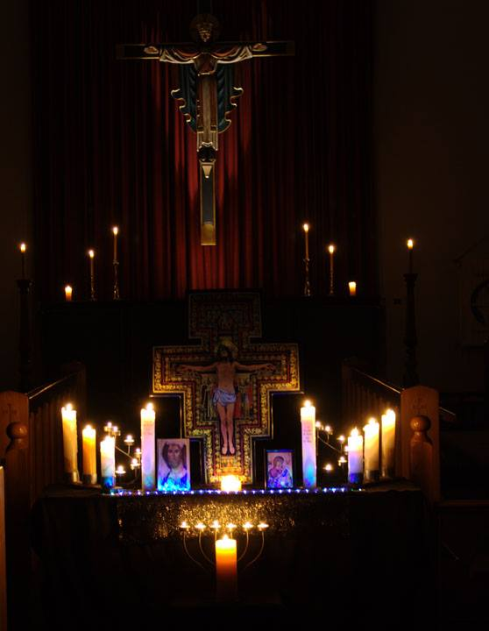
Taizé
at
Holy Trinity
Invercargill
Held on the 2nd and 4th Sunday every month, starting at 7pm.

A Candlelit Service of Reflection and Chants

