Stationery List Team Ruru (Year 1/2), 2019

Please ensure your child has these items on the first day of term.
Please make sure you buy the correct books | Resource | Looks like | Quantity
Please make sure you buy the correct books | Writing  Year 1- My Writing – Book 1 (Green) x 2  Year 2- My Writing – Book 1 (Green) & Book 2 (Red) | 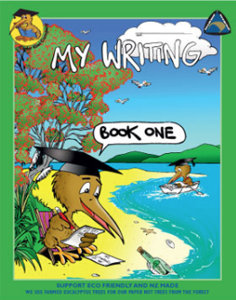  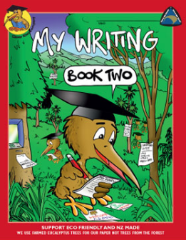 | 2
Please make sure you buy the correct books | Handwriting  LWB | 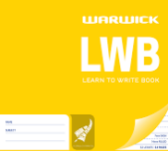 | 1
Please make sure you buy the correct books | Maths  Kiwi All Purpose Book | 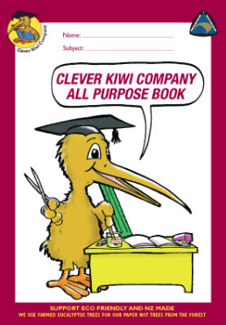 | 1
Please make sure you buy the correct books | Topic/Literacy/Learning Story  Kiwi Activity Book | 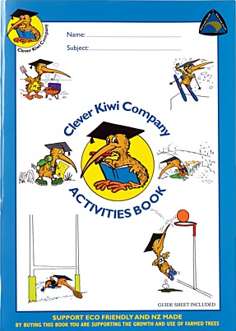 | 1
Please make sure you buy the correct books | Poetry  1A5 | 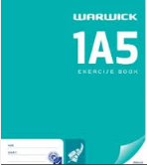 | 1
Please make sure you buy the correct books | Home Learning  1B5 | 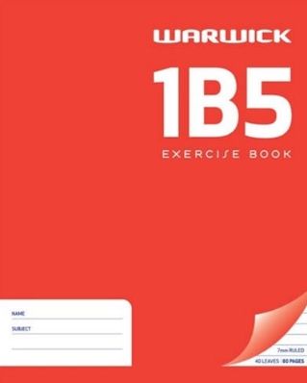 | 1
Please make sure you buy the correct books | Book Bag (large)  Last year’s OK only if in good condition. | 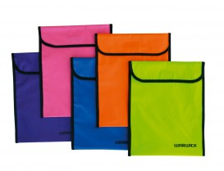 | 1
Please make sure you buy the correct books | Triangular Pencils  (Faber Castell Junior Grip Pencil) | 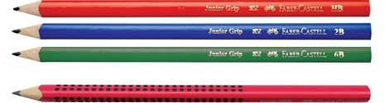 | 6
Please make sure you buy the correct books | Glue Stick – Amos Brand 35gm (large) | 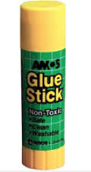 | 5
Please make sure you buy the correct books | Chunky Jovi Crayons | 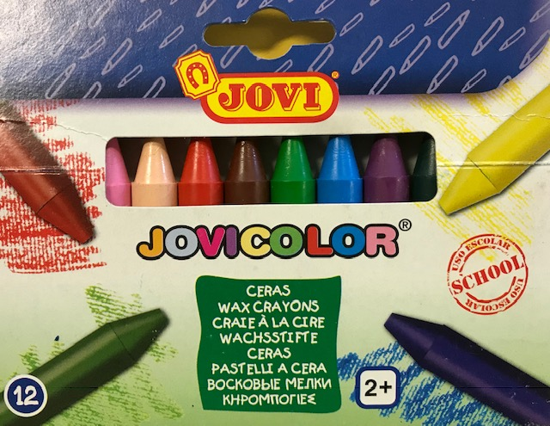 | 1 set  (6 or 12 pack)
Please make sure you buy the correct books | Whiteboard Pens  Black or Blue | 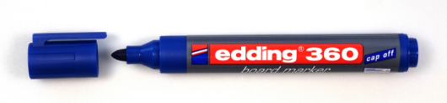 | 4
 | Named Headphones  NOT earbuds | 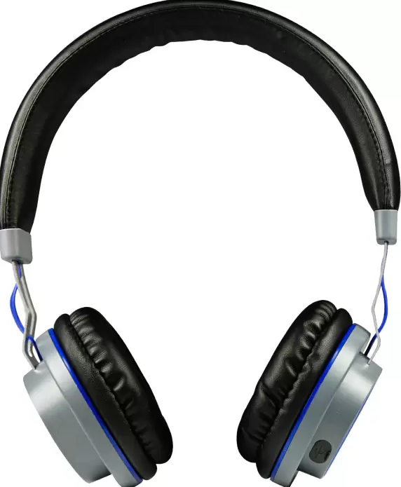 | 1

- All children must have a named drink bottle

