Massey High School Gala Raffle
Westpac Helicopter Appeal
Raffle Tickets $5 each
Raffle drawn 26th October at 7:00pm
Boredom Buster - Platinum Deluxe
Snow Planet Family Pass
1 x month Swimming Lessons, Hilton Brown Hobsonville
Extreme Edge Family Pass
Flippin Fun Entry
Chipmunks 2 x free entries
GGs Woodfired Pizza, Kumeu $50 pizza voucher
Bluetooth Speaker

Boredom Buster - Platinum
Skyline Rotorua Family Pass
Extreme Edge Family Pass
Family Bowling Pass – Henderson
Flippin Fun Entry
Chipmunks 2 x free entries
Bluetooth Speaker

Boredom Buster - Gold
Tree Adventures Family Pass
Extreme Edge Family Pass
Family Bowling Pass – Westgate
Chipmunks 2 x free entries
Bluetooth Speaker

Boredom Buster - Silver
Escape Masters Family Pass
Extreme Edge Family Pass
Chipmunks 4 x free entries
Family Atlas
Bluetooth Speaker

Boredom Buster - Bronze
Flippin Fun Double Pass
Chipmunks 2 x free entries
National Geographic book
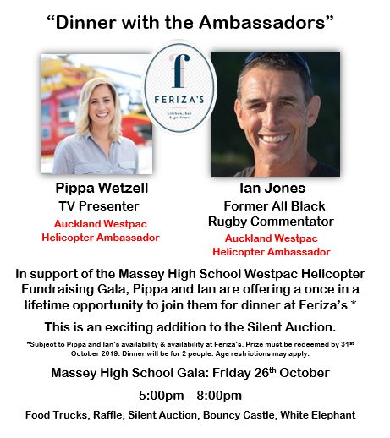
Bluetooth Speaker

Beach Bundle
Chilly Bin
Beach Chairs & Mat
Bluetooth Speaker
Warriors Rugby Ball

Sports Enthusiast
Ted Ashby Family Sailing
All Blacks Shirt
Official Sun Wolves v Brumbies Ball
$30 Jemima’s Burgers Voucher
ASB Sports Bag & Merchandise

Sailing Bundle Deluxe
Ted Ashby Family Sailing
Americas Cup Book
Sunscreen

Pamper Package
High Tea for 2 at the Cordis Hotel
Indulge in Beauty $50 voucher
Ethique Products
Jamberry Nails Products

Coffee Lovers
$100 Columbus Coffee Glen Eden Voucher
Bethells Beanz
Plunger
Coffee Cups
Hospitality Cake

Home Sweet Home Package
Electric Wok
$50 Harvey Furnishing voucher
$50 Bed, Bath & Beyond Voucher
Small Tegal Chicken Hamper

Other Prizes include:
2 x Tegal Hamper (approximately 5 chickens /turkeys)
$100 Fabric Café Hobsonville Voucher
$100 Pak n Save Voucher
$50 Chikos Voucher

Silent Auction
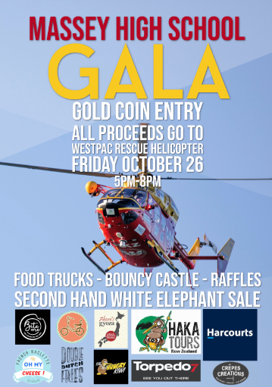
Separate from the Raffle there will also be a Silent Auction on the night which will include: Air NZ Tickets, A 3-Day Haka Tours Mini Break, A Trek Marlin 4, 2019 Mountain Bike, A 2-day Sail with Spirit of Adventure, A Harbour Bridge Climb & Bungy and many more…

